

JK LAKSHMIPAT UNIVERSITY

DIGITAL CIRCUIT AND SYSTEMS  
(EE1120)

Activity 01

LOGIC GATES

Characterization

Date : 16th January 2023

Name : Bobby Sharma

AIM: Verify all the logic gates using tinker cad simulation.

APPARATUS REQUIRED: Tinker Cad Platform in your device.

THEORY: A logic gate is a simple switching circuit that determines whether an input pulse can pass through to the output in digital circuits. The following types of logic gates are commonly used:

* AND
* OR
* NOT
* NOR (Universal gate*)
* NAND (Universal gate*)
* XOR
* XNOR

(* A universal gate is a logic gate which can implement any Boolean function without the need to use any other type of logic gate.)

IC NUMBERS: IC numbers are used to identify the different types of logic gates. The number of gates per IC varies depending on the number of inputs per gate. The basic logic gates are the building blocks of more complex logic circuits.

* NOT GATE: The IC number of the NOT gate is 7404 Hex Inverter. The reason it is called Hex Inverter is because it has 6 NOT gate in its system and the output given by this gate is inversion to the input as shown in figure 1 and 2. The terminal 7 is attached to the ground and the terminal 14 is connected to the power supply. The representation is A = Complement of A

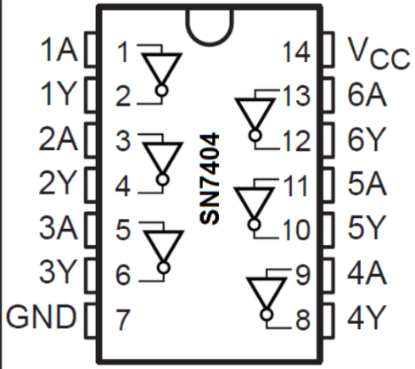 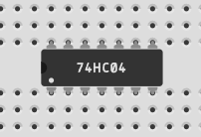

Figure 1 Figure 2

* AND GATE: The IC number of the AND gate is 7408. This gate gives the output by multiplying both the inputs. The representation is Y = A.B

The Quad AND gate are shown in figure 3 and 4. It has 4 AND gates. Later the terminal 7 is attached to the ground and the terminal 14 is connected to the power supply.

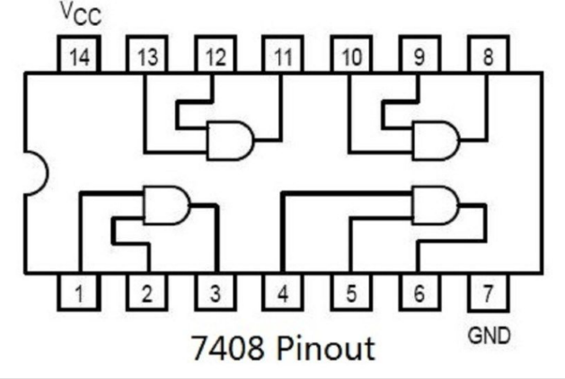 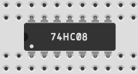

Figure 3 Figure 4

* OR GATE: The IC number of the OR gate is 7432. This gate gives the output by addition of both the inputs. The representation is Y = A+B

The Quad OR gate are shown in figure 5 and 6. It has 4 OR gates. Later the terminal 7 is attached to the ground and the terminal 14 is connected to the power supply.

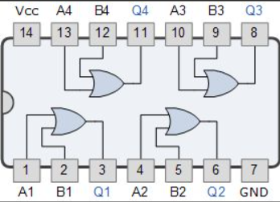 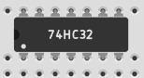

Figure 5 Figure 6

* X-OR GATE: The IC number of the X-OR gate is 7486. If the inputs of the X-OR gate have odd numbers of ones, then the output of the X-OR gate is high. If both inputs are the same value, then the output is low. The representation is Y = A+B (Exclusive or). It can also be represented by

Y = A.(Complement of B)+ (Complement of A).B

The Quad OR gate are shown in figure 7 and 8. It has 4 X - OR gates. Later the terminal 7 is attached to the ground and the terminal 14 is connected to the power supply.

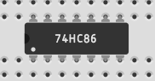 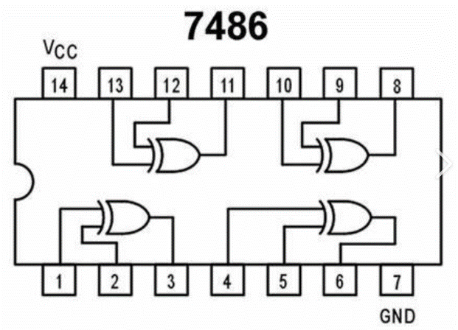

Figure 7 Figure 8

* X-NOR GATE: If the inputs of the X-NOR gate have an odd number of ones then the output is low. If both inputs of the X-NOR gate have the same, then the output is high. If there is no availability of an X-NOR gate, then there is a chance to implement the X-NOR gate by using basic and universal gates. The representation is Y = Complement of (X-OR GATE)

The X-NOR gate is shown in figure 9. It is combination of X-OR gate with the NOT gate . Later the terminal 7(of both gates) is attached to the ground and the terminal 14(of both gates) is connected to the power supply.

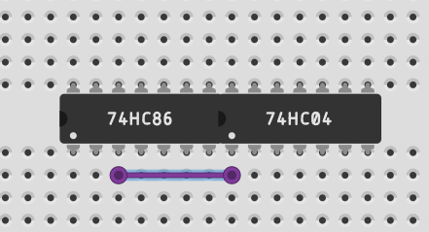

Figure 9

OBSERVATION: The observed outputs of all the basic gates are as follows:

* NOT GATE:

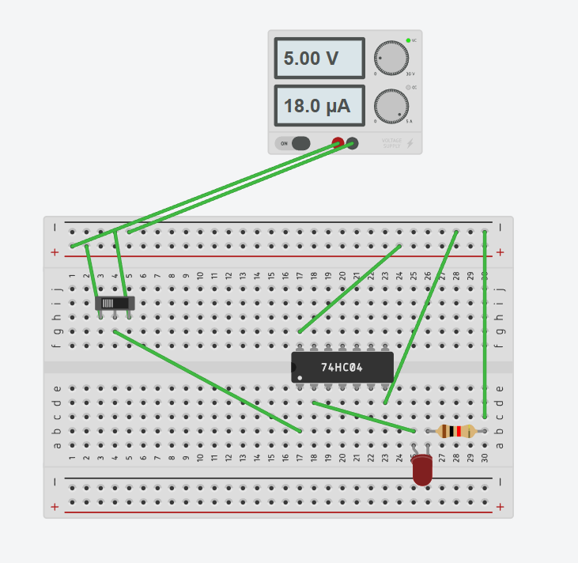 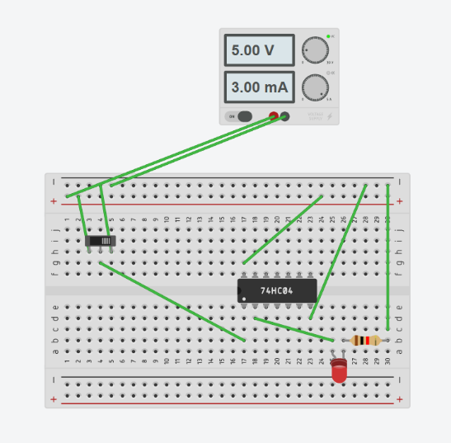

Figure 10 Figure 11

Figures 10 and 11 are showing the outputs when the slider switch is on and off. By observing this we can make the truth table of NOT gate which is shown in table 1.

|  |  |
| --- | --- |
| INPUT | OUTPUT |
| 1 | 0 |
| 0 | 1 |

Table 1

* AND GATE : 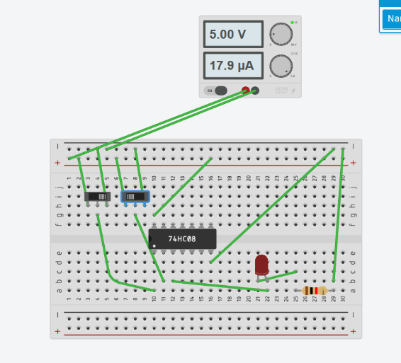 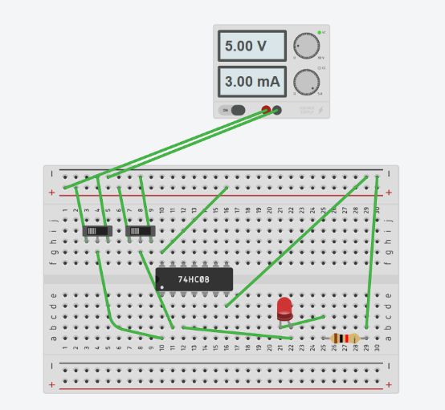

Figure 12 Figure 13

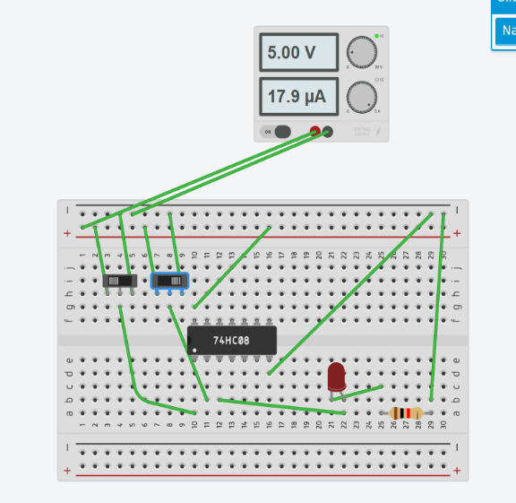 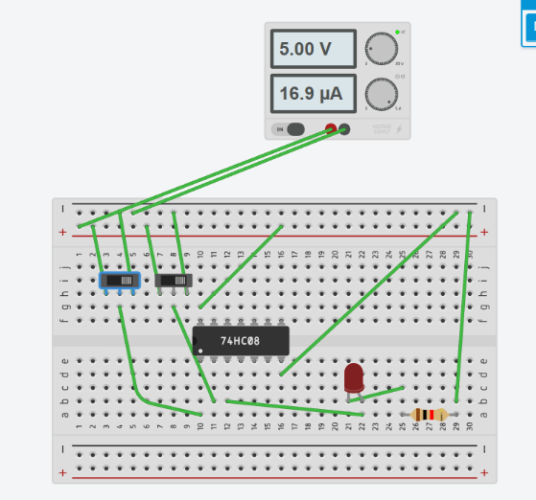

Figure 14 Figure 15

Figures 12,13,14 and 15 are showing the outputs when both the slider switch is on and off. By observing this we can make the truth table of AND gate which is shown in table 2.

|  |  |  |
| --- | --- | --- |
| A | B | Y = A.B |
| 0 | 0 | 0 |
| 0 | 1 | 0 |
| 1 | 0 | 0 |
| 1 | 1 | 1 |

Table 2

* OR GATE:

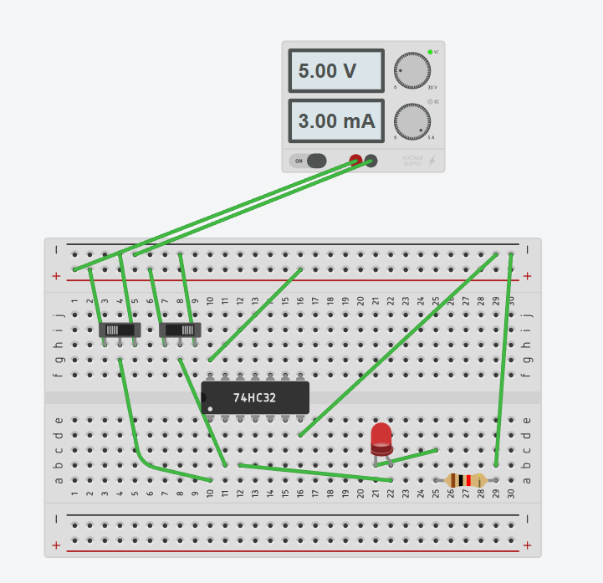 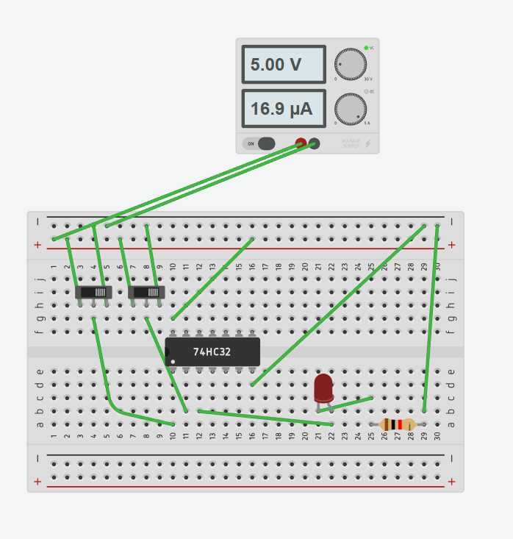

Figure 16 Figure 17

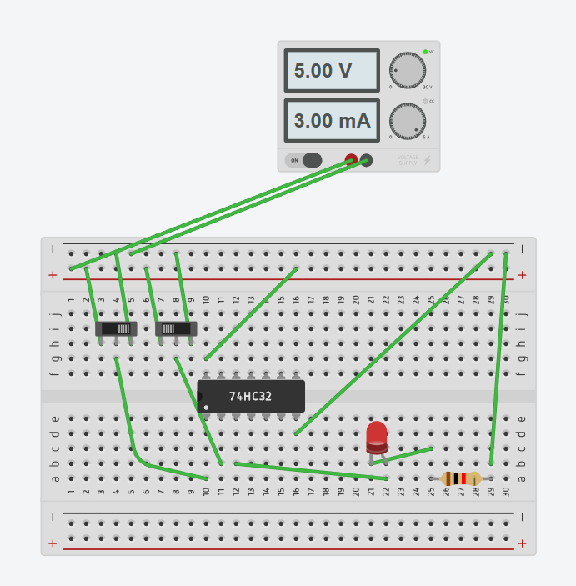 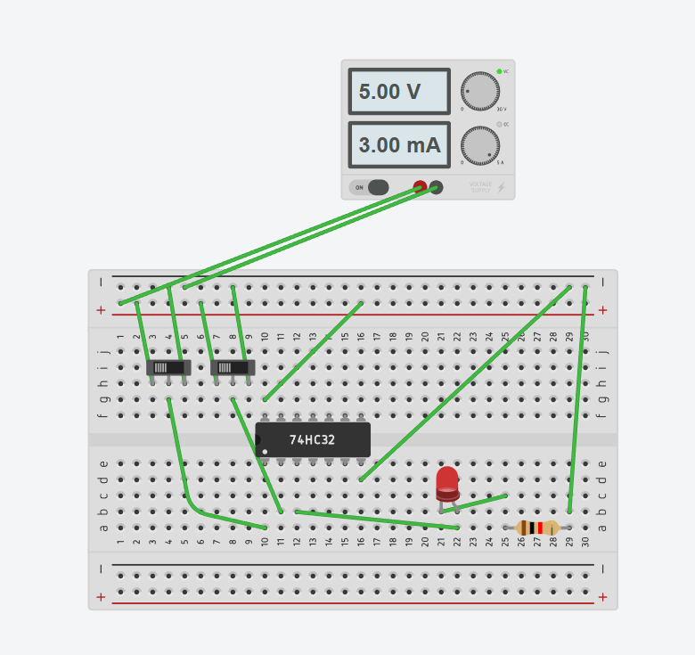

Figure 18 Figure 19

Figures 16,17,18 and 19 are showing the outputs when both the slider switch is on and off. By observing this we can make the truth table of OR gate which is shown in table 3.

|  |  |  |
| --- | --- | --- |
| A | B | Y = A+B |
| 0 | 0 | 0 |
| 0 | 1 | 1 |
| 1 | 0 | 1 |
| 1 | 1 | 1 |

Table 3

* X-OR GATE:

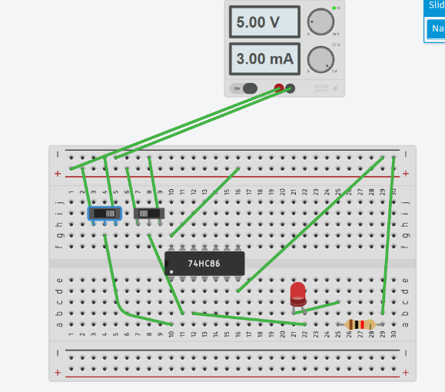 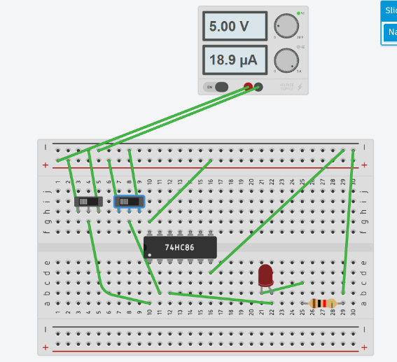

Figure 20 Figure 21

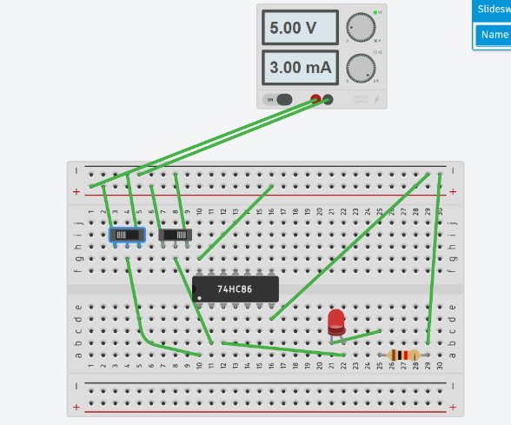 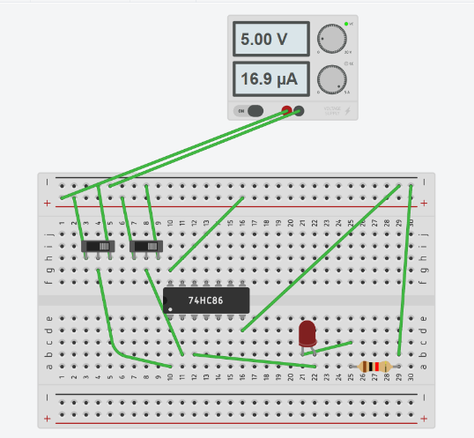

Figure 22 Figure 23

Figures 20,21,22 and 23 are showing the outputs when both the slider switch is on and off. By observing this we can make the truth table of OR gate which is shown in table 4.

|  |  |  |
| --- | --- | --- |
| A | B | Y = A+B (Exclusive or) |
| 0 | 0 | 0 |
| 0 | 1 | 1 |
| 1 | 0 | 1 |
| 1 | 1 | 0 |

Table 4

* X-NOR GATE:

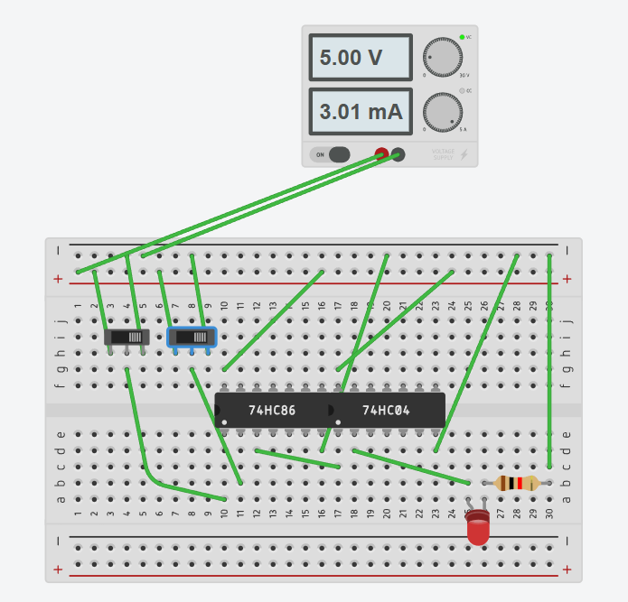 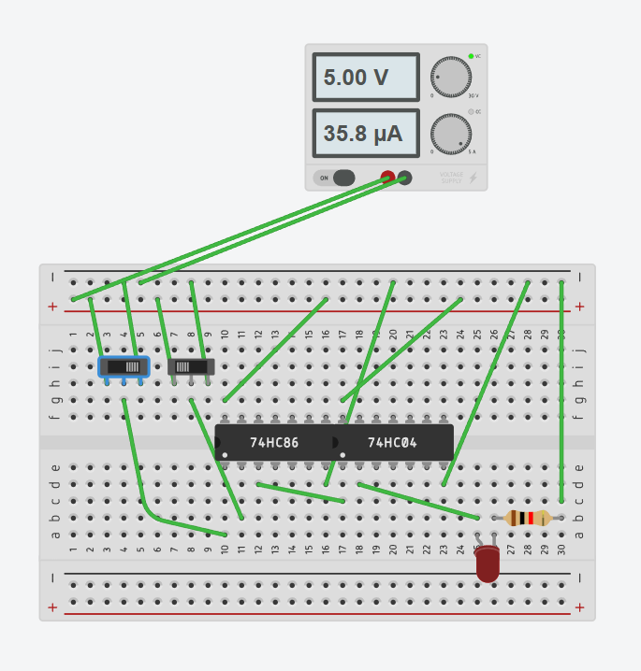

Figure 24 Figure 25

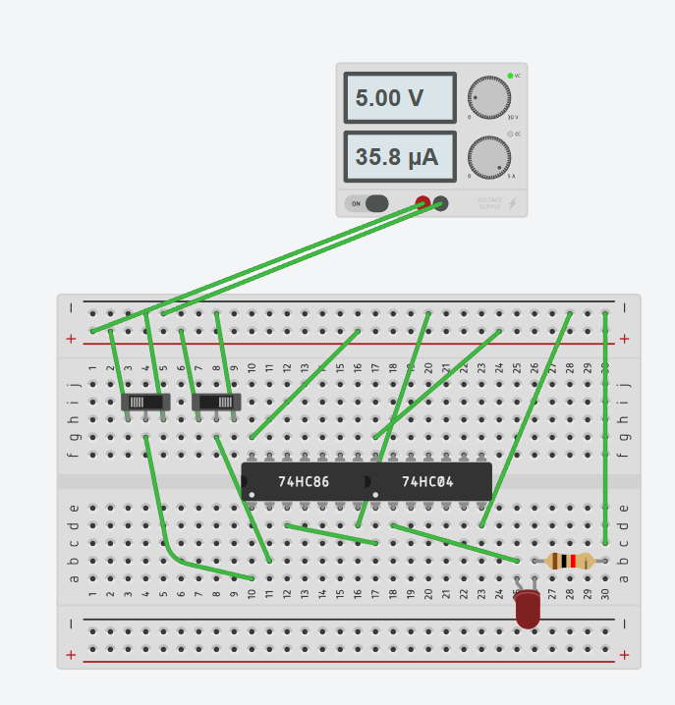 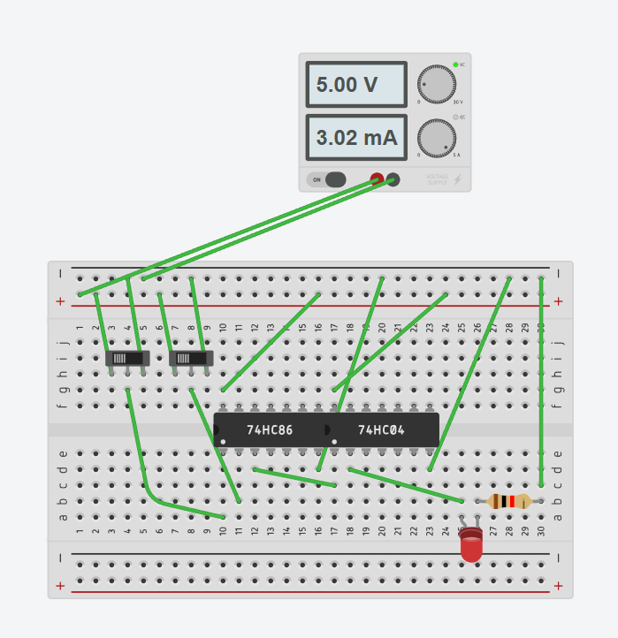

Figure 26 Figure 27

Figures 24,25,26 and 27 are showing the outputs when both the slider switch is on and off. By observing this we can make the truth table of OR gate which is shown in table 5.

|  |  |  |
| --- | --- | --- |
| A | B | Y = Complement of X-OR gate |
| 0 | 0 | 1 |
| 0 | 1 | 0 |
| 1 | 0 | 0 |
| 1 | 1 | 1 |

RESULT: We have concluded all the truth tables of all the basic logic gates from the tinker cad simulation.

APPLICATION IN DAILY LIFE:

Logic gates are fundamental building blocks of digital circuits and are used extensively in various electronic devices and systems. While we may not interact with logic gates directly in our daily lives, they play a crucial role in the functioning of numerous technologies and applications. Here are some examples of how logic gates are applied in daily life:

1. Computers and Smartphones:

* Logic gates are the foundation of digital circuits in computers and smartphones.
* They process and manipulate binary data, enabling the execution of complex tasks and running software applications.

1. Home Appliances:

* Modern home appliances often contain digital control systems that use logic gates.
* Microwaves, washing machines, and refrigerators may use logic gates to control various functions and operations.

1. Security Systems: Security systems, such as alarm systems and access control systems, utilize logic gates for processing signals from sensors and making decisions based on predefined conditions.

Activity 02

Conversion from NAND gate

To all basic gates

Date : 16th January 2024

Name : Bobby Sharma

AIM: Design all the logic gates using NAND gate only using tinker cad.

APPARATUS REQUIRED: Tinker Cad Platform in your device.

THEORY: A logic gate is a simple switching circuit that determines whether an input pulse can pass through to the output in digital circuits. The following types of logic gates are commonly used:

* AND
* OR
* NOT
* NOR (Universal gate*)
* NAND (Universal gate*)
* XOR
* XNOR

(* A universal gate is a logic gate which can implement any Boolean function without the need to use any other type of logic gate.)

* NOT GATE: The IC number of the NOT gate is 7404 Hex Inverter. The output given by this gate is inversion to the input as shown in figure 1. The conversion from NAND gate to NOT gate can be done by using the same input which results in the conversion of the input given by the user.

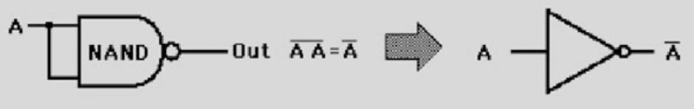

Figure 1

* AND GATE: The IC number of the AND gate is 7408. This gate gives the output by multiplying both the inputs. The Quad AND gate are shown in figure 2. The conversion can be done by just reversing the output of the NAND gate which will lead us to expected output of AND gate.

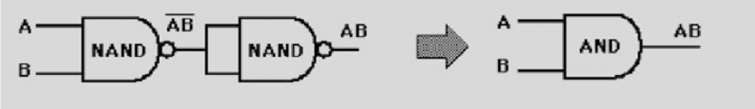

Figure 2

* OR GATE: The IC number of the OR gate is 7432. This gate gives the output by addition of both the inputs. The Quad OR gate are shown in figure3. The conversion is done by applying De-Morgan’s Law on A+B which is explained in figure 3. The output can check through the truth table of OR gate.

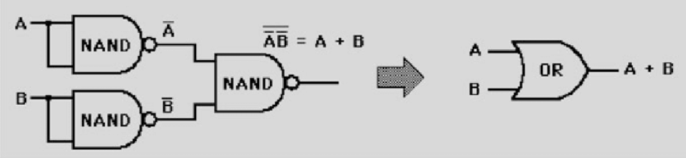

Figure 3

* X-OR GATE: The IC number of the X-OR gate is 7486. The Quad OR gate are shown in figure 4 and 5. As we know the other way of representing X-OR gate is as follows Y = A.(Complement of B)+ (Complement of A).B

As the representation suggests, we must make the AND gate from A and Complement of B and vice versa. Later, we must take their output as an input and make the OR gate which will give us the output of X-OR gate.

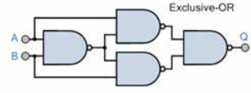 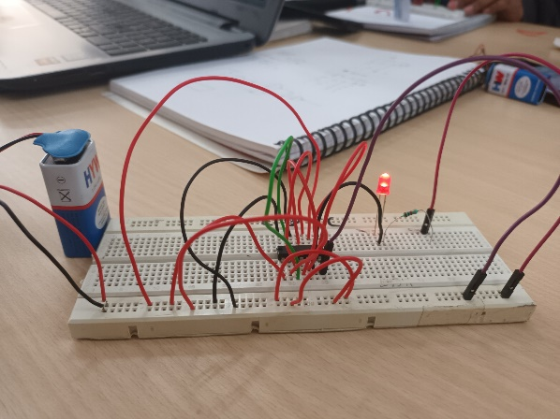

Figure 4 Figure 5

* X-NOR GATE: The representation is Y = Complement of (X-OR GATE). The X-NOR gate is shown in figure 6 and 7. It is combination of X-OR gate with the NOT gate. So we can just add the combination of NAND gate (that we used for NOT gate) to the combination of NAND gate (that we used for X-OR gate).

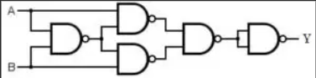 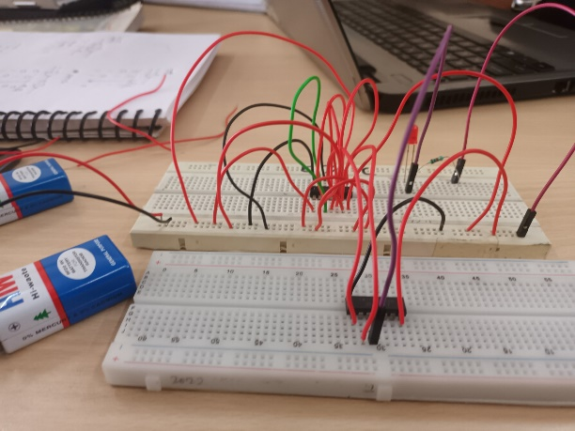

Figure 6 Figure 7

OBSERVATION: The observed outputs of all the basic gates are as follows:

* NOT GATE:

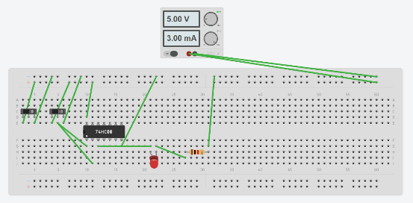 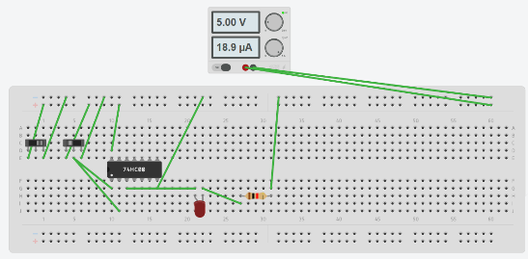

Figure 8 Figure 9

Figures 8 and 9 are showing the outputs when the slider switch is on and off. By observing this we can make the truth table of NOT gate which is shown in table 1.

|  |  |
| --- | --- |
| INPUT | OUTPUT |
| 1 | 0 |
| 0 | 1 |

Table 1

* AND GATE : 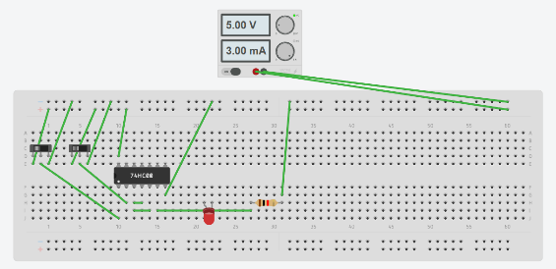 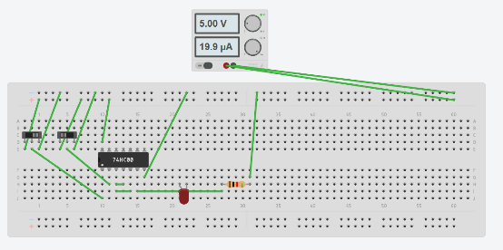

Figure 10 Figure 11

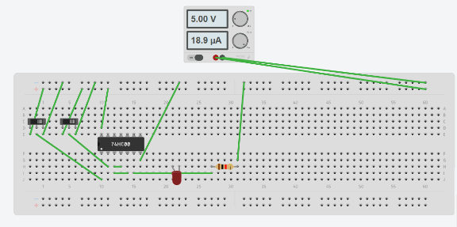 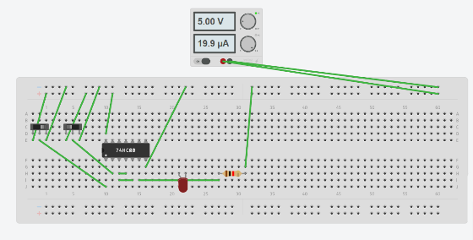

Figure 12 Figure 13

Figures 10,11,12 and 13 are showing the outputs when both the slider switch is on and off. By observing this we can make the truth table of AND gate which is shown in table 2.

|  |  |  |
| --- | --- | --- |
| A | B | Y = A.B |
| 0 | 0 | 0 |
| 0 | 1 | 0 |
| 1 | 0 | 0 |
| 1 | 1 | 1 |

Table 2

* OR GATE:

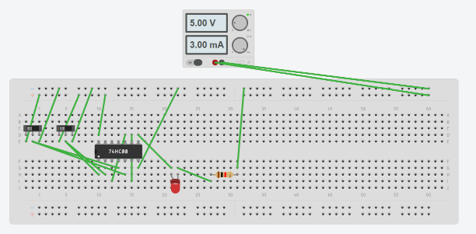 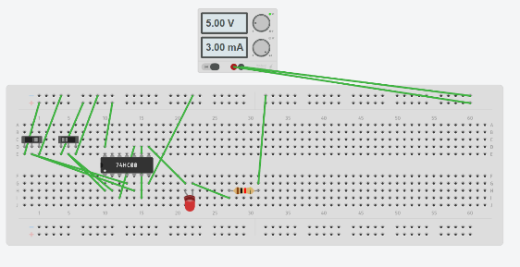

Figure 14 Figure 15

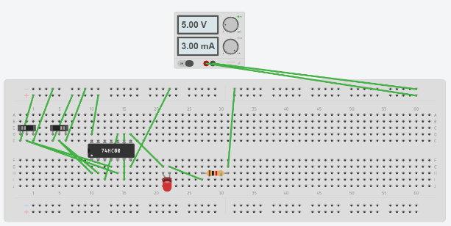 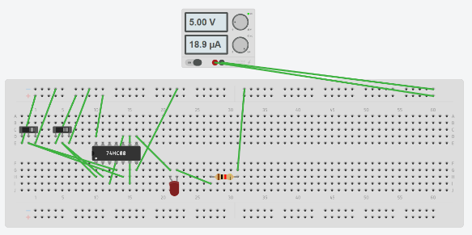

Figure 16 Figure 17

Figures 14,15,16 and 17 are showing the outputs when both the slider switch is on and off. By observing this we can make the truth table of OR gate which is shown in table 3.

|  |  |  |
| --- | --- | --- |
| A | B | Y = A+B |
| 0 | 0 | 0 |
| 0 | 1 | 1 |
| 1 | 0 | 1 |
| 1 | 1 | 1 |

Table 3

* X-OR GATE:

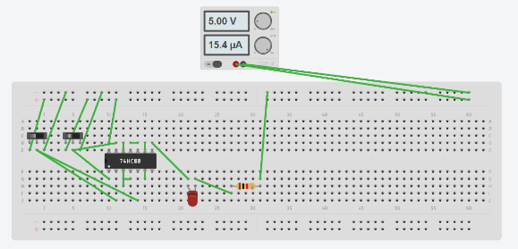 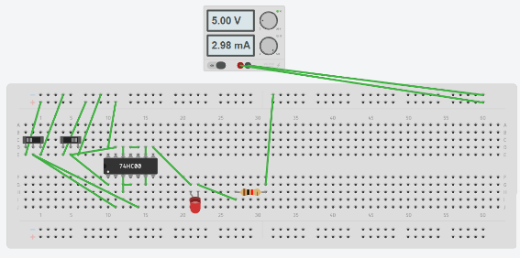

Figure 18 Figure 19

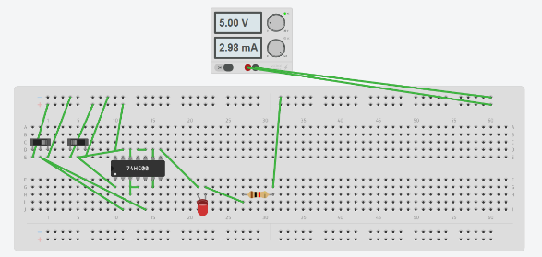 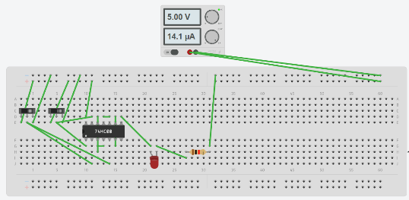

Figure 20 Figure 21

Figures 18,19,20 and 21 are showing the outputs when both the slider switch is on and off. By observing this we can make the truth table of OR gate which is shown in table 4.

|  |  |  |
| --- | --- | --- |
| A | B | Y = A+B (Exclusive or) |
| 0 | 0 | 0 |
| 0 | 1 | 1 |
| 1 | 0 | 1 |
| 1 | 1 | 0 |

Table 4

* X-NOR GATE:

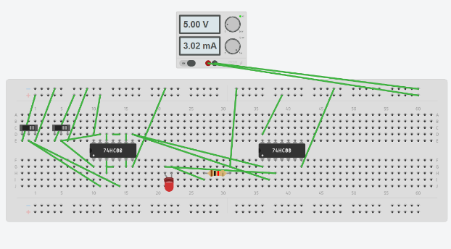 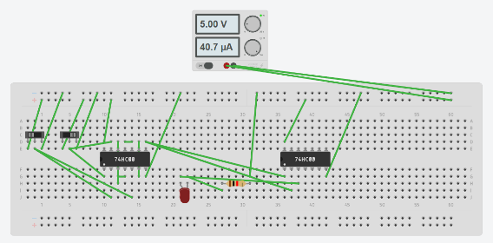

Figure 22 Figure 23

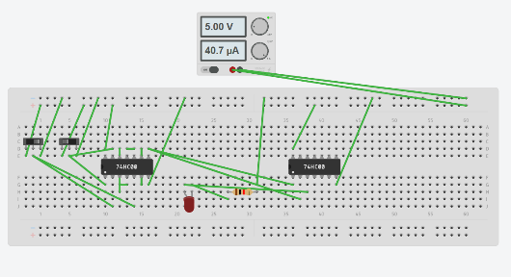 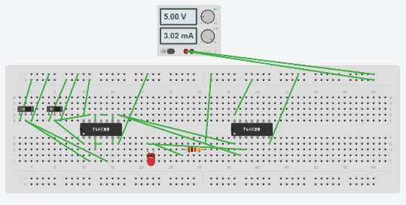

Figure 24 Figure 25

Figures 22,23,24 and 25 are showing the outputs when both the slider switch is on and off. By observing this we can make the truth table of OR gate which is shown in table 5.

|  |  |  |
| --- | --- | --- |
| A | B | Y = Complement of X-OR gate |
| 0 | 0 | 1 |
| 0 | 1 | 0 |
| 1 | 0 | 0 |
| 1 | 1 | 1 |

Table 5

RESULT: We have concluded all the truth tables of all the basic logic gates from NAND gate using tinker cad simulation.

APPLICATION IN DAILY LIFE:

Converting NAND gates into other gates in daily life is not a direct practical application that you would encounter in everyday scenarios. However, the significance lies in the theoretical and practical aspects of digital circuit design. Here are some reasons why converting NAND gates into other gates is important in the field of digital electronics:

* Universal Property: NAND gates are considered universal gates because you can use them to create any other basic logic gate. This universality simplifies circuit design and reduces the number of gate types needed in integrated circuits.
* Simplification of Circuit Design: Converting NAND gates into other gates allows designers to simplify circuit designs. By using a single type of gate (NAND), it becomes easier to standardize and optimize the layout of digital circuits.
* Economic Considerations: Integrated circuit manufacturing involves the fabrication of millions or even billions of transistors on a single chip. If a NAND gate can be used to implement various other gates, it can lead to cost savings in terms of manufacturing, testing, and overall production.

In summary, while the direct need for converting NAND gates into other gates may not be evident in everyday life, it is a fundamental concept in digital electronics and circuit design. Engineers and designers leverage this knowledge to create efficient, standardized, and cost-effective digital systems.

Activity 03

Conversion from NAND gate

To all basic gates

Date : 25th January 2024

Name : Bobby Sharma

AIM: Design all the logic gates using NAND gate only on breadboard.

APPARATUS REQUIRED:

* Breadboard
* Jumping wires
* Connecting wires
* LED
* Resistor
* NAND (IC = 7400)
* Battery

THEORY: A logic gate is a simple switching circuit that determines whether an input pulse can pass through to the output in digital circuits. The following types of logic gates are commonly used:

* AND
* OR
* NOT
* NOR (Universal gate*)
* NAND (Universal gate*)
* XOR
* XNOR

(* A universal gate is a logic gate which can implement any Boolean function without the need to use any other type of logic gate.)

* NOT GATE: The IC number of the NOT gate is 7404 Hex Inverter. The output given by this gate is inversion to the input as shown in figure 1. The conversion from NAND gate to NOT gate can be done by using the same input which results in the conversion of the input given by the user.



Figure 1

* AND GATE: The IC number of the AND gate is 7408. This gate gives the output by multiplying both the inputs. The Quad AND gate are shown in figure 2. The conversion can be done by just reversing the output of the NAND gate which will lead us to expected output of AND gate.



Figure 2

* OR GATE: The IC number of the OR gate is 7432. This gate gives the output by addition of both the inputs. The Quad OR gate are shown in figure3. The conversion is done by applying De-Morgan’s Law on A+B which is explained in figure 3. The output can check through the truth table of OR gate.



Figure 3

* X-OR GATE: The IC number of the X-OR gate is 7486. The Quad OR gate are shown in figure 4 and 5. As we know the other way of representing X-OR gate is as follows Y = A.(Complement of B)+ (Complement of A).B

As the representation suggests, we must make the AND gate from A and Complement of B and vice versa. Later, we must take their output as an input and make the OR gate which will give us the output of X-OR gate.



Figure 4

* X-NOR GATE: The representation is Y = Complement of (X-OR GATE). The X-NOR gate is shown in figure 6 and 7. It is combination of X-OR gate with the NOT gate. So, we can just add the combination of NAND gate (that we used for NOT gate) to the combination of NAND gate (that we used for X-OR gate).



Figure 6

OBSERVATION: The observed outputs of all the basic gates are as follows:

* X-OR GATE:

 

Figure 18 Figure 19

 

Figure 20 Figure 21



Figure 22

Figures 18,19,20 and 21 are showing the outputs when both the slider switch is on and off. By observing this we can make the truth table of OR gate which is shown in table 4.

|  |  |  |
| --- | --- | --- |
| A | B | Y = A+B (Exclusive or) |
| 0 | 0 | 0 |
| 0 | 1 | 1 |
| 1 | 0 | 1 |
| 1 | 1 | 0 |

Table 4

* X-NOR GATE:

 

Figure 22 Figure 23

 

Figure 24 Figure 25



Figure 26

Figures 22,23,24 and 25 are showing the outputs when both the slider switch is on and off. By observing this we can make the truth table of OR gate which is shown in table 5.

|  |  |  |
| --- | --- | --- |
| A | B | Y = Complement of X-OR gate |
| 0 | 0 | 1 |
| 0 | 1 | 0 |
| 1 | 0 | 0 |
| 1 | 1 | 1 |

Table 5

RESULT: We have concluded all the truth tables of all the basic logic gates from NAND gate on breadboard.

APPLICATION IN DAILY LIFE:

Converting NAND gates into other gates in daily life is not a direct practical application that you would encounter in everyday scenarios. However, the significance lies in the theoretical and practical aspects of digital circuit design. Here are some reasons why converting NAND gates into other gates is important in the field of digital electronics:

* Universal Property: NAND gates are considered universal gates because you can use them to create any other basic logic gate. This universality simplifies circuit design and reduces the number of gate types needed in integrated circuits.
* Simplification of Circuit Design: Converting NAND gates into other gates allows designers to simplify circuit designs. By using a single type of gate (NAND), it becomes easier to standardize and optimize the layout of digital circuits.
* Economic Considerations: Integrated circuit manufacturing involves the fabrication of millions or even billions of transistors on a single chip. If a NAND gate can be used to implement various other gates, it can lead to cost savings in terms of manufacturing, testing, and overall production.

In summary, while the direct need for converting NAND gates into other gates may not be evident in everyday life, it is a fundamental concept in digital electronics and circuit design. Engineers and designers leverage this knowledge to create efficient, standardized, and cost-effective digital systems.

Activity 04

Logic gates using VHDL

Date : 16th February 2023

Name : Bobby Sharma

AIM: Design all the logic gates using VHDL (Hardware Description Language).

APPARATUS REQUIRED: VHDL in your device.

THEORY:

VHDL stands for very high-speed integrated circuit hardware description language. It is a programming language used to model a digital system by dataflow, behavioral and structural style of modeling. This language was first introduced in 1981 for the department of Defense (DoD) under the VHSIC program.

A logic gate is a simple switching circuit that determines whether an input pulse can pass through to the output in digital circuits. The following types of logic gates are commonly used:

* AND
* OR
* NOT
* NOR (Universal gate*)
* NAND (Universal gate*)
* XOR
* XNOR

(* A universal gate is a logic gate which can implement any Boolean function without the need to use any other type of logic gate.)

OBSERVATION: The observed outputs of all the basic gates are as follows:

* NOT GATE:

VHDL Code:

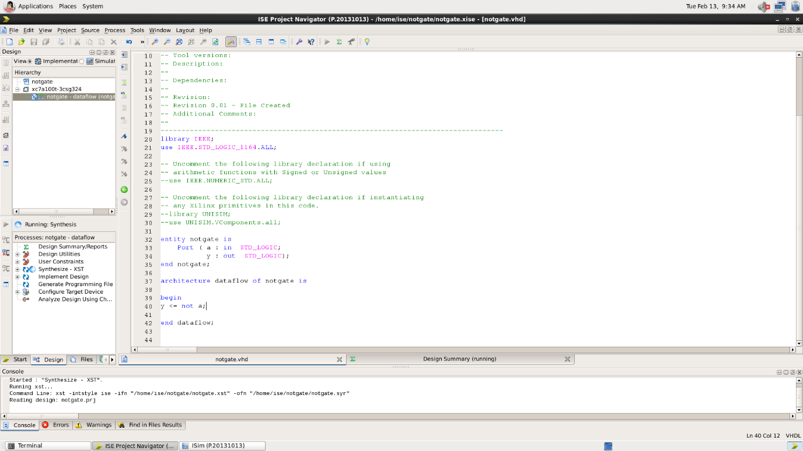

RTL Diagram : 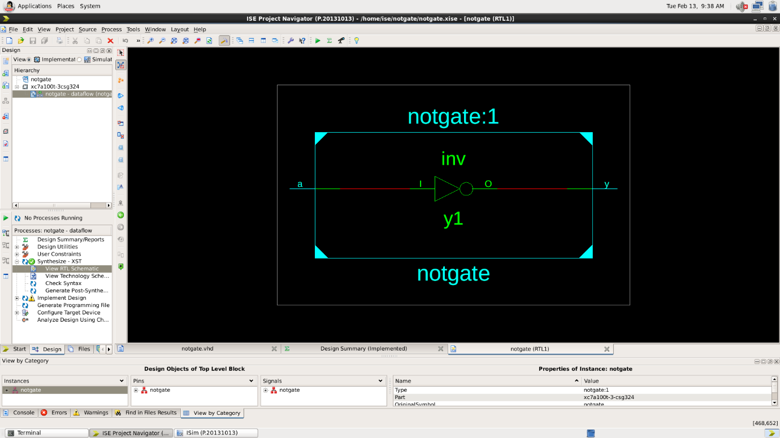

Test Bench Code: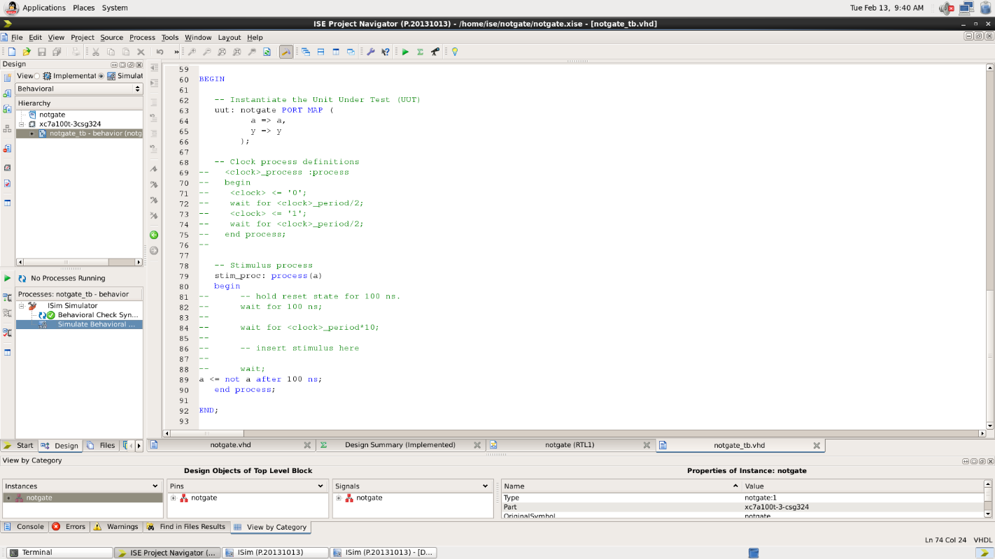

Waveform: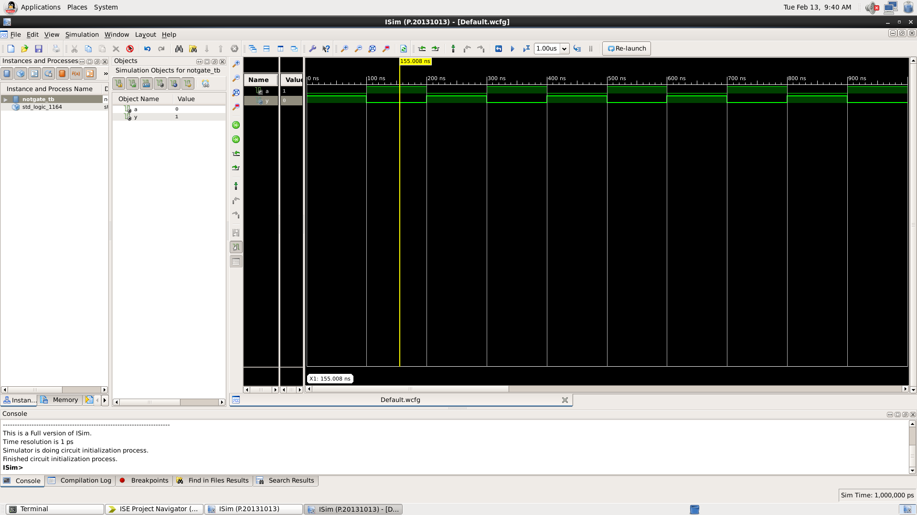

Here the yellow line represents the input - 1 and output -0, which signifies the working of NOT gate. In which we can see the change of input signals after every 100 nano seconds.

|  |  |
| --- | --- |
| INPUT | OUTPUT |
| 1 | 0 |
| 0 | 1 |

Table 1

* AND GATE :

VHDL Code: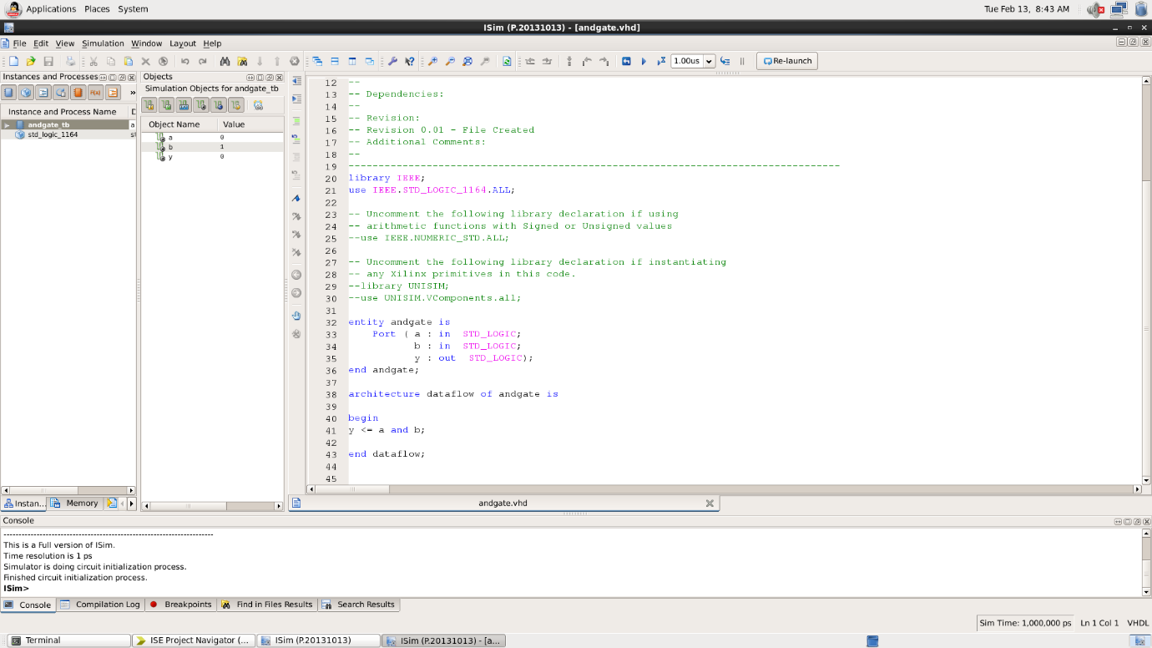

RTL Diagram:

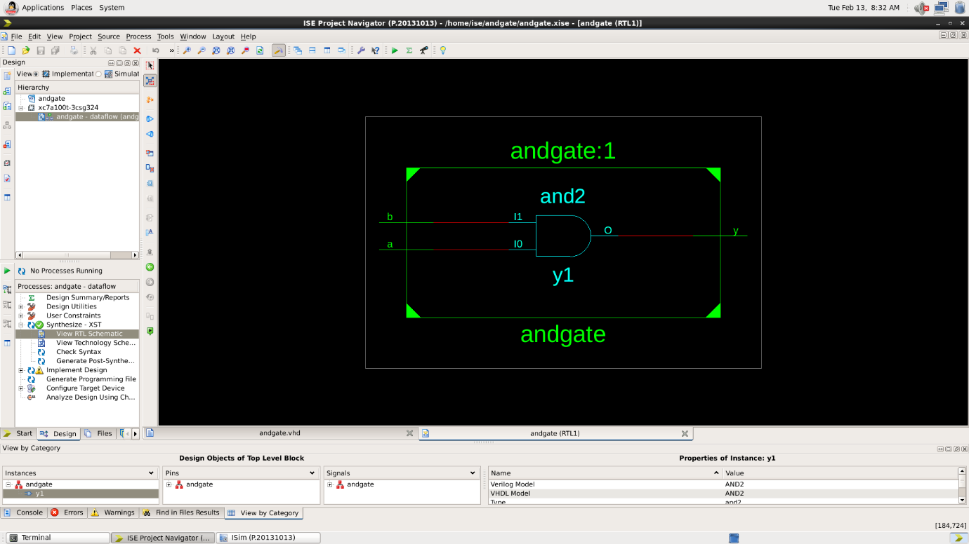

Test Bench Code: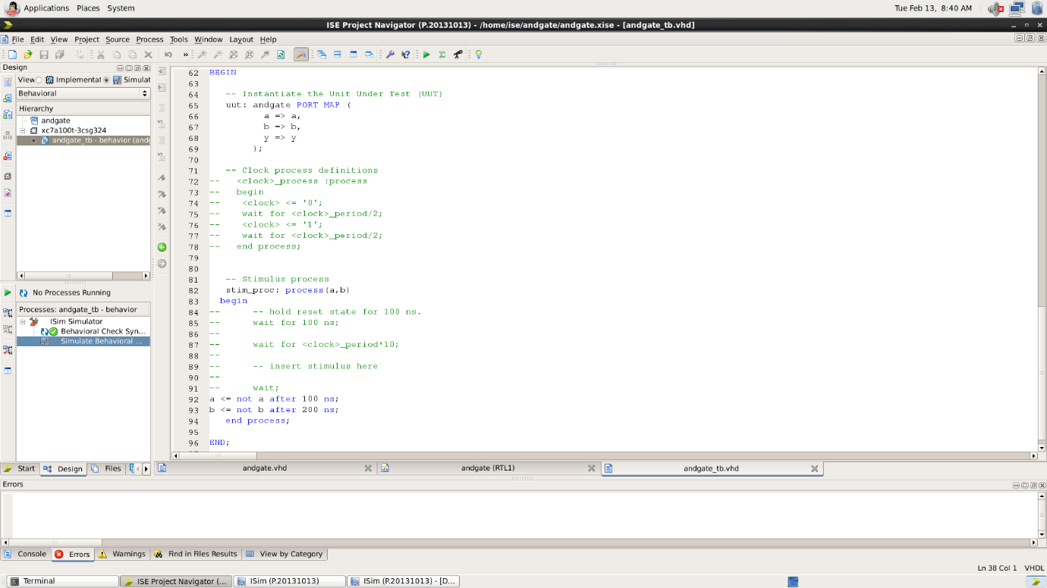

Waveform:

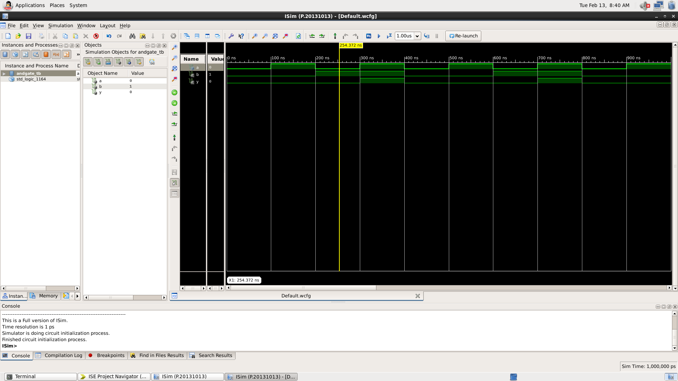

Here the yellow line represents the input (a=0 and b=1) and output -0, which signifies the working of AND gate. In which we can see the change of input signals of and b after every 100 and 200 nano seconds respectively.

|  |  |  |
| --- | --- | --- |
| A | B | Y = A.B |
| 0 | 0 | 0 |
| 0 | 1 | 0 |
| 1 | 0 | 0 |
| 1 | 1 | 1 |

Table 2

* OR GATE:

VHDL Code: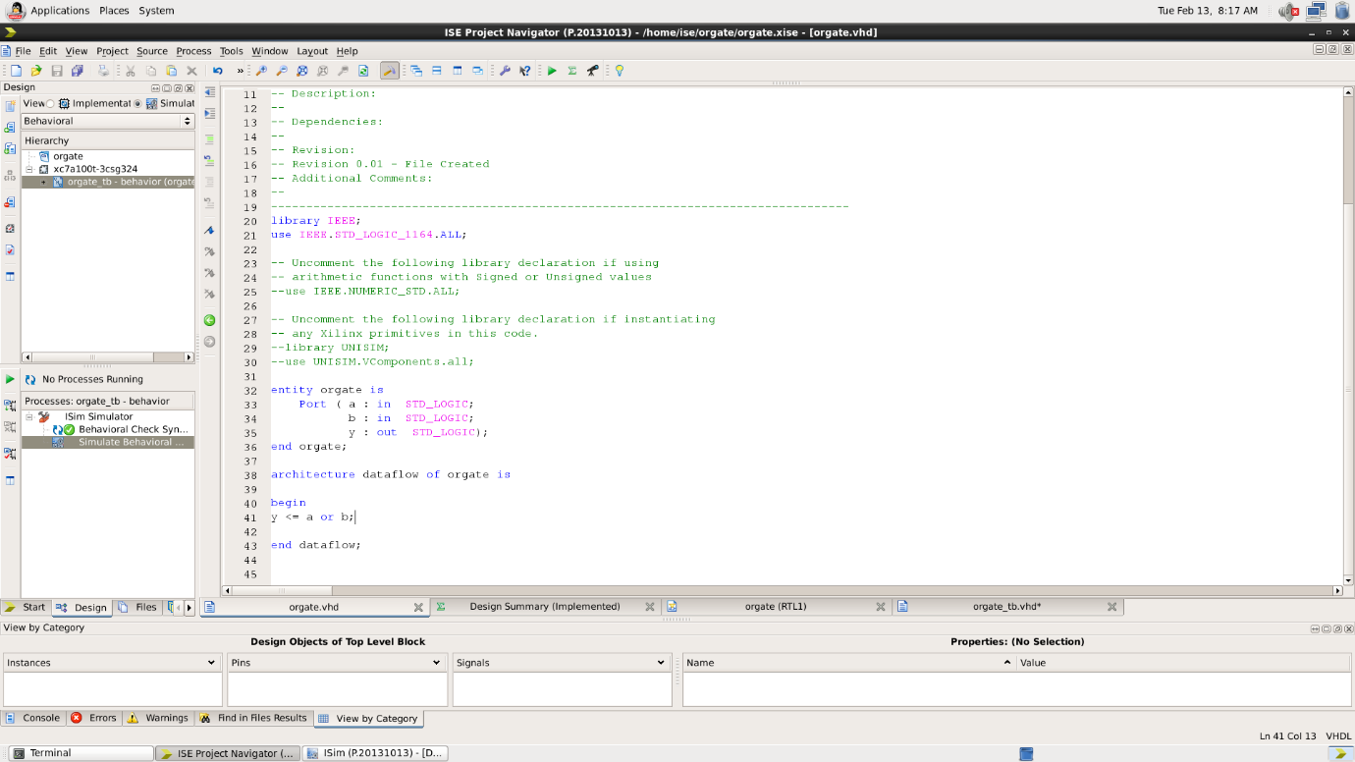

RTL Diagram:

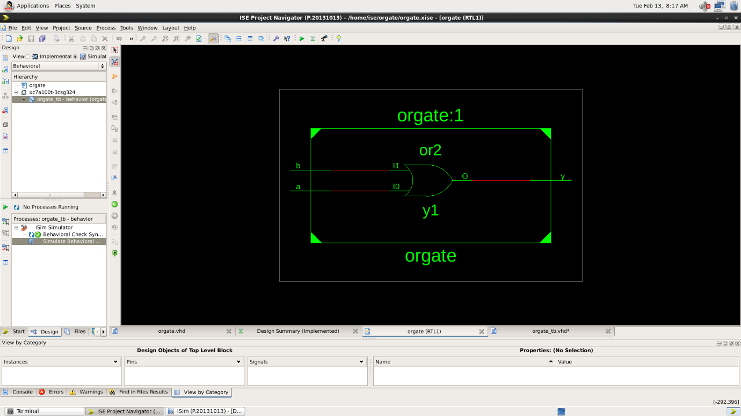

Test Bench Code: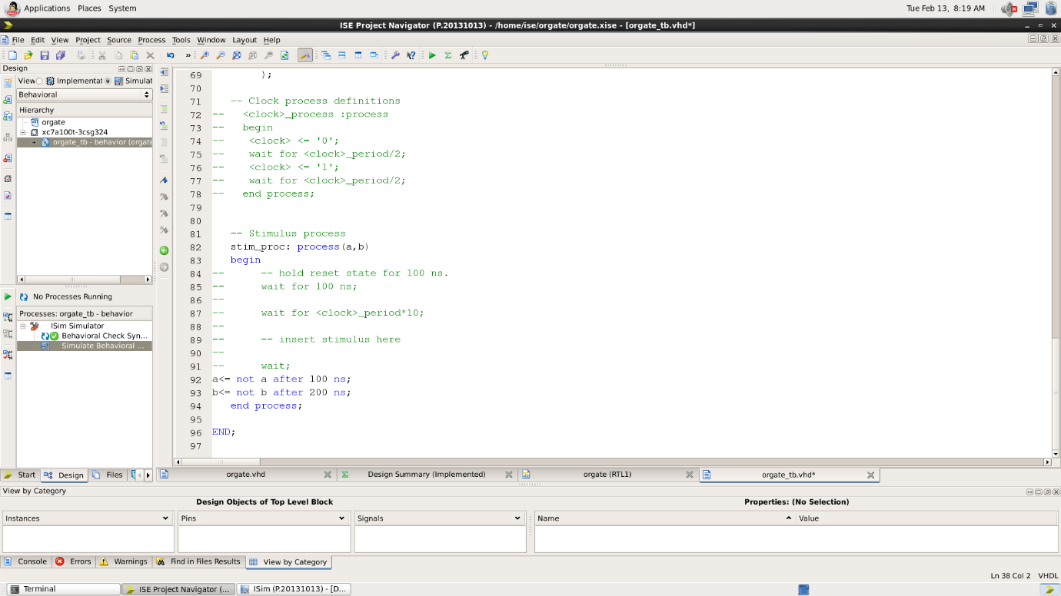

Waveform:

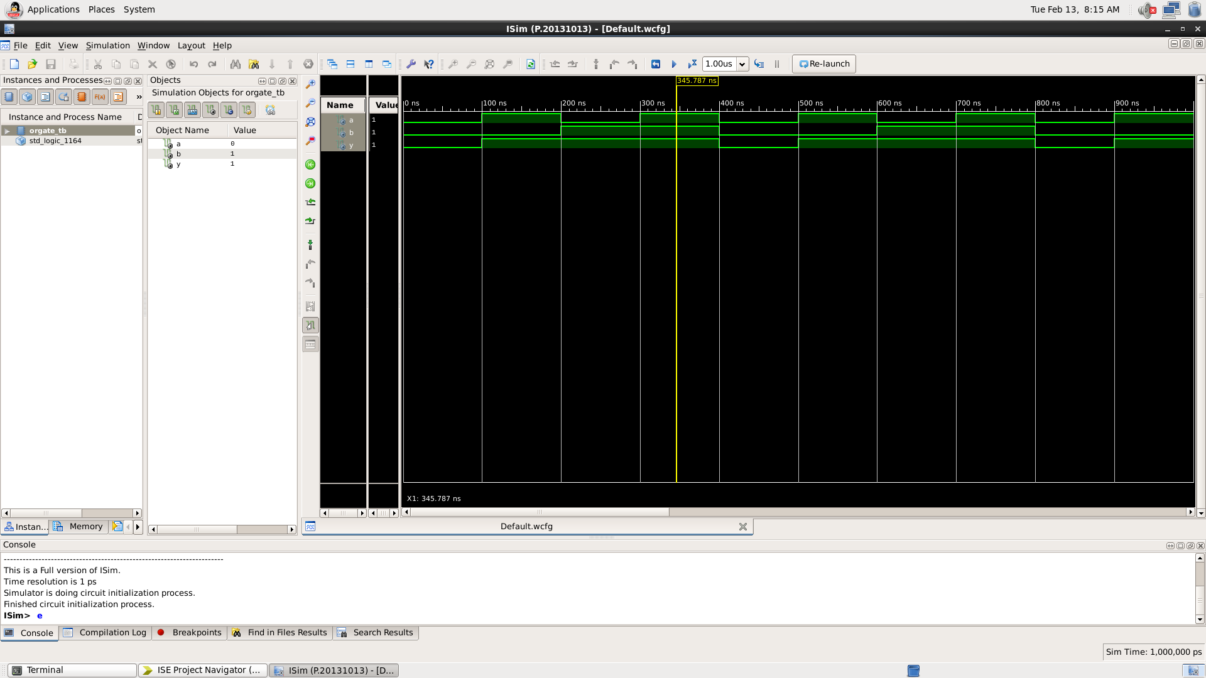

Here the yellow line represents the input (a=1 and b=1) and output -1, which signifies the working of OR gate. In which we can see the change of input signals of and b after every 100 and 200 nano seconds respectively.

|  |  |  |
| --- | --- | --- |
| A | B | Y = A+B |
| 0 | 0 | 0 |
| 0 | 1 | 1 |
| 1 | 0 | 1 |
| 1 | 1 | 1 |

Table 3

* X-OR GATE:

VHDL Code: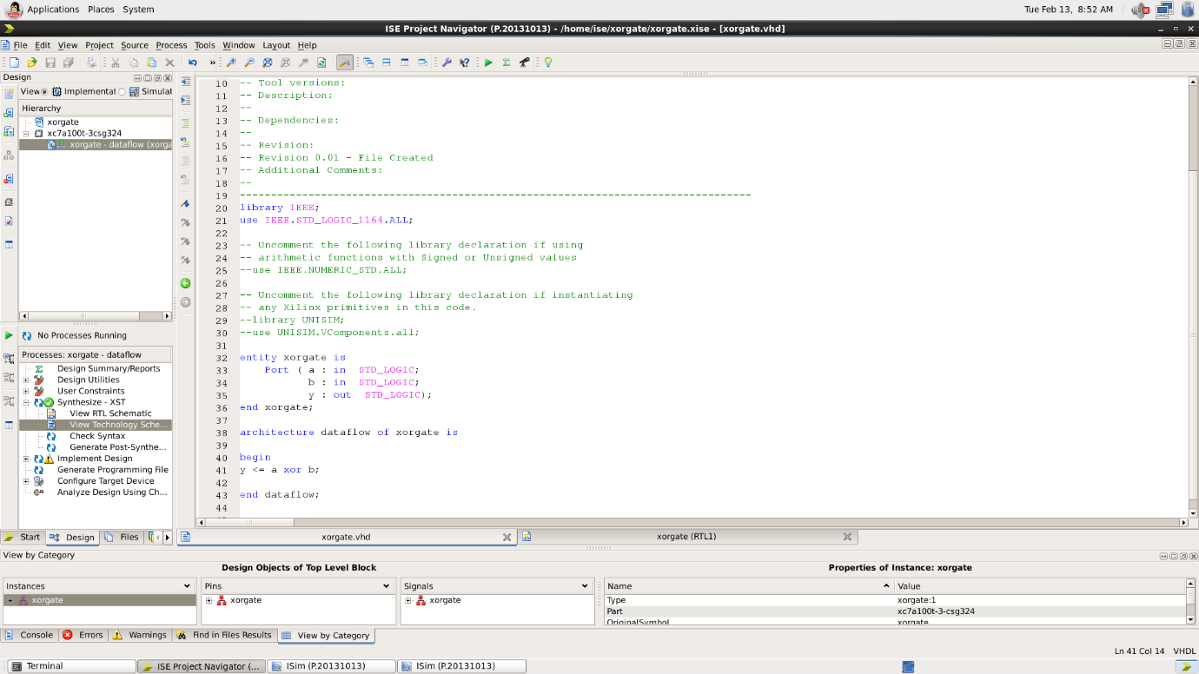

RTL Diagram:

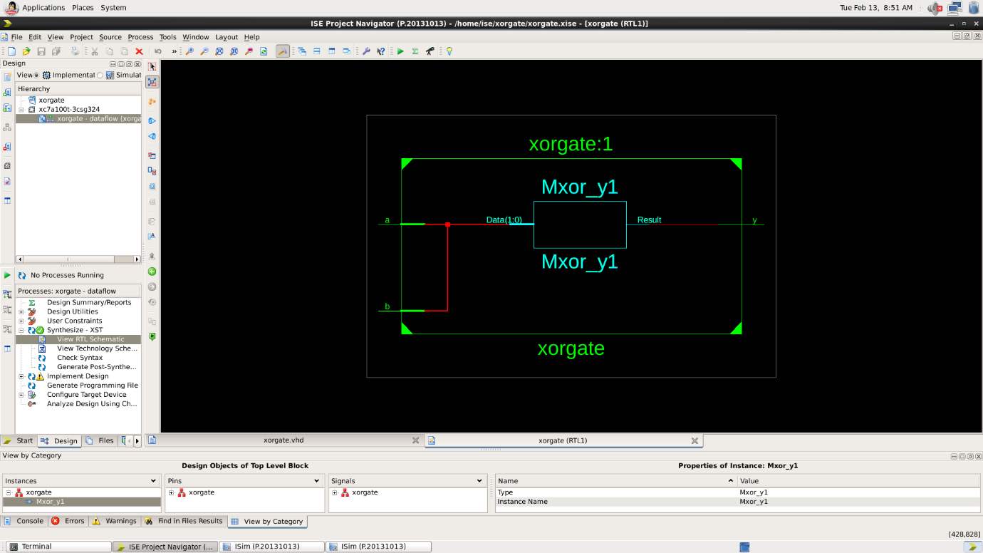

Test Bench Code: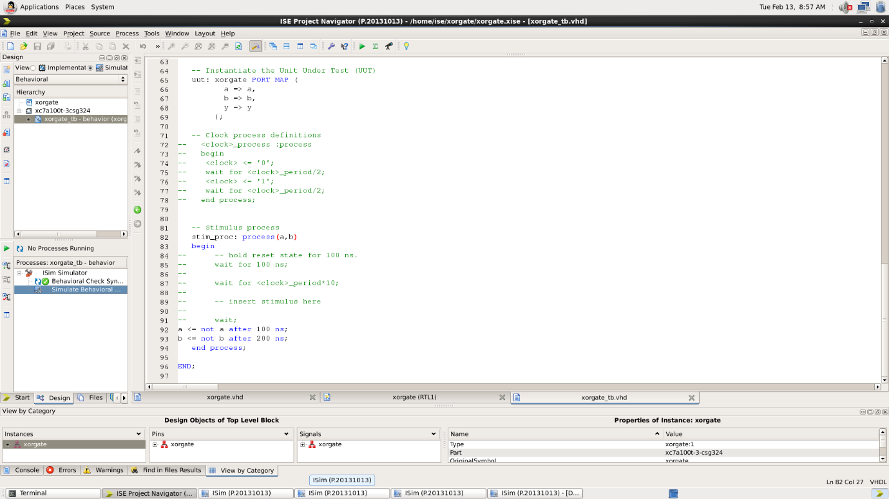

Waveform:

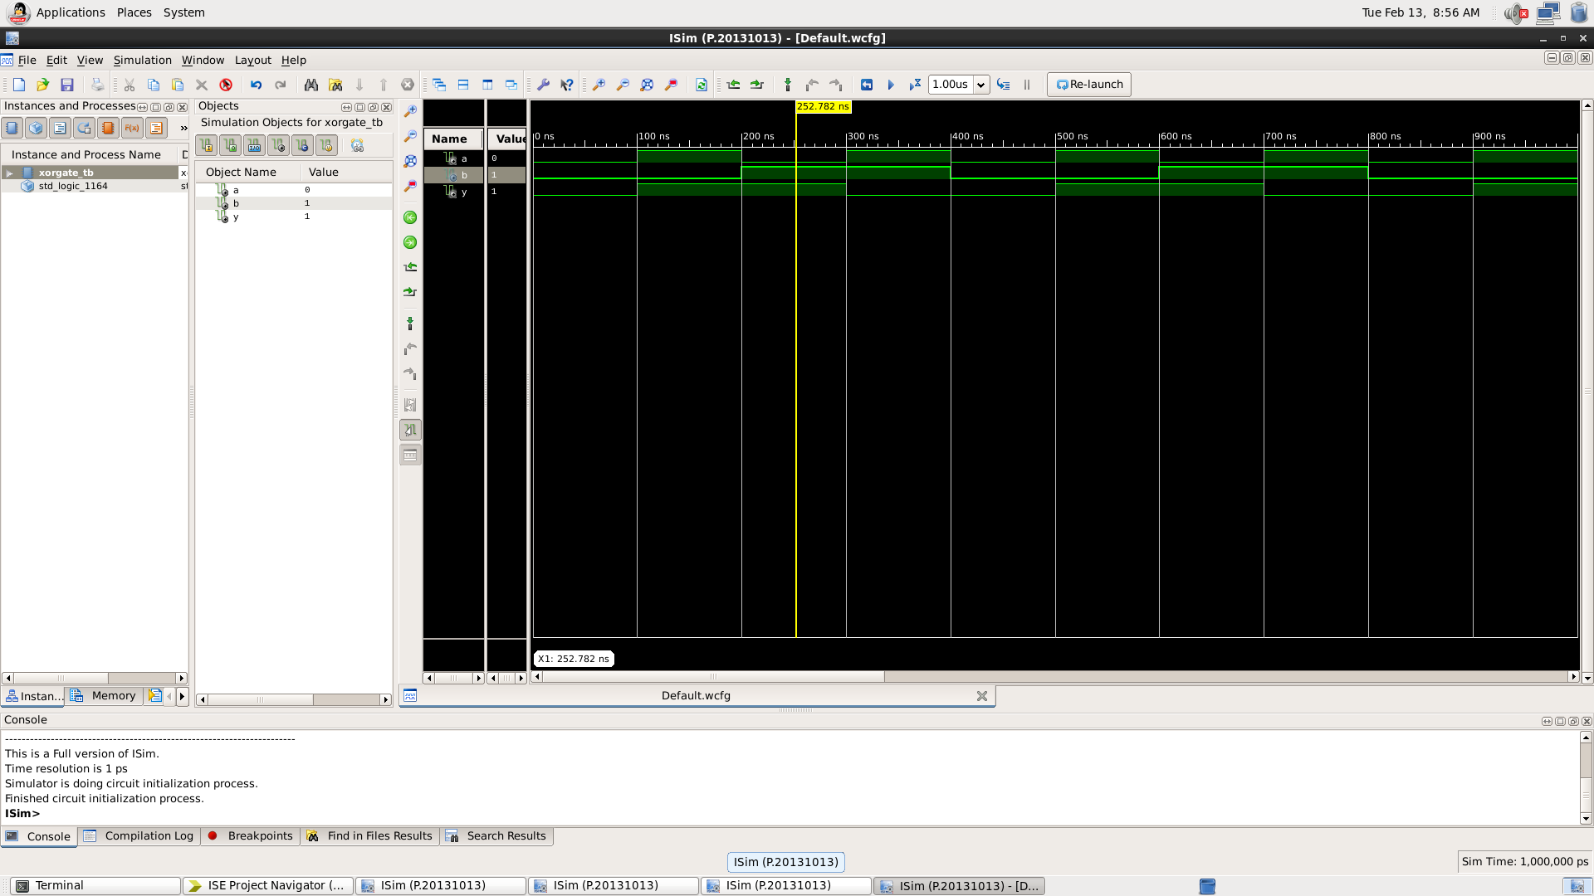

Here the yellow line represents the input (a=0 and b=1) and output -1, which signifies the working of XOR gate. In which we can see the change of input signals of and b after every 100 and 200 nano seconds respectively.

|  |  |  |
| --- | --- | --- |
| A | B | Y = A+B (Exclusive or) |
| 0 | 0 | 0 |
| 0 | 1 | 1 |
| 1 | 0 | 1 |
| 1 | 1 | 0 |

Table 4

* X-NOR GATE:

VHDL Code: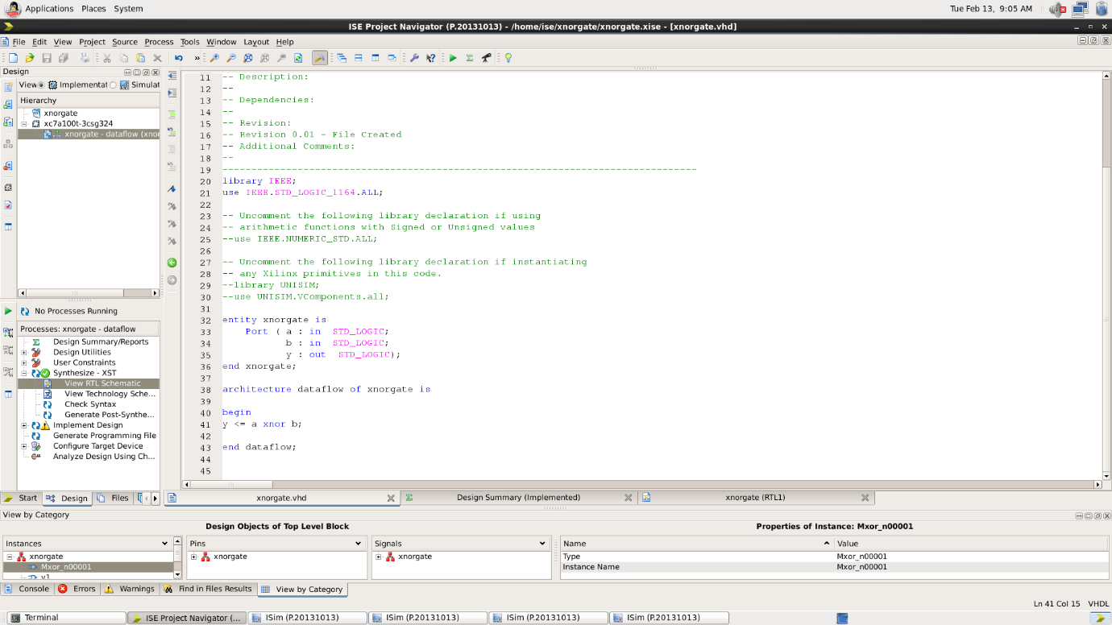

RTL Diagram:

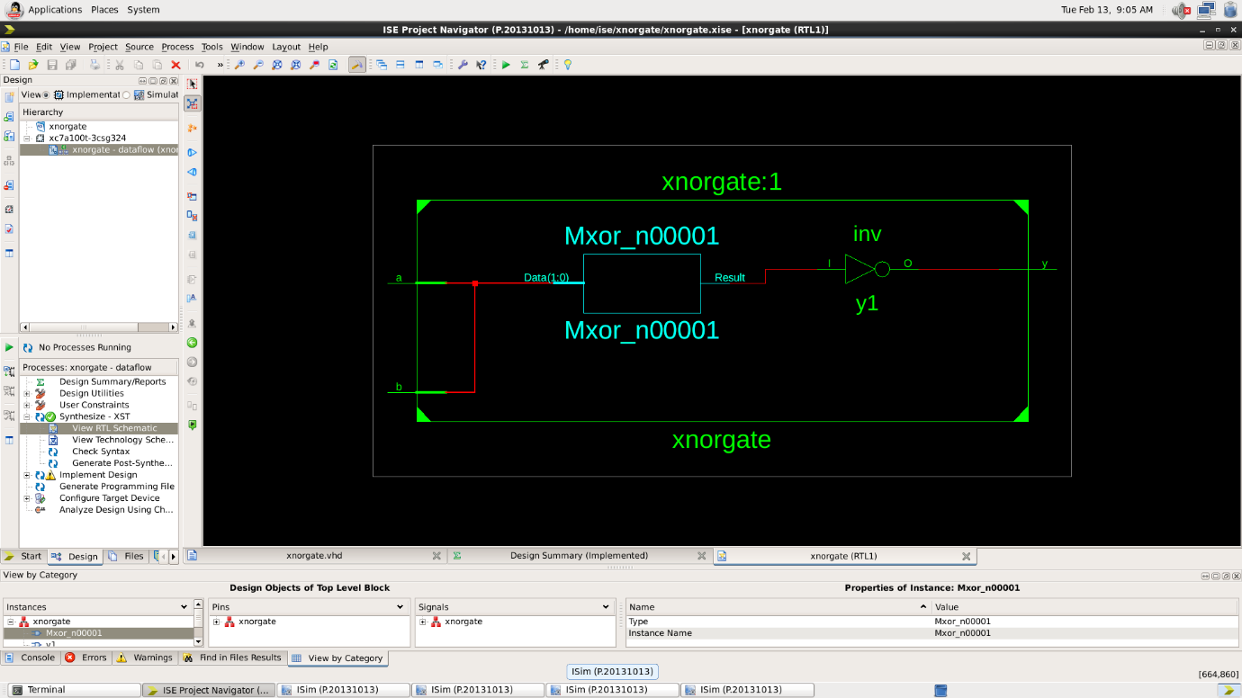

Test Bench Code: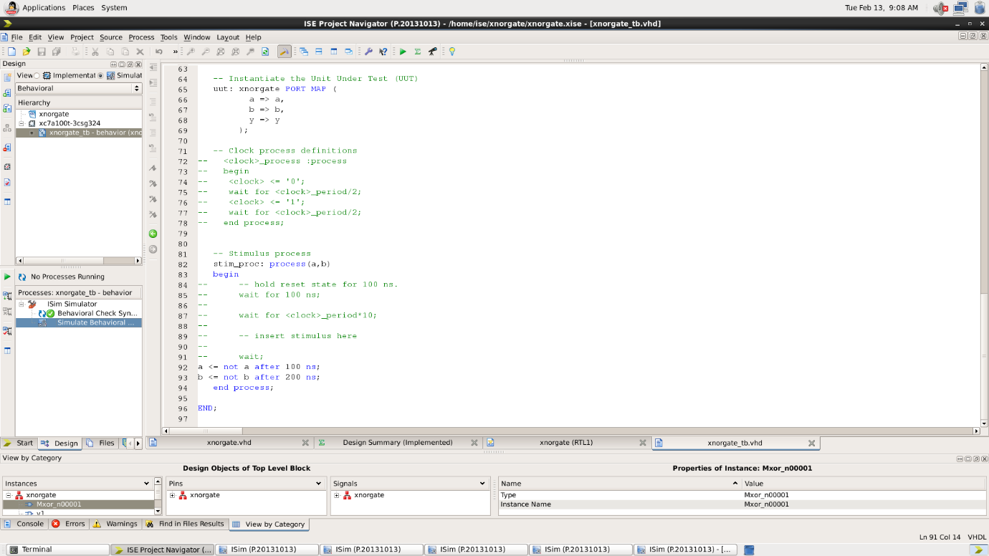

Waveform:

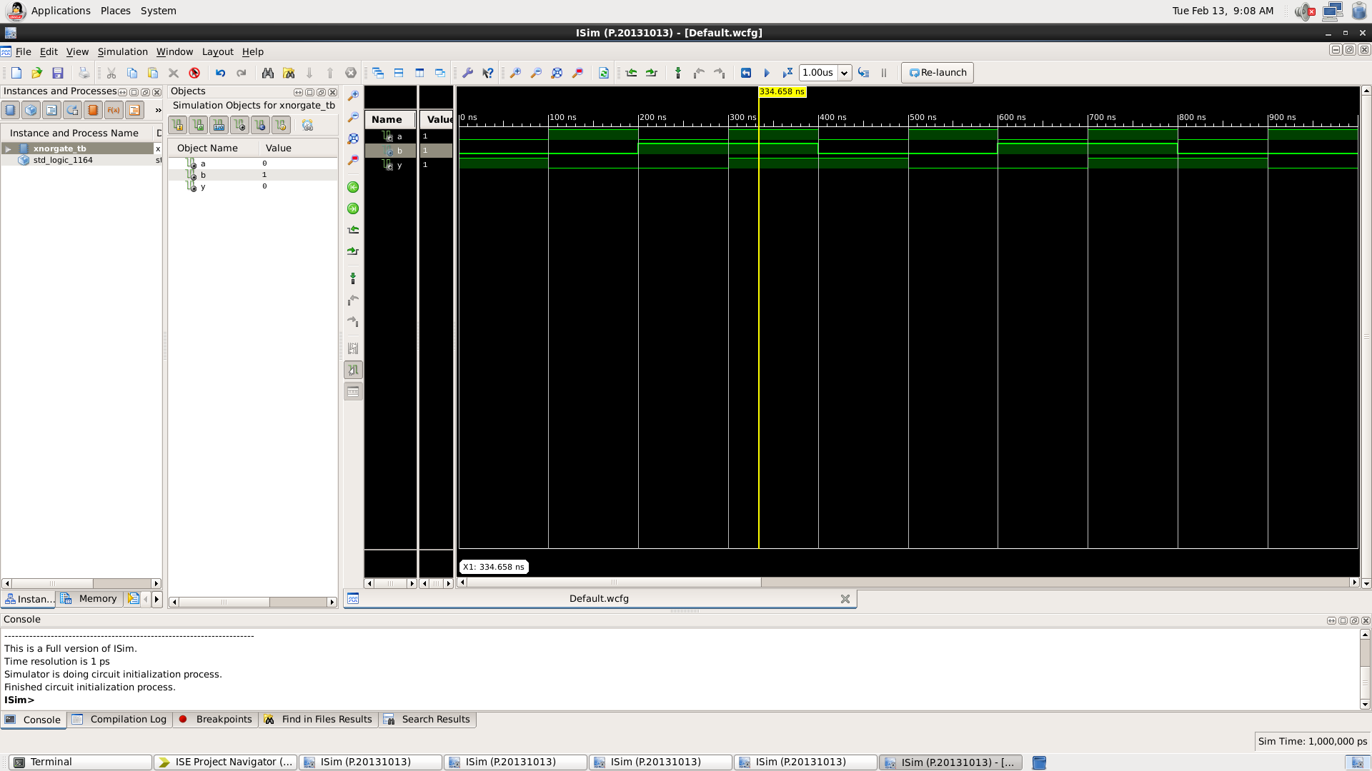

Here the yellow line represents the input (a=1 and b=1) and output -1, which signifies the working of XNOR gate. In which we can see the change of input signals of and b after every 100 and 200 nano seconds respectively.

|  |  |  |
| --- | --- | --- |
| A | B | Y = Complement of XOR gate |
| 0 | 0 | 1 |
| 0 | 1 | 0 |
| 1 | 0 | 0 |
| 1 | 1 | 1 |

Table 5

* NAND GATE:

VHDL Code: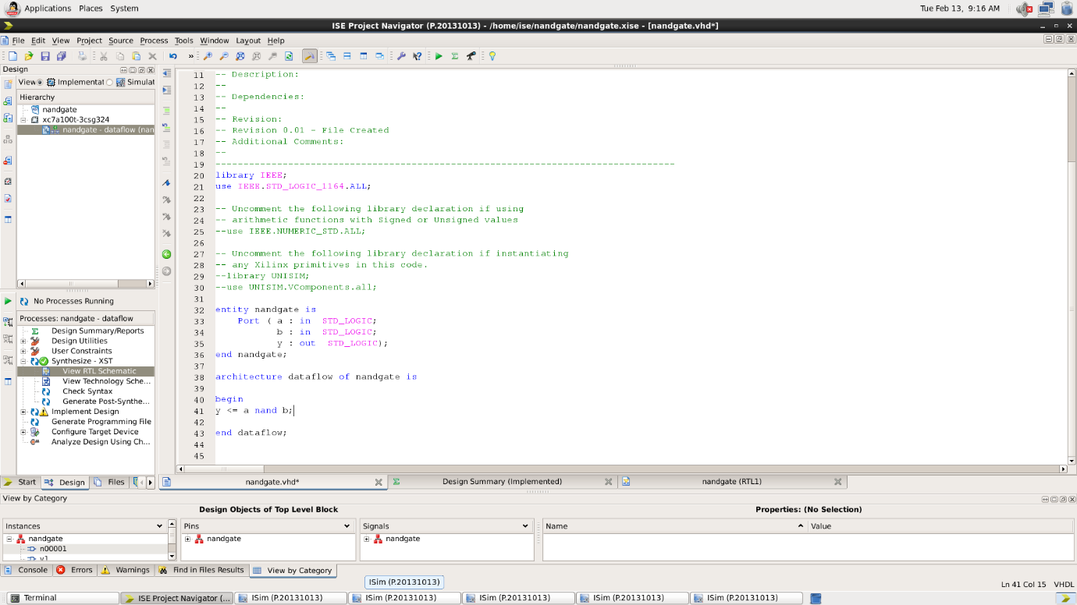

RTL Diagram:

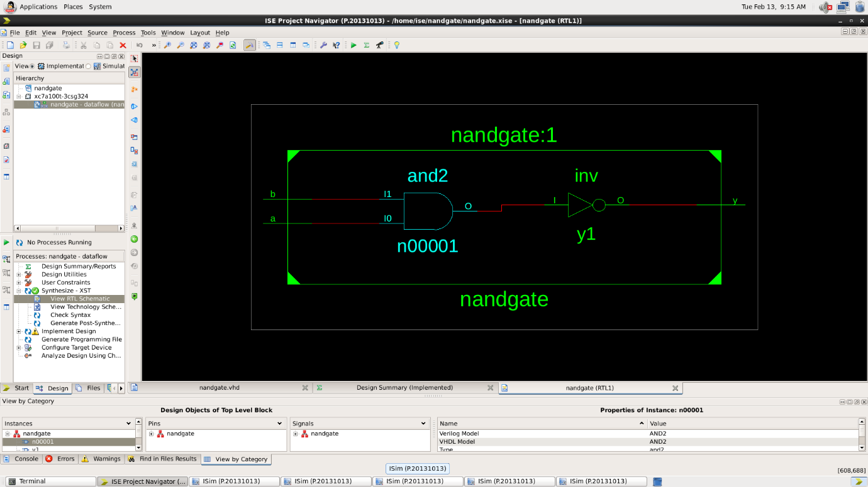

Test Bench Code: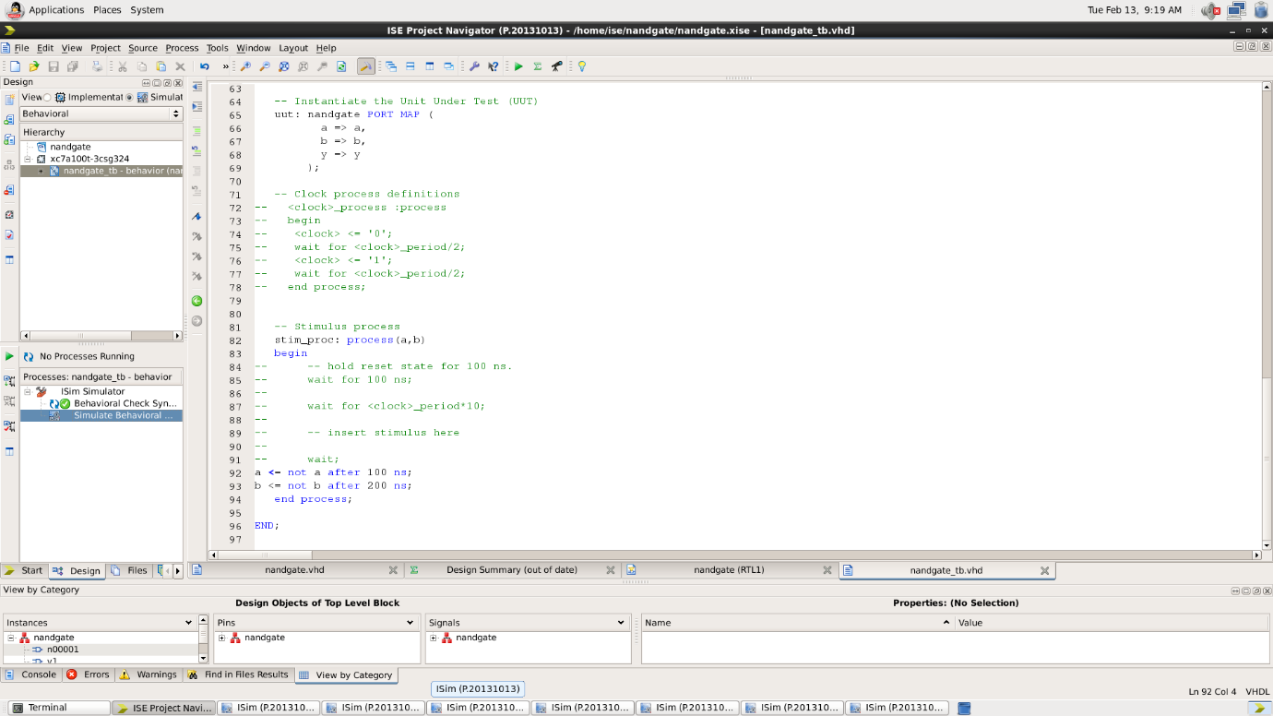

Waveform:

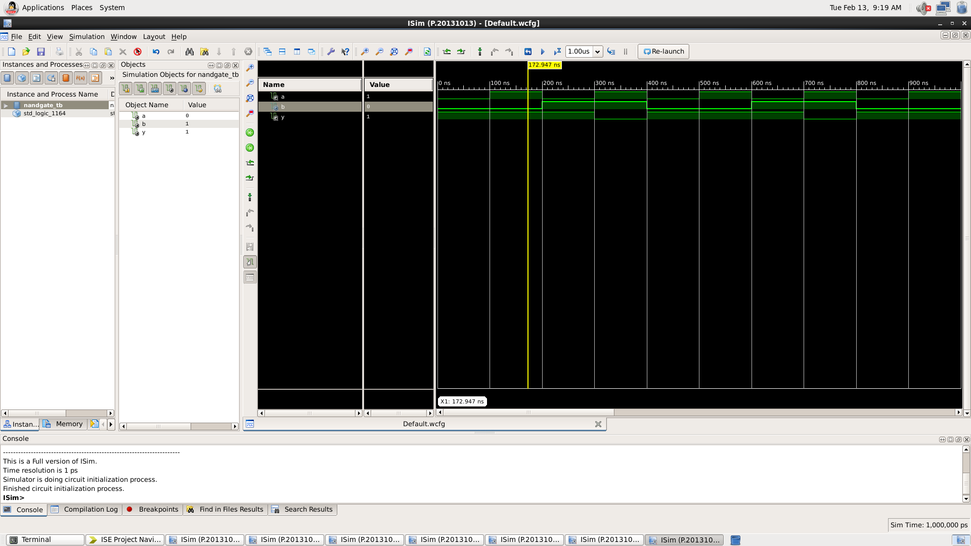

Here the yellow line represents the input (a=1 and b=0) and output -1, which signifies the working of NAND gate. In which we can see the change of input signals of and b after every 100 and 200 nano seconds respectively.

|  |  |  |
| --- | --- | --- |
| A | B | Y = Complement of AND gate |
| 0 | 0 | 1 |
| 0 | 1 | 1 |
| 1 | 0 | 1 |
| 1 | 1 | 0 |

* NOR GATE:

VHDL Code: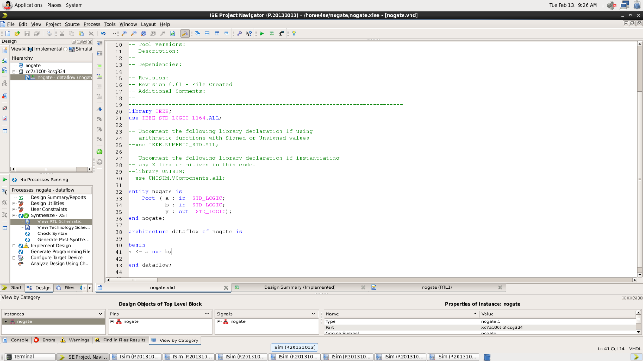

RTL Diagram:

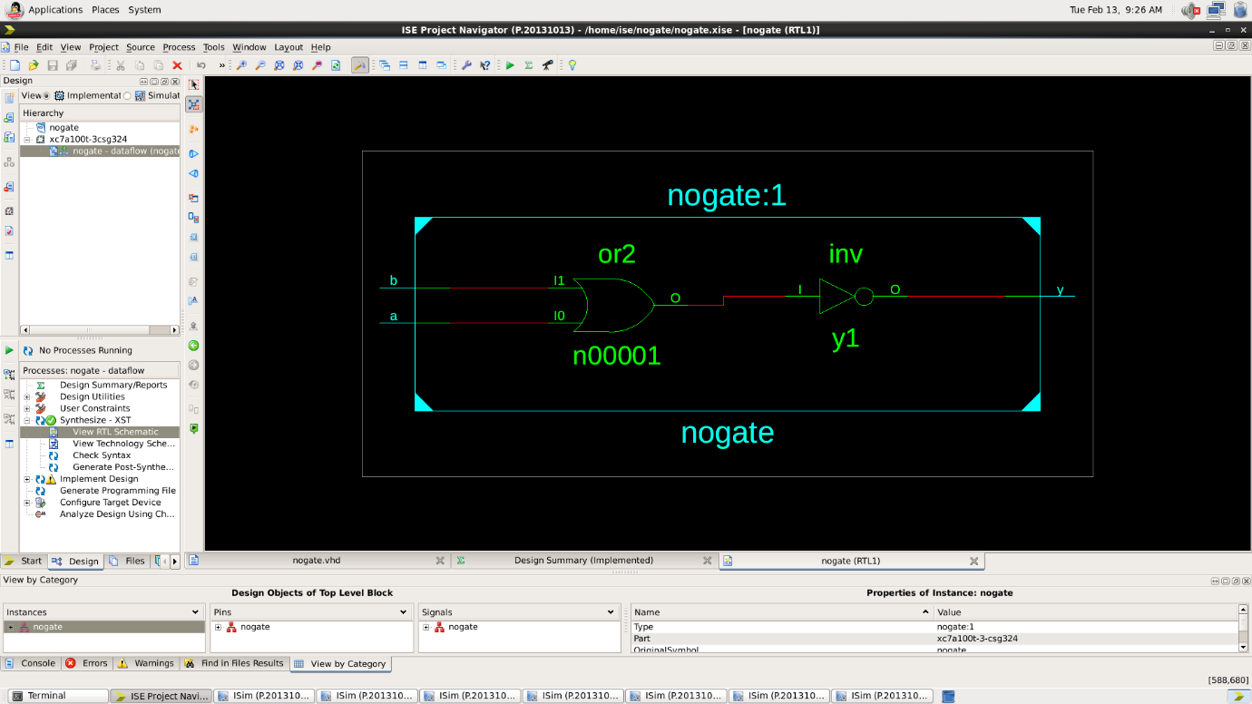

Test Bench Code: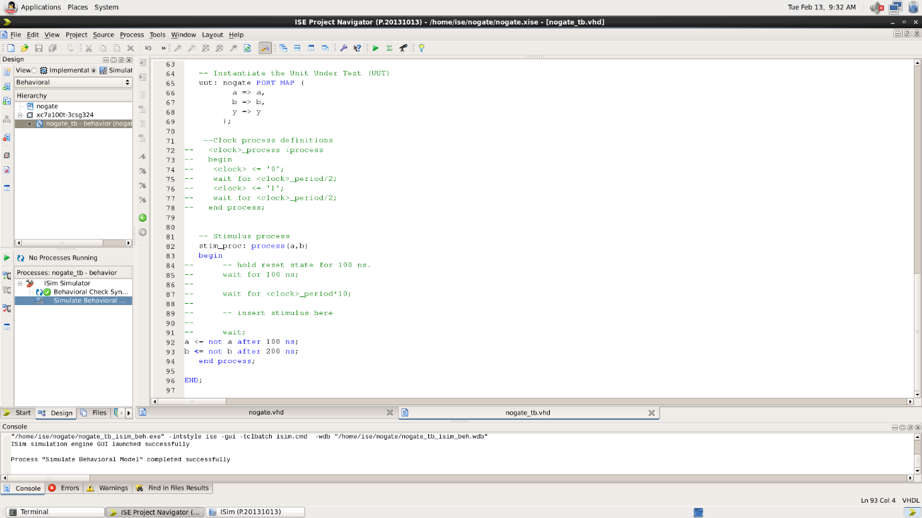

Waveform:

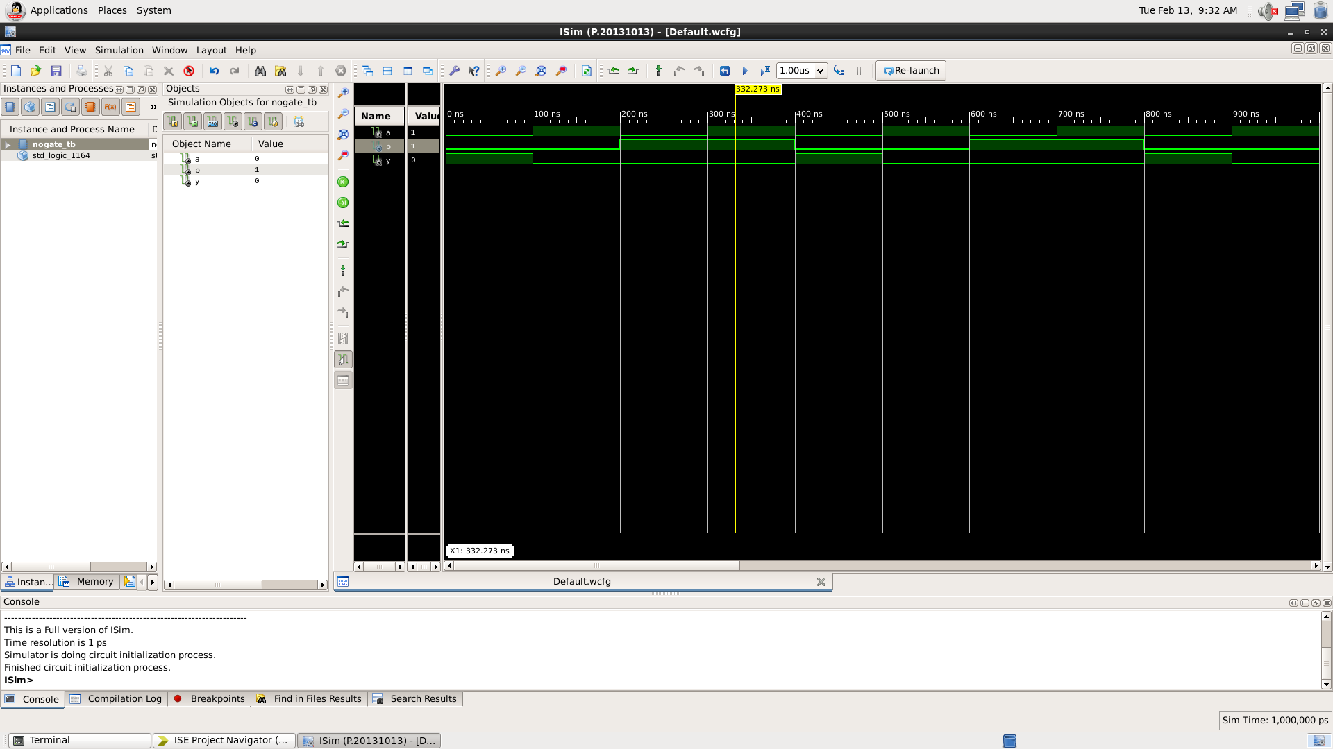

Here the yellow line represents the input (a=1 and b=0) and output -0, which signifies the working of NOR gate. In which we can see the change of input signals of and b after every 100 and 200 nano seconds respectively.

|  |  |  |
| --- | --- | --- |
| A | B | Y = Complement of OR gate |
| 0 | 0 | 1 |
| 0 | 1 | 0 |
| 1 | 0 | 0 |
| 1 | 1 | 0 |

RESULT: We have concluded all the truth tables of all the basic logic gates using tinker cad simulation.

APPLICATION IN DAILY LIFE:

VHDL (VHSIC Hardware Description Language) is primarily used for the description and simulation of digital circuits and systems. While it is more commonly associated with the field of digital design and hardware engineering, its impact can be indirectly observed in various aspects of daily life through the products and technologies that rely on digital systems. Here are some applications and areas where VHDL plays a role:

* Consumer Electronics: VHDL is used in the design and verification of digital components in consumer electronics such as smartphones, tablets, TVs, and audio devices. The digital signal processing, control logic, and communication interfaces often involve VHDL in their design.
* Automotive Systems: Modern vehicles incorporate numerous digital systems for engine control, safety features, infotainment, and more. VHDL is employed in the design and testing of the digital components within these systems.
* Communication Systems: VHDL is used in the development of communication systems, including network routers, switches, and wireless communication devices. It plays a crucial role in the design of digital signal processing algorithms and communication protocols.

Activity 05

Half Adder and Full Adder using VHDL language.

Date : 20th February 2023

Name : Bobby Sharma

Roll no. = 2023BTECH023

AIM:Design and Simulation of Half adder and Full Adder using VHDL language using Xilinx ISETool.

SOFTWARE REQUIRED: Xilinx ISE tool in your device.

THEORY:

VHDL stands for very high-speed integrated circuit hardware description language. It is a programming language used to model a digital system by dataflow, behavioral and structural style of modeling. This language was first introduced in 1981 for the department of Defense (DoD) under the VHSIC program.

In this modeling style, the flow of data through the entity is expressed using concurrent (parallel) signal. The concurrent statements in VHDL are WHEN and GENERATE. Besides them, assignments using only operators (AND, NOT, +, *, sll, etc.) can also be used to construct code. Finally, a special kind of assignment, called BLOCK, can also be employed in this kind of code.

In concurrent code, the following can be used −

* Operators
* The WHEN statement (WHEN/ELSE or WITH/SELECT/WHEN);
* The GENERATE statement;
* The BLOCK statement

**Half Adder:** A half adder is a digital logic circuit that performs binary addition of two single-bit binary numbers. It has two inputs, A and B, and two outputs, SUM, and CARRY. The SUM output is the least significant bit (LSB) of the result, while the CARRY output is the most significant bit (MSB) of the result, indicating whether there was a carry-over from the addition of the two inputs. The half adder can be implemented using basic gates such as XOR and AND gates.

**Full Adder:** Full Adder is the adder that adds three inputs and produces two outputs. The first two inputs are A and B, and the third input is an input carry as C-IN. The output carry is designated as C-OUT and the normal output is designated as S which is SUM. The C-OUT is also known as the majority 1’s detector, whose output goes high when more than one input is high. A full adder logic is designed in such a manner that can take eight inputs together to create a byte-wide adder and cascade the carry bit from one adder to another. we use a full adder because when a carry-in bit is available, another 1-bit adder must be used since a 1-bit half-adder does not take a carry-in bit. A 1-bit full adder adds three operands and generates 2-bit results.

OBSERVATION: The observed outputs of all the basic gates are as follows:

* HALF ADDER :

VHDL Code: RTL Diagram:

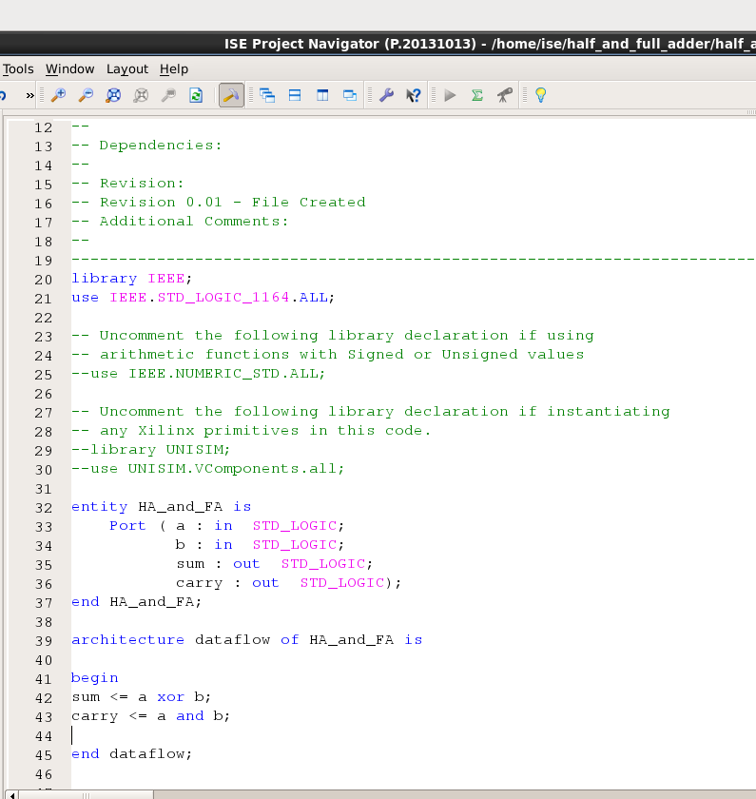 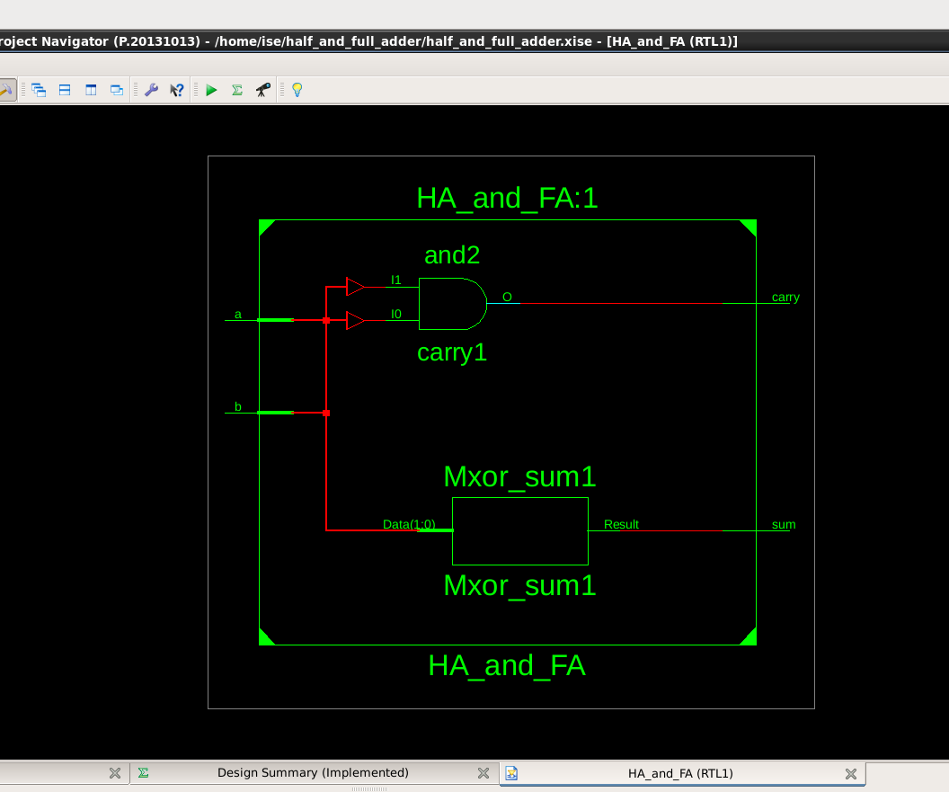

Figure 1 Figure 2

Test Bench Code: Waveform:

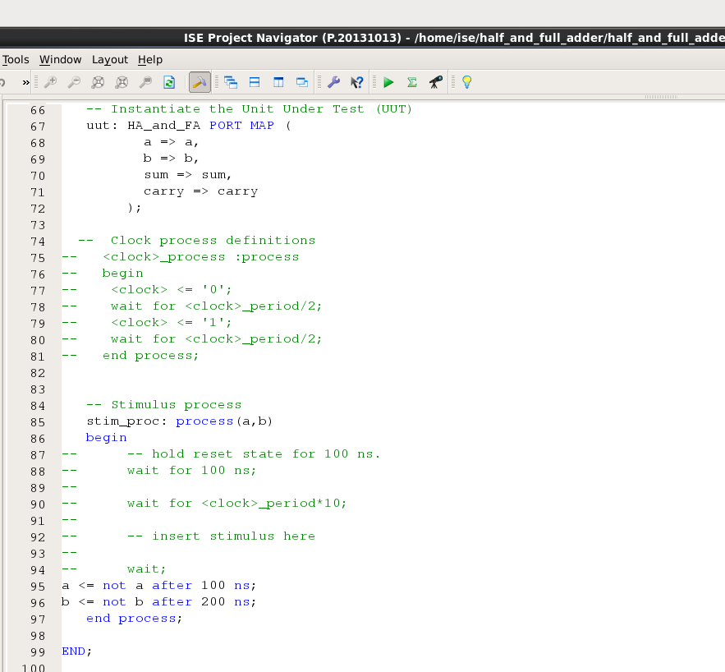 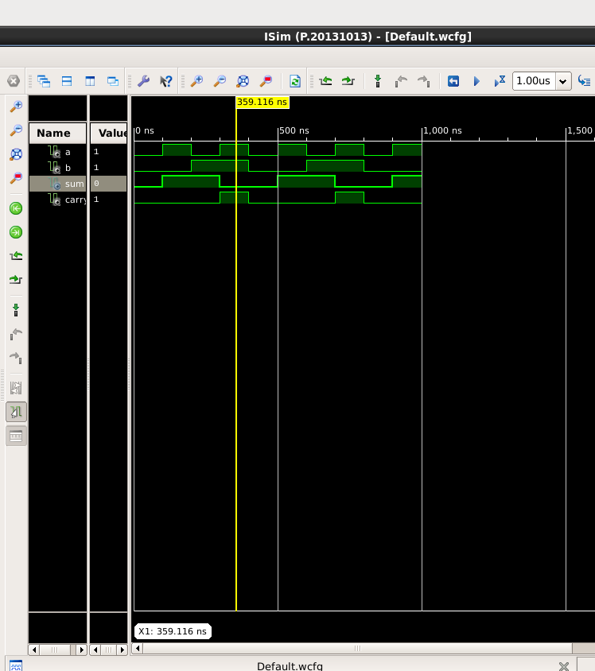

Figure 3 Figure 4

Here the yellow line in figure 4 represents the input (a=1 and b=1) and sum =0 and carry =1, which signifies the working of

**Sum = a xor b,**

**Carry = a and b**

respectively. In which we can see the change of input signals of and b after every 100 and 200 nano seconds.

|  |  |  |  |
| --- | --- | --- | --- |
| A | B | Sum | Carry |
| 0 | 0 | 0 | 0 |
| 0 | 1 | 1 | 0 |
| 1 | 0 | 1 | 0 |
| 1 | 1 | 0 | 1 |

Table 1

* FULL ADDER:

VHDL Code: RTL Diagram:

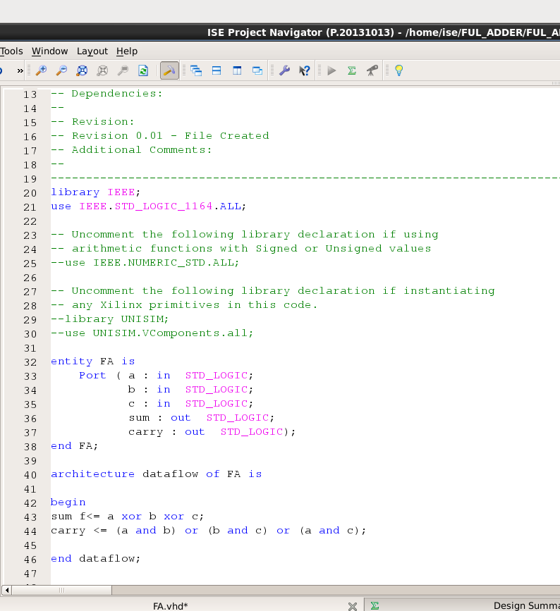 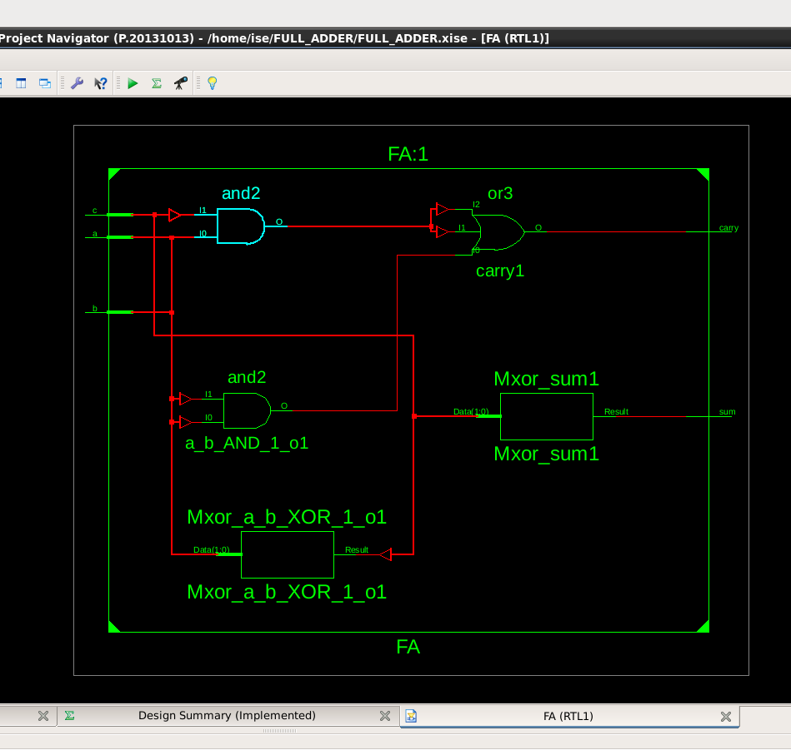

Figure 6 Figure 7

Test Bench Code:

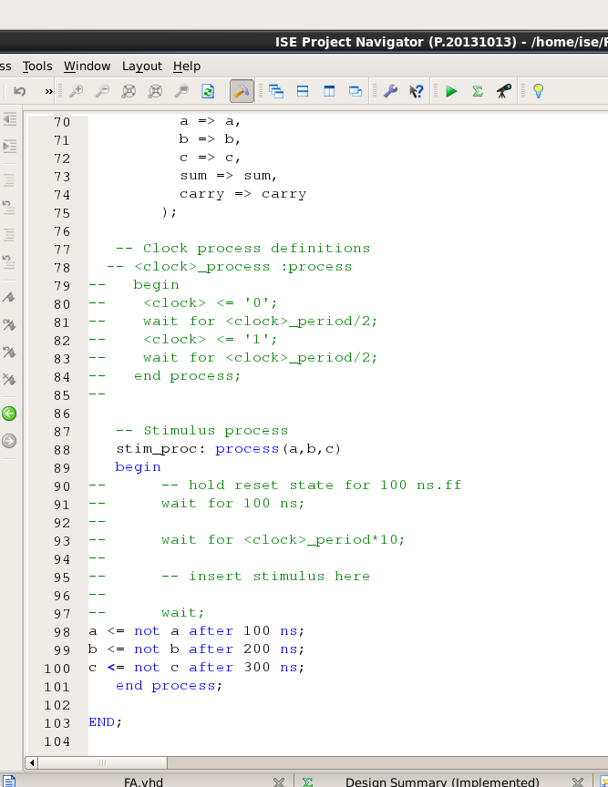

Figure 7

Waveform:

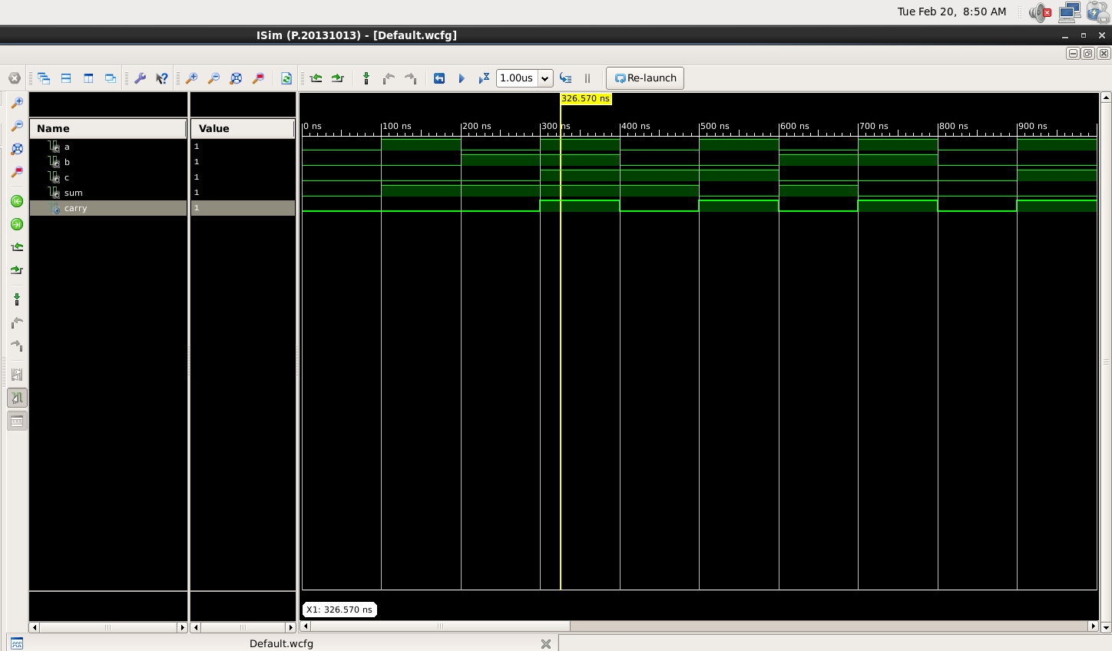

Figure 8

Here the yellow line in figure 8 represents the input (a=1, b=1 and carry(in)=1) and sum = 1 and carry(out) = 1, which signifies the working of

**Sum = a xor b xor c,**

**Carry(out) = (a and b) or (b and c) or (a and c)**

respectively. In which we can see the change of input signals of and b after every 100, 200 and 300 nano seconds respectively.

|  |  |  |  |  |
| --- | --- | --- | --- | --- |
| A | B | Carry(in) | Sum | Carry(out) |
| 0 | 0 | 0 | 0 | 0 |
| 0 | 0 | 1 | 1 | 0 |
| 0 | 1 | 0 | 1 | 0 |
| 0 | 1 | 1 | 0 | 1 |
| 1 | 0 | 0 | 1 | 0 |
| 1 | 0 | 1 | 0 | 1 |
| 1 | 1 | 0 | 0 | 1 |
| 1 | 1 | 1 | 1 | 1 |

Table 2

RESULT: We have concluded all the truth tables of half adder and full adder using VHDL language in Xilinx Vivado tool.

APPLICATION IN DAILY LIFE:

Half adders and full adders are fundamental building blocks in digital electronics, specifically in the design of digital circuits and arithmetic operations. While they may not have direct applications in daily life for the average person, they play a crucial role in various electronic devices and technologies that we encounter regularly. Here are some applications:

* Binary Arithmetic in Computers: Half adders and full adders are extensively used in the arithmetic logic unit (ALU) of a computer processor. They perform binary addition, which is fundamental to all computer operations, including calculations, data manipulation, and processing.
* Digital Signal Processors (DSPs): Digital signal processors use adders to perform various mathematical operations quickly and efficiently. This is crucial in applications such as audio signal processing, image processing, and telecommunications.
* Memory Addressing: Binary addition is used in memory addressing systems. Computers and microcontrollers utilize adders to calculate memory addresses for data retrieval and storage.

Activity 06

BCD to seven segmented Decoder

Date : 29th February 2023

Name : Bobby Sharma

Roll no. = 2023BTECH023

AIM:Design 4- bit BCD to seven segmented decoder and show all output from 0 to 9 on display.

APPARATUS REQUIRED:

* Breadboard
* IC 4511
* Seven segmented displays
* Jumper wires
* Switches
* Resistors
* Battery

THEORY:

The decoder is an essential component in BCD to seven segment decoders. A decoder is nothing, but a combinational logic circuit mainly used for converting a BCD to an equivalent decimal number. It can be a BCD to seven segment decoders. A combinational logic circuit can be built with logic gates which include inputs as well as outputs. The output of this circuit mainly lies in the current condition of the inputs.

The best examples of this circuit are multiplexers, demultiplexers, adders, subtractors, encoders, decoders, etc. Figure 1 displays all the numbers in seven- segmented display.

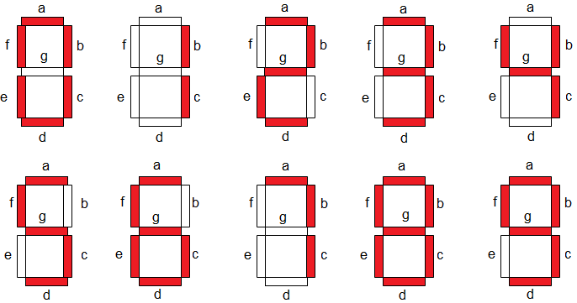

Figure 1

The circuit design, as well as operation, mainly depends on the concepts of Boolean algebra as well as logic gates. A seven segment LED display circuit can be built with eight LEDs. The common terminals are either anode otherwise cathode. A general cathode seven segment display includes 8 pins where 7-pins are input pins that are marked with from a to g & 8th-pin is a ground pin.

CIRCUIT DIAGRAM : The circuit connections are as follows:

* At First, one terminal of the switches is connected to source and the other terminal is connected to the resistors which is further connected to input pins number 1,2,6,7.
* After connecting all the resistors, switches to the input pins, pin 3,4 should connect to the source and pin 5 to ground (which is negative terminal of battery).
* Later, we will be connecting pin 8 and 16 to the ground and source respectively.
* Now, we will be connecting rest of the pins to the seven-segment display as stated in diagram

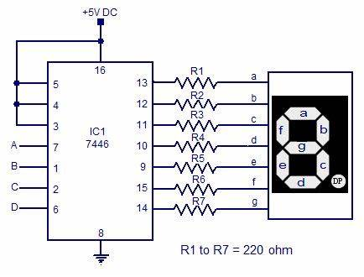

Figure 2

OBSERVATION: The observed output on seven- segment display are as follows:

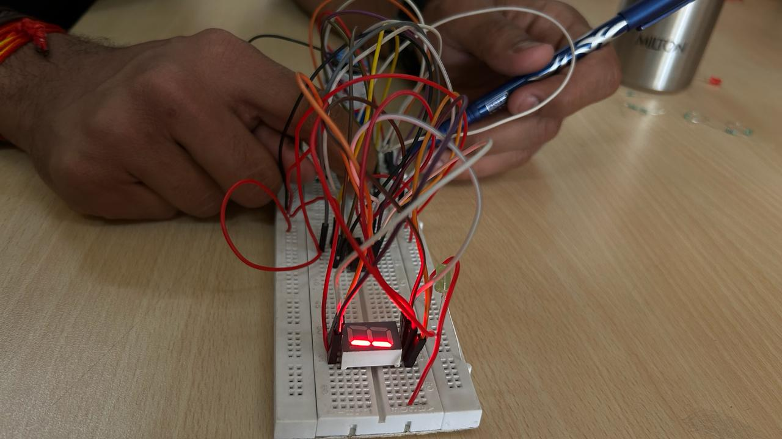 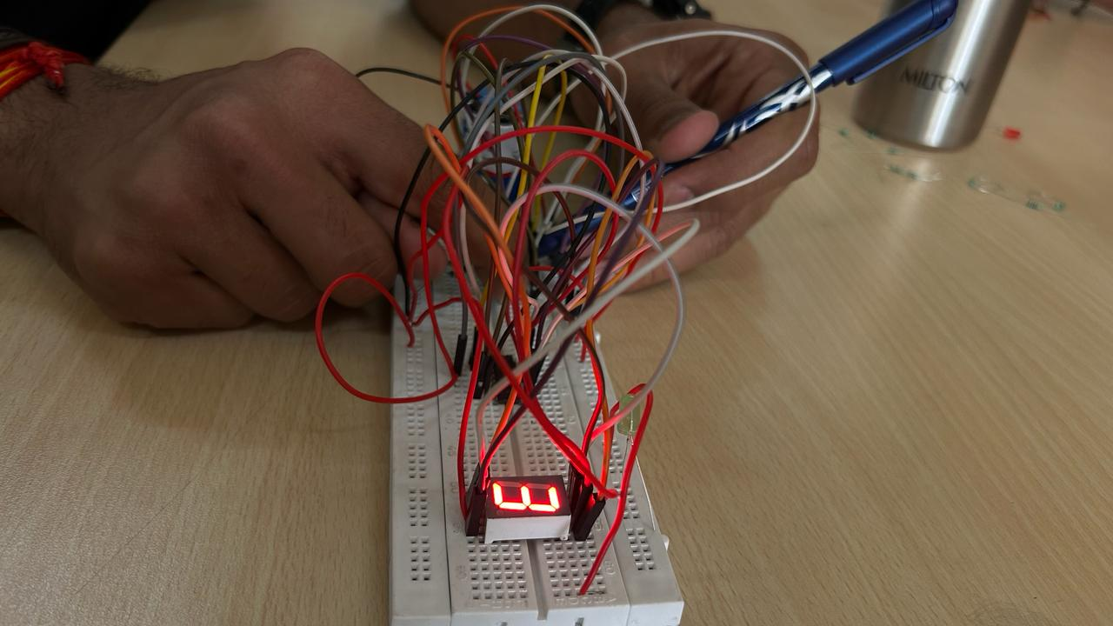

Figure 3 Figure 4

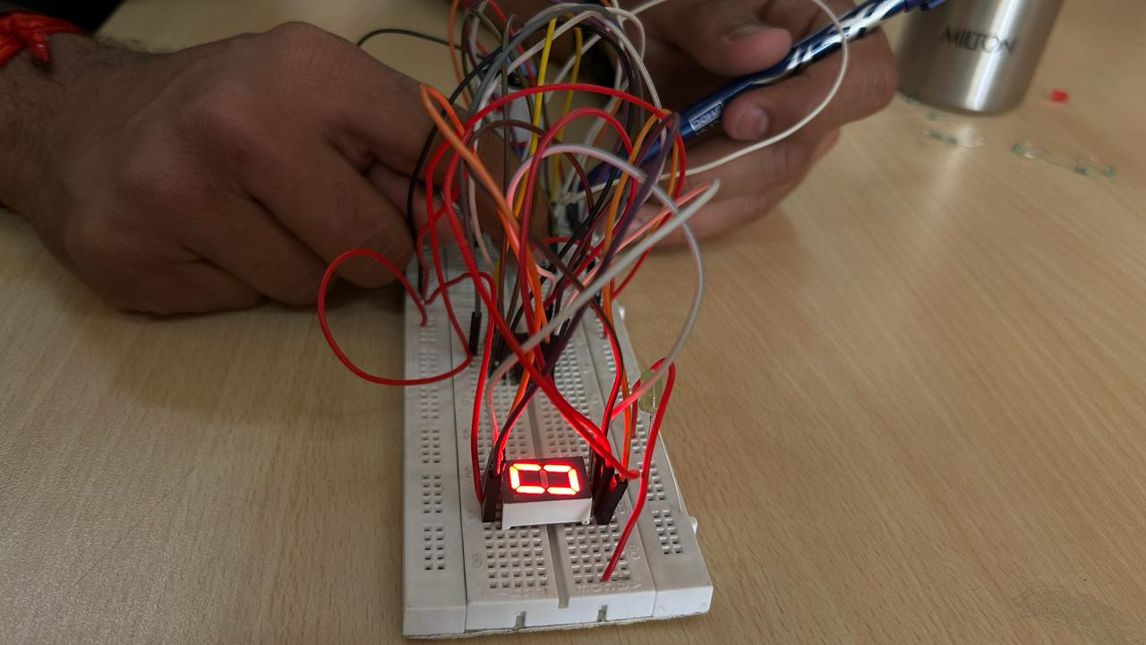 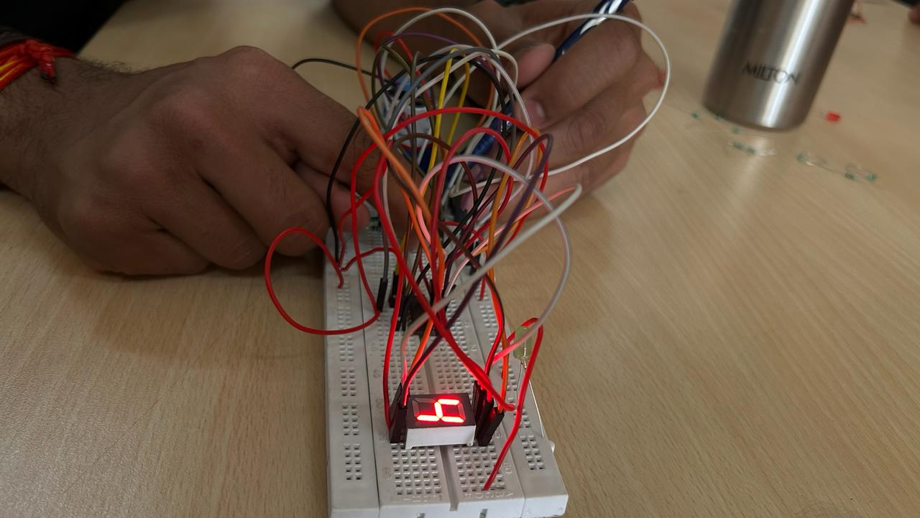

Figure 5 Figure 6

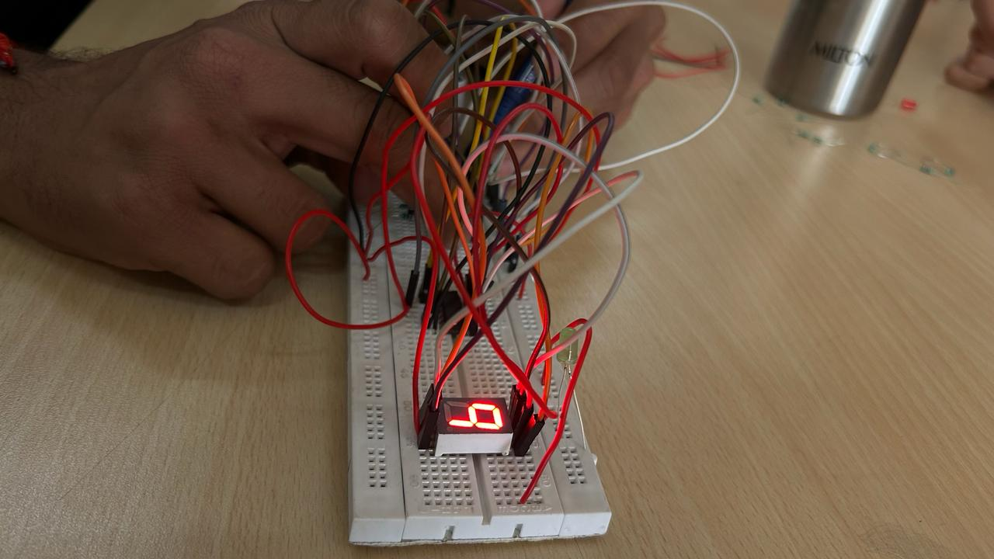 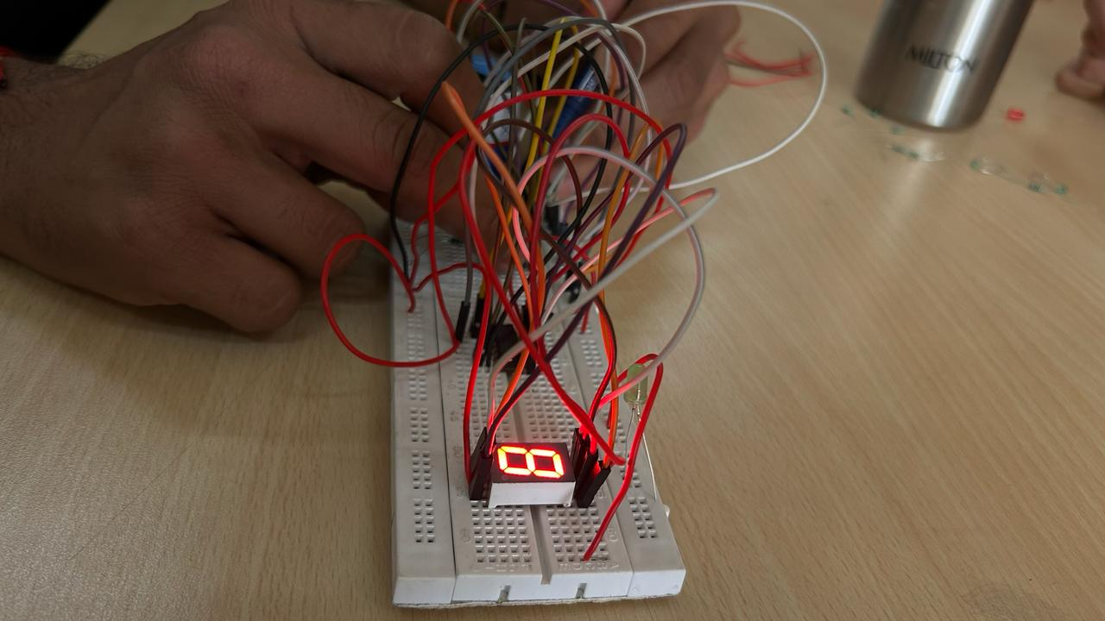

Figure 7 Figure 8

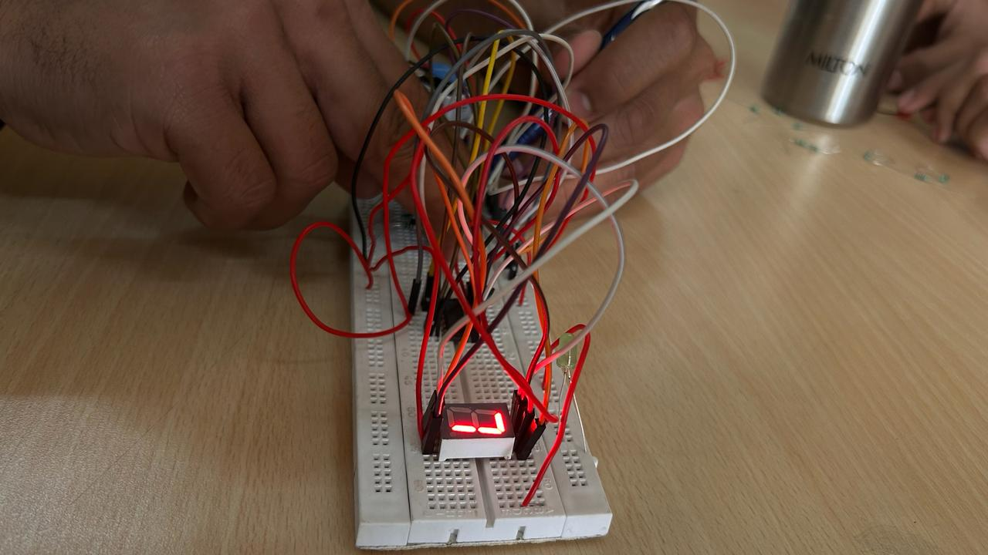 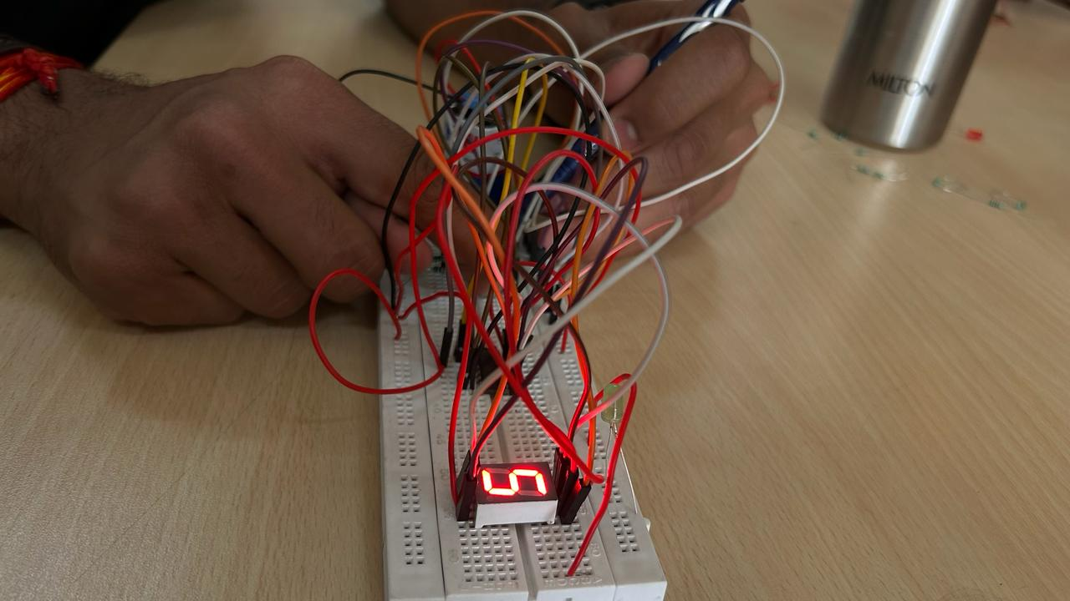

Figure 9 Figure 10

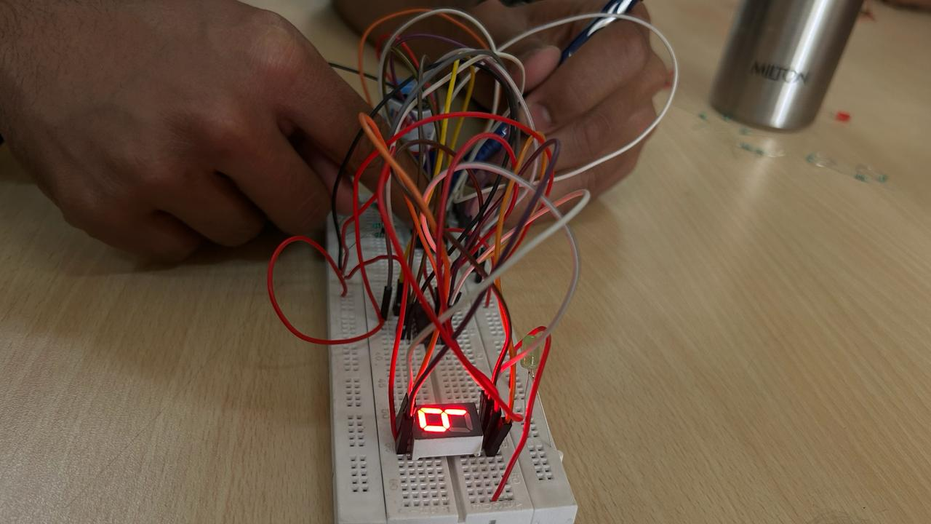

Figure 11

By this this observed output, we can easily form the truth table:

|  |  |  |  |  |  |  |  |  |  |  |
| --- | --- | --- | --- | --- | --- | --- | --- | --- | --- | --- |
| **x** | **y** | **z** | **w** | **a** | **b** | **c** | **d** | **e** | **f** | **g** |
| 0 | 0 | 0 | 0 | 0 | 0 | 0 | 0 | 0 | 0 | 1 |
| 0 | 0 | 0 | 1 | 1 | 0 | 0 | 1 | 1 | 1 | 1 |
| 0 | 0 | 1 | 0 | 0 | 0 | 1 | 0 | 0 | 1 | 0 |
| 0 | 0 | 1 | 1 | 0 | 0 | 0 | 0 | 1 | 1 | 0 |
| 0 | 1 | 0 | 0 | 1 | 0 | 0 | 1 | 1 | 0 | 0 |
| 0 | 1 | 0 | 1 | 0 | 1 | 0 | 0 | 1 | 0 | 0 |
| 0 | 1 | 1 | 0 | 0 | 1 | 0 | 0 | 0 | 0 | 0 |
| 1 | 1 | 1 | 1 | 0 | 0 | 0 | 1 | 1 | 1 | 1 |
| 1 | 0 | 0 | 0 | 0 | 0 | 0 | 0 | 0 | 0 | 0 |
| 1 | 0 | 0 | 1 | 0 | 0 | 0 | 1 | 0 | 0 | 0 |

RESULT: We have concluded the truth table observed from the display by connecting IC 4511 from seven segment decoders.

APPLICATION IN DAILY LIFE:

A Binary-Coded Decimal (BCD) to Seven-Segment Decoder is a digital circuit that converts a binary-coded decimal input (4 bits) into the corresponding 7-segment display output. Each decimal digit is represented by a 4-bit binary code, and the seven-segment display is a common way to visually represent numbers. Here's an example of a real-life application for a BCD to Seven-Segment Decoder:

* Digital Clocks and Timers: Many digital clocks and timers use BCD to Seven-Segment Decoders to convert the time information into a format that can be displayed on a seven-segment display. The hours and minutes are typically represented in BCD, and the decoder converts these codes into signals that illuminate the corresponding segments of the display.

Activity 07

4 – Bit Adder using VHDL language.

Date : 5th March 2024

Name : Bobby Sharma

Roll no. = 2023BTECH023

# AIM: Design and Simulation of Full Adder using HA (Structural Modelling) using VHDL language using Xilinx ISE Tool.

SOFTWARE REQUIRED: Xilinx ISE tool in your device.

THEORY:

Combinational circuits that can add two binary digits (bits) and a carry bit and produces a sum bit and a carry bit as output is known as a **full adder**.

In other words, a combinational circuit which is designed to add three binary digits and produces two outputs (sum and carry) is known as a full adder. Thus, a full adder circuit adds three binary digits, where two are the inputs and one is the carry forwarded from the previous addition. The block diagram and circuit diagram of the full adder are shown in Figure-1.

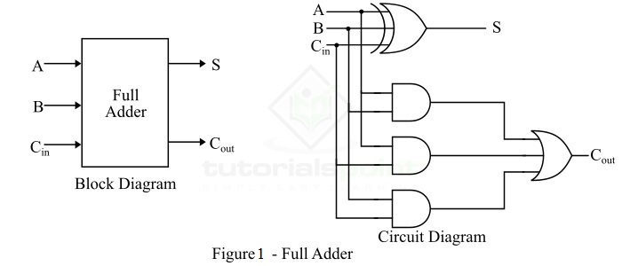

Hence, the circuit of the full adder consists of one EX-OR gate, three AND gates and one OR gate, which are connected as shown in the full adder circuit in Figure-1.

OBSERVATION: The observed outputs of all the basic gates are as follows:

* FULL ADDER:

VHDL Code: RTL Diagram:

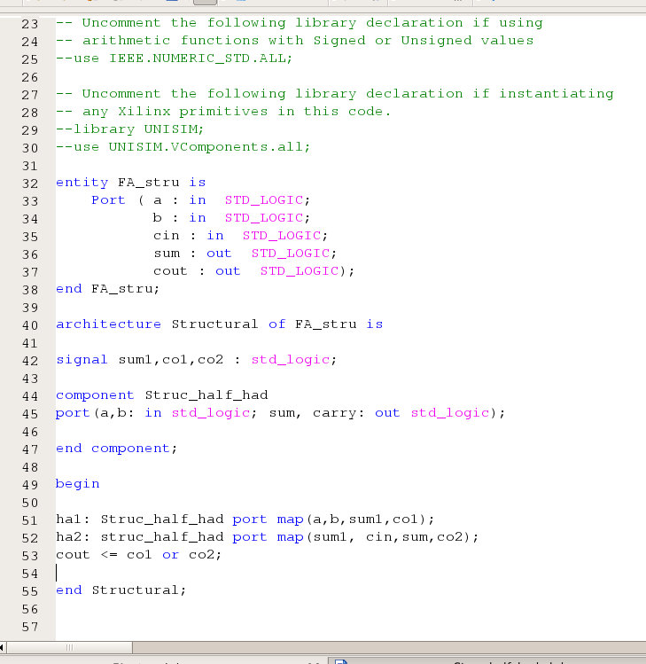 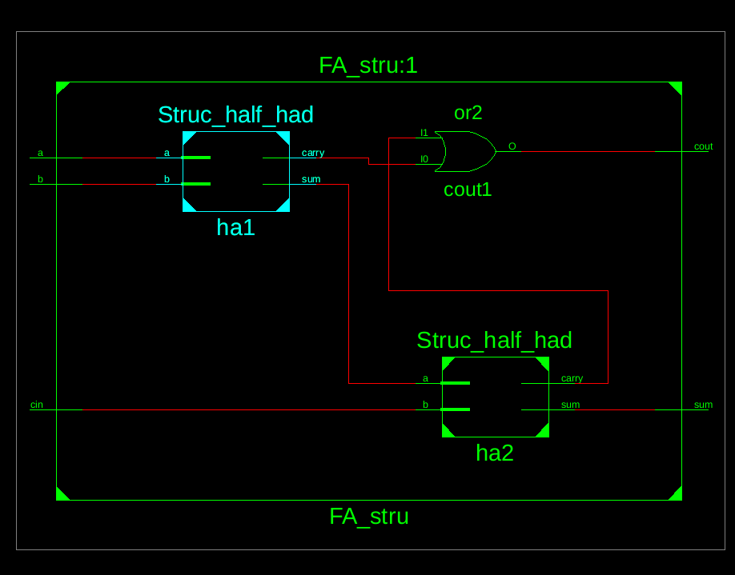

Figure 2 Figure 3

Test Bench Code:

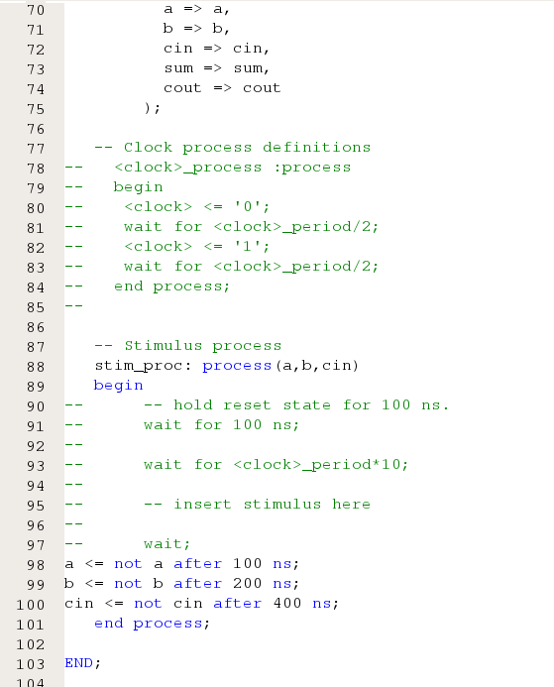

Figure 4

Waveform:

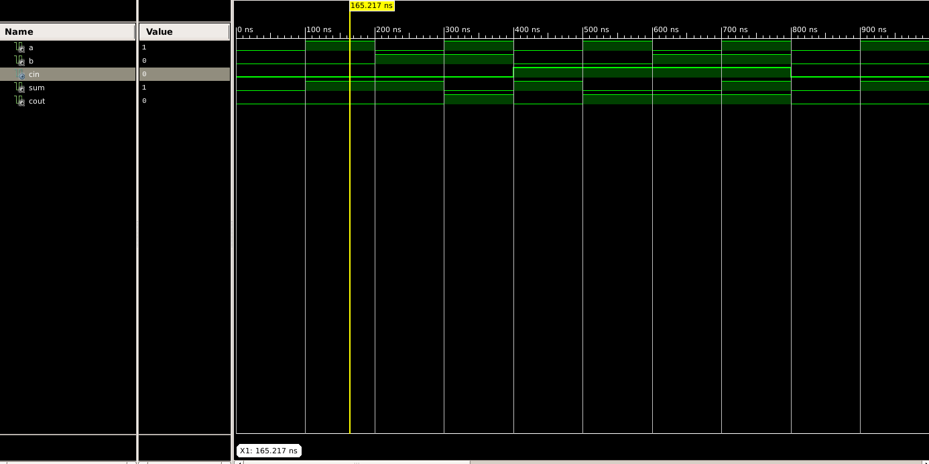

Figure 5

Here the yellow line in figure 5 represents the input (a=1, b=0 and carry(in)=0) and output(sum = 1 and carry(out) = 0). In which we can see the change of input signals of and b after every 100, 200 and 400 nano seconds respectively.

The truth table for a full adder using half adder (structural modelling) lists all possible combinations of inputs (A, B, and Cin) and the corresponding outputs (Sum and Cout).

|  |  |  |  |  |
| --- | --- | --- | --- | --- |
| A | B | Carry(in) | Sum | Carry(out) |
| 0 | 0 | 0 | 0 | 0 |
| 0 | 0 | 1 | 1 | 0 |
| 0 | 1 | 0 | 1 | 0 |
| 0 | 1 | 1 | 0 | 1 |
| 1 | 0 | 0 | 1 | 0 |
| 1 | 0 | 1 | 0 | 1 |
| 1 | 1 | 0 | 0 | 1 |
| 1 | 1 | 1 | 1 | 1 |

Table 1

# RESULT: We have concluded the truth table of full adder using VHDL language in Xilinx ISE Tool.

APPLICATION IN DAILY LIFE:

A full adder is a digital circuit that performs addition of three binary digits: two operands and a carry input. While it might not be directly visible in everyday life, full adders and digital circuits, in general, play a crucial role in various technologies and applications that we encounter on a daily basis. Here are some examples:

* Computers and Processors: Full adders are fundamental building blocks of arithmetic logic units (ALUs) in central processing units (CPUs). CPUs are the brains of computers, and they use full adders to perform arithmetic operations like addition.
* Calculators: Digital calculators use full adders in their circuitry to perform addition operations. Whether it's a simple handheld calculator or a more sophisticated scientific calculator, the underlying digital circuitry relies on the principles of binary addition.
* Digital Signal Processors (DSPs): DSPs are specialized microprocessors designed for processing digital signals, often used in audio processing, image processing, and communication systems. Full adders are used in these systems for various arithmetic operations.

Activity 08

4 – Bit Adder using VHDL language.

Date : 5th March 2024

Name : Bobby Sharma

Roll no. = 2023BTECH023

# AIM: Design and Simulation of 4 bit Full Adder using single bit FA (Structural Modelling) using VHDL language using Xilinx ISE Tool.

SOFTWARE REQUIRED: Xilinx ISE tool in your device.

THEORY:

In binary addition, you add each pair of corresponding bits from the two binary numbers, starting from the least significant bit (LSB). If the sum of two bits is 0 or 1, it directly goes into the result. If the sum is 2, it is represented as '10' in binary, and a carry is generated. If the sum is 3, it is represented as '11' in binary, and again, a carry is generated.

SCCHEMATIC DIAGRAM:

A 4-bit adder is constructed using four full adders connected in series. Each full adder takes three inputs: A, B, and a carry-in (Cin) from the previous stage. The outputs are a sum (S) and a carry-out (Cout).

The carry-out from each stage is connected to the carry-in of the next stage. The schematic diagram of a 4-bit adder illustrates how the full adders are interconnected, with inputs and outputs properly arranged. Each full adder block receives inputs A, B, and the carry-in (Cin), and produces a sum (S) and a carry-out (Cout).

The final output is a 4-bit sum and a carry-out is represented in figure 1.

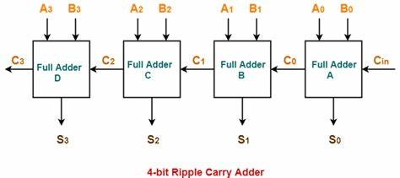

Figure 1

Overflow occurs when the sum of two positive numbers is too large to be represented with the given number of bits. In a 4-bit adder, overflow can be detected by checking the carry-out from the most significant bit (MSB).

OBSERVATION: The observed outputs of all the basic gates are as follows:

* FULL ADDER:

VHDL Code: RTL Diagram:

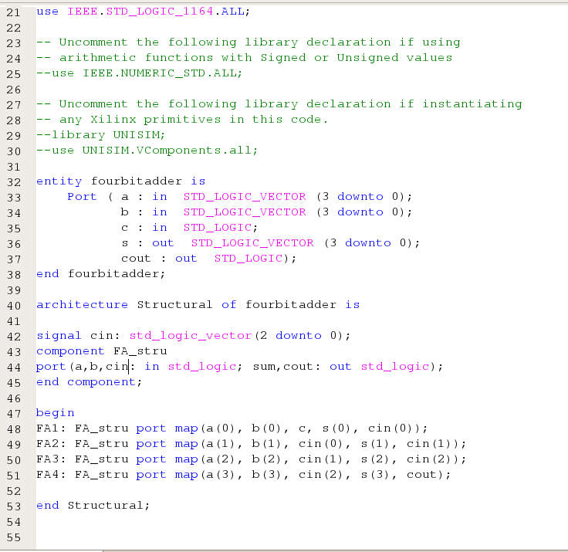 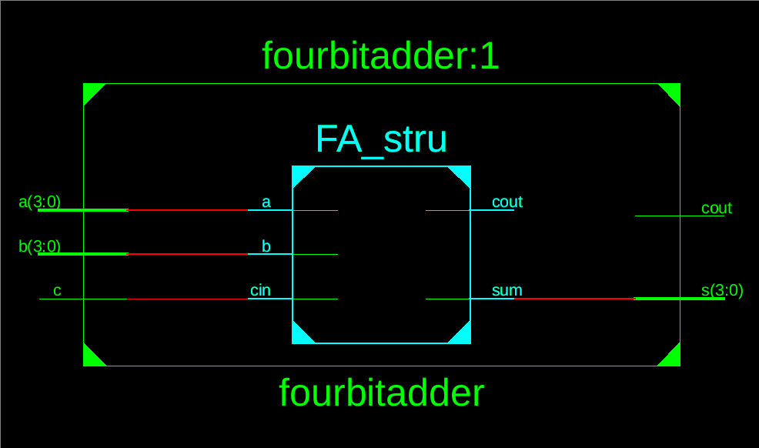

Figure 2 Figure 3

Test Bench Code:

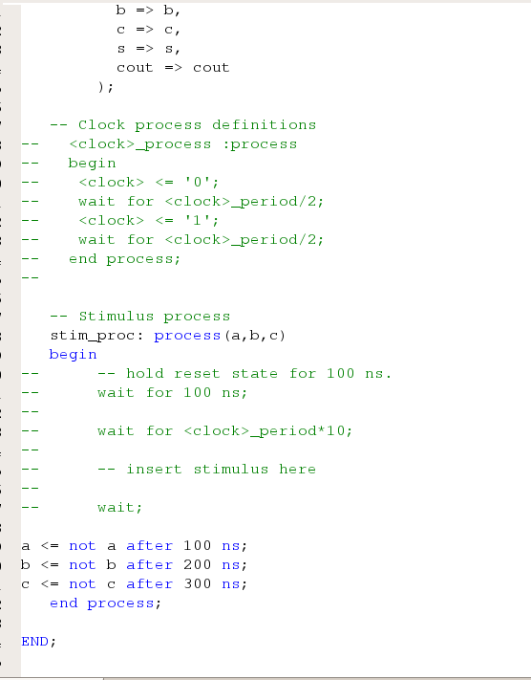

Figure 4

Waveform:

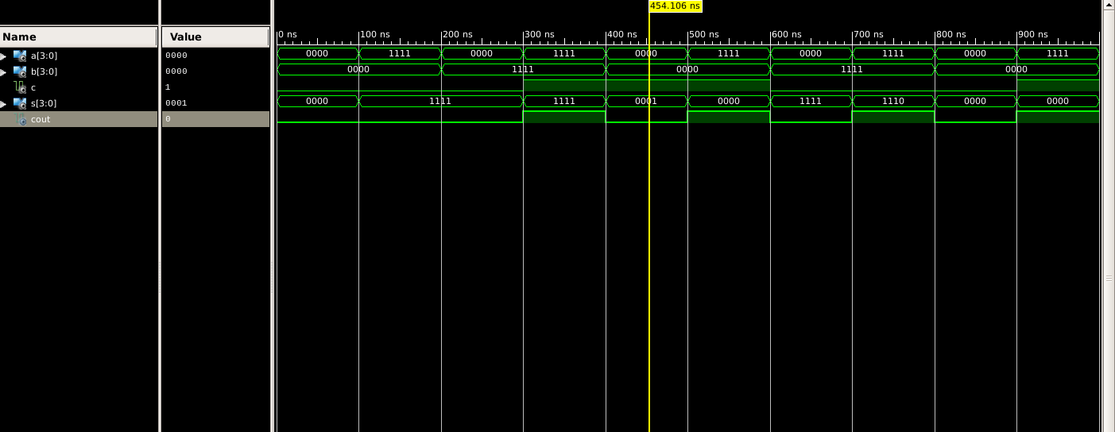

Figure 5

Here the yellow line in figure 5 represents the input (a=0000, b=0000 and carry(in)=1) and output(sum = 0001 and carry(out) = 0). In which we can see the change of input signals of and b after every 100, 200 and 300 nano seconds respectively.

The truth table for a 4-bit adder lists all possible combinations of inputs (A, B, and Cin) and the corresponding outputs (Sum and Cout).

|  |  |  |  |  |
| --- | --- | --- | --- | --- |
| A | B | Carry(in) | Sum | Carry(out) |
| 0 | 0 | 0 | 0 | 0 |
| 0 | 0 | 1 | 1 | 0 |
| 0 | 1 | 0 | 1 | 0 |
| 0 | 1 | 1 | 0 | 1 |
| 1 | 0 | 0 | 1 | 0 |
| 1 | 0 | 1 | 0 | 1 |
| 1 | 1 | 0 | 0 | 1 |
| 1 | 1 | 1 | 1 | 1 |

Table 1

# RESULT: We have concluded the truth table of full adder using VHDL language in Xilinx ISE Tool.

APPLICATION IN DAILY LIFE:

A 4-bit adder is a digital circuit that performs the addition of two 4-bit binary numbers. While you may not directly encounter 4-bit adders in your daily life, they play a crucial role in various electronic devices and systems. Here are some applications where 4-bit adders, and similar circuits, are used:

* Microprocessors and Microcontrollers: 4-bit adders are essential components in the arithmetic logic unit (ALU) of microprocessors and microcontrollers. ALUs perform arithmetic and logic operations, including addition, subtraction, AND, OR, XOR, etc.
* Calculators: The arithmetic operations in electronic calculators involve the use of adders. Although modern calculators use more advanced architectures, the basic principle of binary addition is still applicable.
* Digital Signal Processing (DSP): In audio and image processing applications, 4-bit adders are used in digital signal processors for tasks such as filtering, convolution, and other mathematical operations.
* Memory Addressing: In computer memory systems, addressing involves the addition of binary numbers to access specific memory locations. 4-bit adders may be used in the memory addressing circuits.
* Data Communication: In data communication systems, 4-bit adders are used for error detection and correction, encoding, and decoding processes.
* Control Systems: Digital control systems often use arithmetic operations for processing feedback and adjusting control signals. 4-bit adders can be part of the control circuitry in such systems.

Activity 09

2 – Bit Multiplier using VHDL language.

Date : 14th March 2024

Name : Bobby Sharma

Roll no. = 2023BTECH023

# AIM: Design and Simulation of 2bit multiplier (Structural Modelling) using VHDL language using Xilinx ISE Tool.

SOFTWARE REQUIRED: Xilinx ISE tool in your device.

THEORY: A 2-bit multiplier is a digital circuit designed to perform multiplication on two binary numbers, each represented with 2 bits. The theory behind a 2-bit multiplier involves understanding how binary multiplication works and then implementing a circuit to perform this operation efficiently. Here's an overview of the theory behind a 2-bit multiplier:

* **Binary Multiplication Basics**: In binary multiplication, each bit of one number (the multiplicand) is multiplied by each bit of the other number (the multiplier), similar to the process of multiplication in decimal. The multiplication process involves shifting and adding operations. The partial products obtained from each multiplication are then added together to get the result.
* **Partial Products:** For a 2-bit multiplier, four partial products are generated, one for each combination of the bits in the multiplicand and multiplier. The partial products are generated by multiplying each bit of the multiplicand with each bit of the multiplier.
* **Addition of Partial Products**: After generating the partial products, they are added together to obtain the result. Since we're dealing with only 2-bit numbers, the final result can be at most a 4-bit number (two bits from each partial product and a possible carry bit from addition).
* **Implementation of 2-bit Multiplier:** The implementation of a 2-bit multiplier can be done using combinatorial logic circuits such as AND gates for multiplication and XOR gates for addition. The circuit consists of blocks for generating partial products and then adding them together. Various techniques such as Wallace tree multiplier or carry-save adders can be employed for efficient addition of partial products.

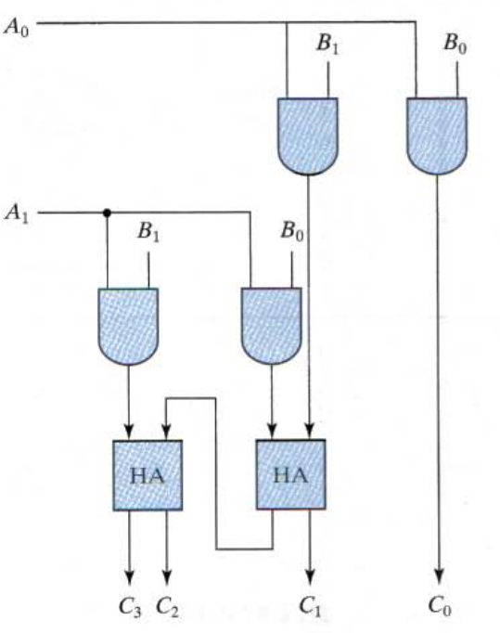

Figure 1

OBSERVATION: The observed outputs of all the basic gates are as follows:

* FULL ADDER:

VHDL Code: RTL Diagram:

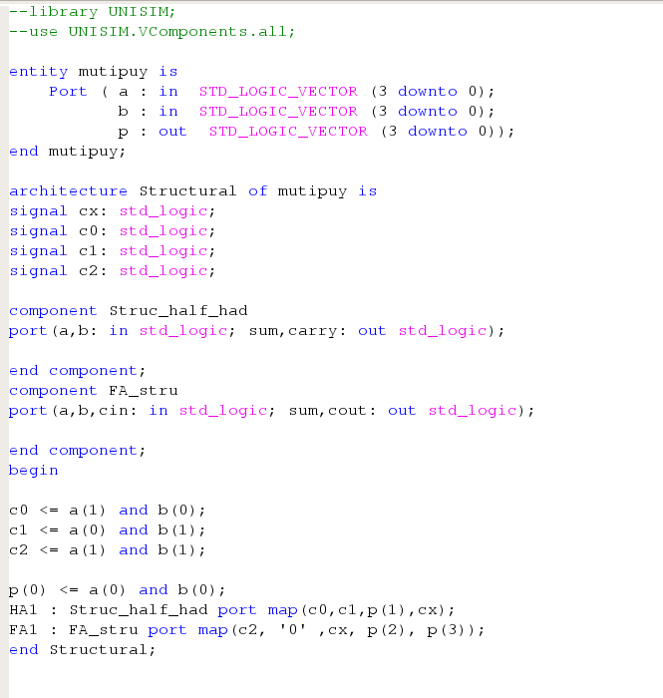 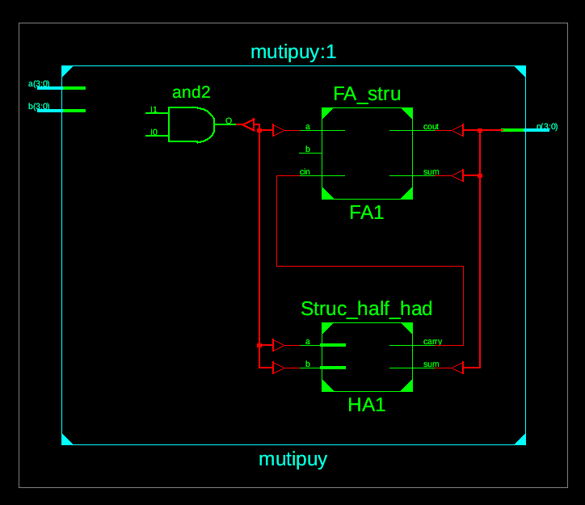

Figure 2 Figure 3

Test Bench Code:

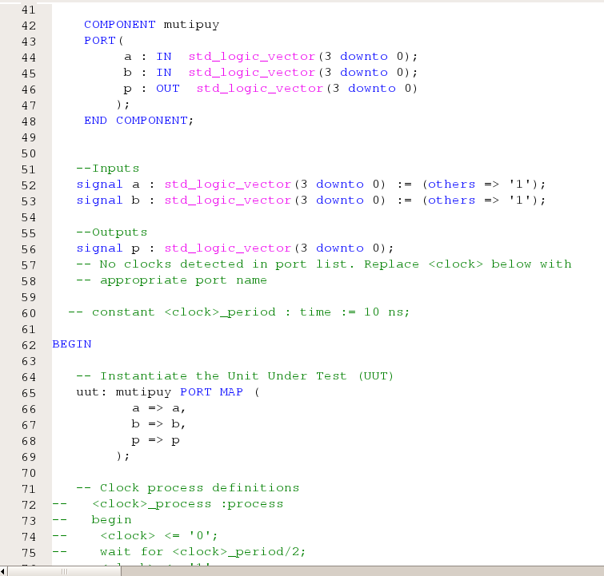

Figure 4

Waveform:

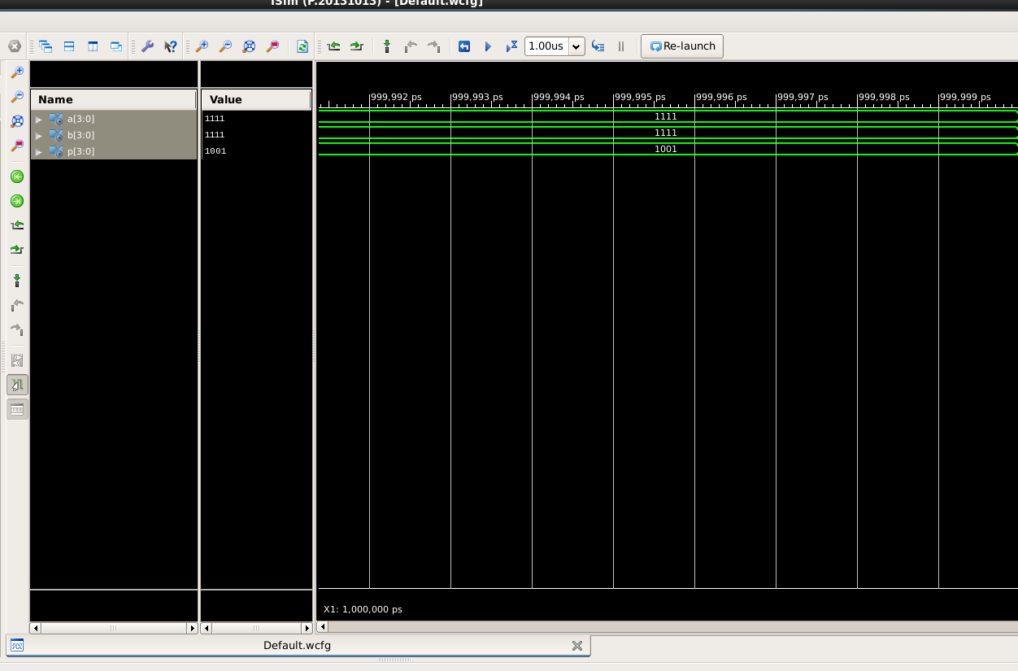

Figure 5

Here the yellow line in figure 5 represents the input (a=11, b=11) and output(sum = 1001). In which we can see the change of input signals of and b after every 100, 200 and 300 nano seconds respectively.

The truth table for a 4-bit adder lists all possible combinations of inputs (A, B, and Cin) and the corresponding outputs (Sum and Cout).

|  |  |  |  |  |  |  |  |
| --- | --- | --- | --- | --- | --- | --- | --- |
| A1 | A0 | B1 | B0 | F3 | F2 | F1 | F0 |
| 0 | 0 | 0 | 0 | 0 | 0 | 0 | 0 |
| 0 | 0 | 0 | 1 | 0 | 0 | 0 | 0 |
| 0 | 0 | 1 | 0 | 0 | 0 | 0 | 0 |
| 0 | 0 | 1 | 1 | 0 | 0 | 0 | 0 |
| 0 | 1 | 0 | 0 | 0 | 0 | 0 | 0 |
| 0 | 1 | 0 | 1 | 0 | 0 | 0 | 1 |
| 0 | 1 | 1 | 0 | 0 | 0 | 1 | 0 |
| 0 | 1 | 1 | 1 | 0 | 0 | 1 | 1 |
| 1 | 0 | 0 | 0 | 0 | 0 | 0 | 0 |
| 1 | 0 | 0 | 1 | 0 | 0 | 1 | 0 |
| 1 | 0 | 1 | 0 | 0 | 1 | 0 | 0 |
| 1 | 0 | 1 | 1 | 0 | 1 | 1 | 0 |
| 1 | 1 | 0 | 0 | 0 | 0 | 0 | 0 |
| 1 | 1 | 0 | 1 | 0 | 0 | 1 | 1 |
| 1 | 1 | 1 | 0 | 0 | 1 | 1 | 0 |
| 1 | 1 | 1 | 1 | 1 | 0 | 0 | 1 |

Table 1

# RESULT: We have concluded the truth table of 2-bit multiplier using VHDL language in Xilinx ISE Tool.

APPLICATION IN DAILY LIFE:

* Digital Watches and Clocks: Many digital watches and clocks use binary-coded decimal (BCD) representations for timekeeping. Multiplication operations may be required for tasks like adjusting time zones, calculating elapsed time, or performing time-related calculations, albeit with larger multipliers.
* Mobile Phones and Computers: While modern processors have significantly more complex arithmetic units, the fundamental principles of multiplication are still at play. In everyday applications, multiplication operations occur in various computational tasks, such as in gaming, image processing, financial calculations, and more.
* Financial Transactions: Banking and financial applications often involve calculations that can be broken down into multiplication operations. For instance, when calculating interest rates, loan repayments, currency conversions, or investment returns, multiplication is a fundamental arithmetic operation.
* Automotive Systems: In automotive systems, various sensors and actuators rely on microcontrollers or digital signal processors (DSPs) for control and processing tasks. These controllers often involve arithmetic operations like multiplication for tasks such as engine control, fuel injection timing, anti-lock braking systems (ABS), traction control, and more.

Activity 10

4 – Bit Carry Look Ahead Adder using VHDL language.

Date : 14th March 2024

Name : Bobby Sharma

Roll no. = 2023BTECH023

# AIM: Design and Simulation of 4-bit carry look ahead adder (Structural Modelling) using VHDL language using Xilinx ISE Tool.

SOFTWARE REQUIRED: Xilinx ISE tool in your device.

THEORY: A 4-bit Carry Look-Ahead (CLA) adder is a type of digital circuit used to add two 4-bit binary numbers together. It's designed to reduce the time delay inherent in ripple carry adders by generating the carry signals for multiple stages simultaneously, rather than propagating them sequentially. This results in faster addition of numbers compared to traditional ripple carry adders.

* Binary Addition: Before diving into the CLA adder, it's important to understand binary addition. In binary addition, we add two binary numbers bit by bit, starting from the least significant bit (LSB) and propagating carries to higher-order bits as needed.
* Carry Propagation Delay: In a ripple carry adder, each stage waits for the carry out from the previous stage before it can produce its own carry out. This introduces a propagation delay which increases linearly with the number of bits.
* Carry Look-Ahead Logic: In a Carry Look-Ahead adder, the carry out for each stage is calculated independently of the previous stage's carry out. This is achieved using a set of logic gates that predict the carry based on the inputs, rather than waiting for the carry to propagate.
* Generate and Propagate Signals: The Carry Look-Ahead logic typically involves two key signals: Generate (G) and Propagate (P). The Generate signal indicates whether a carry must be generated at a particular stage (i.e., whether both input bits are 1), while the Propagate signal indicates whether a carry from a previous stage can propagate to the current stage (i.e., whether at least one input bit is 1).
* Carry Generation: The Generate signal for each stage is calculated by taking the logical AND of the input bits at that stage. This indicates whether a carry must be generated at that stage.
* Carry Propagation: The Propagate signal for each stage is calculated by taking the logical OR of the input bits at that stage. This indicates whether a carry from a previous stage can propagate to the current stage.
* Carry Look-Ahead Logic: Once the Generate and Propagate signals are computed for each stage, the carry out for each stage can be determined using these signals and the carry in. This is typically done using logical operations such as AND, OR, and XOR.
* Sum Generation: The sum bit for each stage is computed using the XOR operation between the input bits and the carry in.
* Final Sum and Carry Out: The final sum bits and the carry out from the most significant stage are obtained by propagating the carry generated by the individual stages.

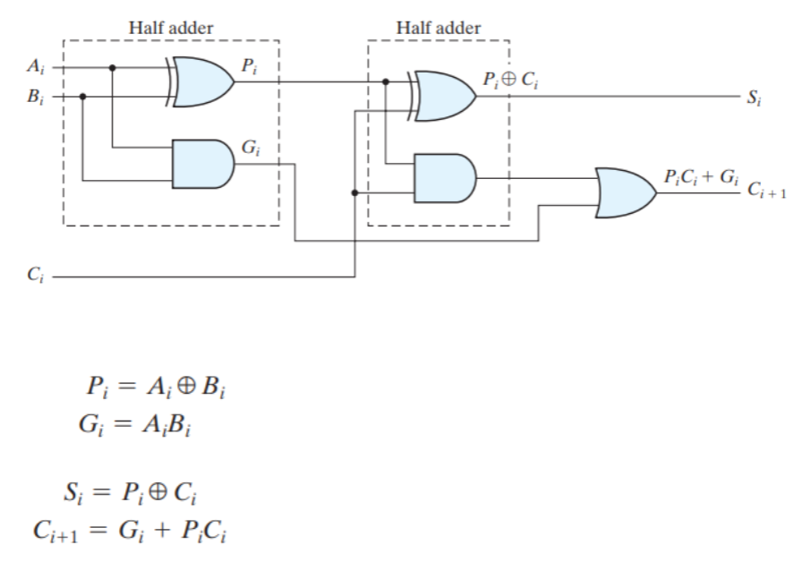

Figure 1

OBSERVATION: The observed outputs of all the basic gates are as follows:

* FULL ADDER:

VHDL Code: RTL Diagram:

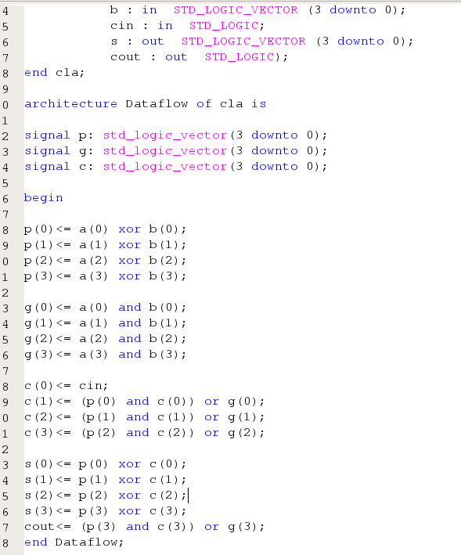 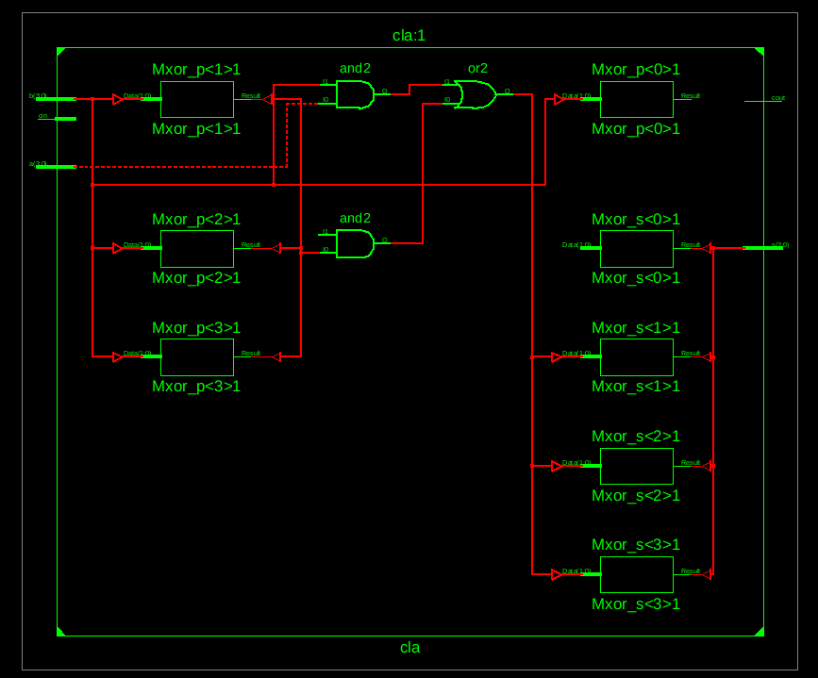

Figure 2 Figure 3

Test Bench Code:

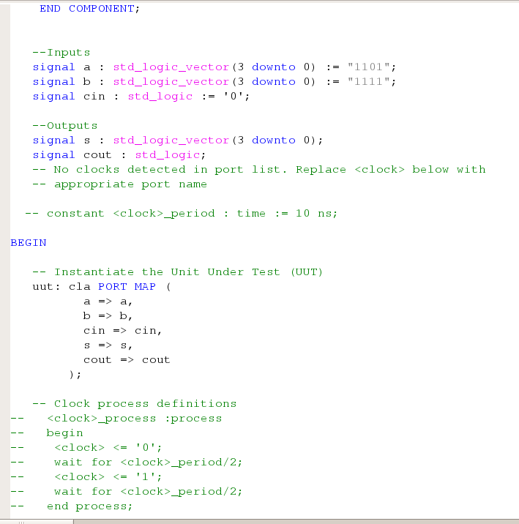

Figure 4

Waveform:

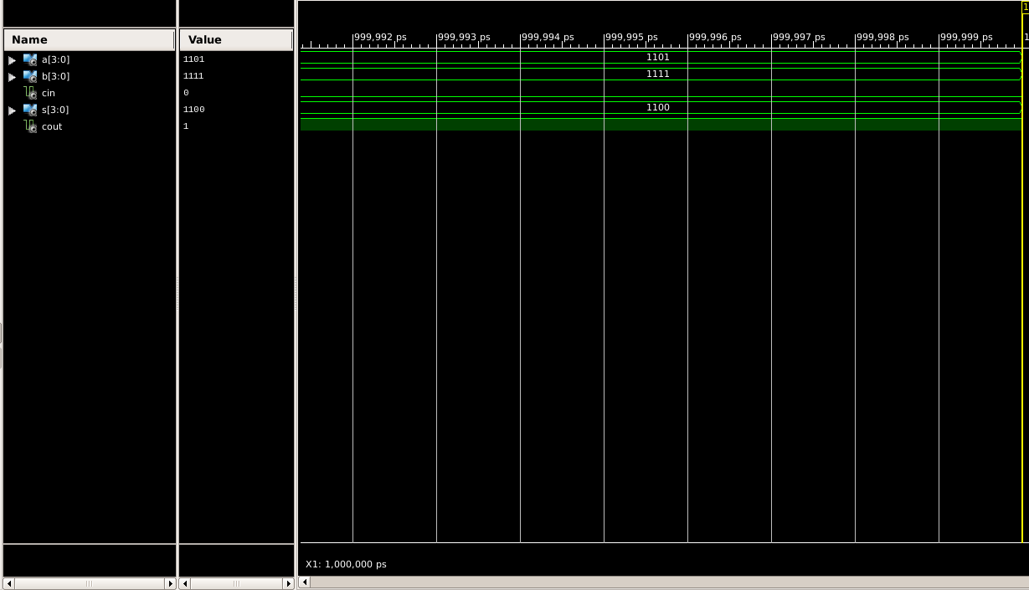

Figure 5

Here the yellow line in figure 5 represents the input (a=1111, b=1101) and output(sum = 1100 and carry = 1 ). The truth table for a 4-bit adder lists all possible combinations of inputs (A, B, and Cin) and the corresponding outputs (Sum and Cout).

|  |  |  |  |  |
| --- | --- | --- | --- | --- |
| A | B | Cin | S | Cout |
| 0 | 0 | 0 | 0 | 0 |
| 0 | 0 | 1 | 1 | 0 |
| 0 | 1 | 0 | 1 | 0 |
| 0 | 1 | 1 | 0 | 1 |
| 1 | 0 | 0 | 1 | 0 |
| 1 | 0 | 1 | 0 | 1 |
| 1 | 1 | 0 | 0 | 1 |
| 1 | 1 | 1 | 1 | 1 |

Table 1

# RESULT: We have concluded the truth table of 4-bit carry look ahead adder using VHDL language in Xilinx ISE Tool.

APPLICATION IN DAILY LIFE:

* **Computers and Mobile Devices**: Inside the CPU (Central Processing Unit) of computers and mobile devices, arithmetic and logic units (ALUs) utilize adders for performing arithmetic operations. When you add numbers in a spreadsheet, play a game, or browse the web, you're indirectly using the adders within the CPU.
* **Financial Transactions**: Banking systems, payment gateways, and financial institutions use digital circuits for processing financial transactions. These systems involve arithmetic operations such as addition for calculating balances, transaction amounts, etc.
* **Communications**: In communication systems, adders are used for error correction, data compression, encryption, and various signal processing tasks. For instance, in wireless communication, signal processing circuits use adders to process incoming signals for decoding and analysis.
* **Digital Media**: Digital signal processing (DSP) in devices like cameras, audio recorders, and music players heavily rely on arithmetic operations. Adders are used in these devices for tasks such as image processing, audio filtering, and compression/decompression.

Activity 11

Design 8:1 multiplexer structural and dataflow

using VHDL language.

Date : 27th March 2024

Name : Bobby Sharma

Roll no. = 2023BTECH023

# AIM: Design and Simulation of 8 to 1 Multiplexer using Structural Modelling (use 2:1 mux) and data flow modelling both in VHDL language using Xilinx

SOFTWARE REQUIRED: Xilinx ISE tool in your device.

THEORY: A multiplexer is a combinational circuit featuring numerous data inputs and a solitary output, the selection of which depends on control or select inputs. To manage N input lines, log2(N) selection lines are essential, or conversely, for 2^n input lines, n selection lines are requisite. Multiplexers are alternatively termed as "N-to-1 selectors," parallel-to-serial converters, many-to-one circuits, and universal logic circuits. Their primary utility lies in augmenting the quantity of data transmissible over a network within a specified timeframe and bandwidth.

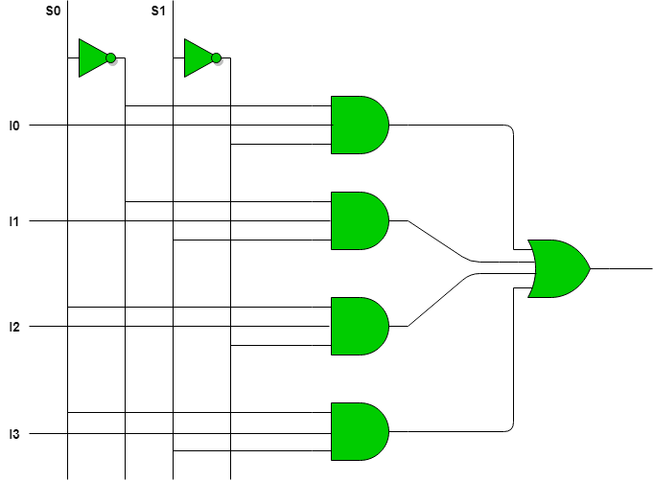

Figure 1

We can make 8:1 multiplexer from 2:1 multiplexer as shown in figure 2:

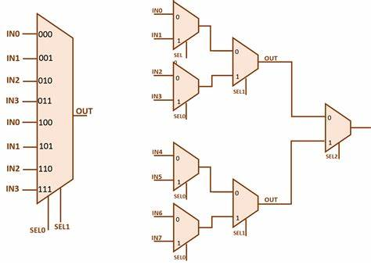

Figure 2

OBSERVATION: The observed outputs of multiplexer are as follows:

USING DATAFLOW:

VHDL Code: RTL Diagram:

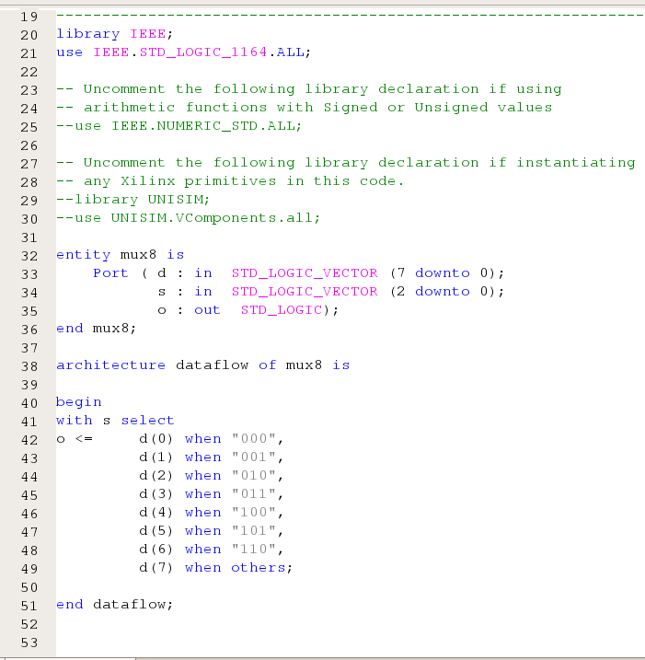 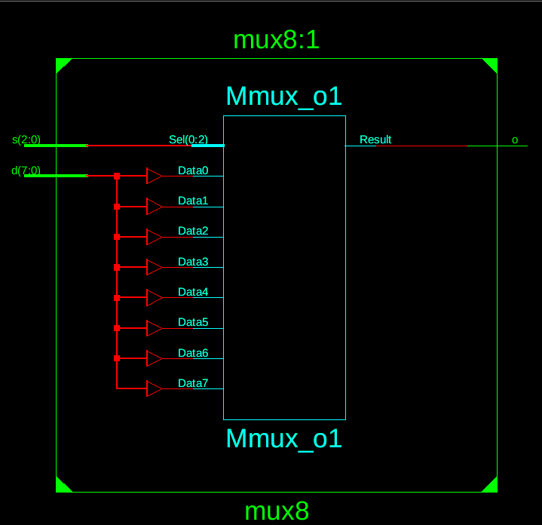

Figure 3 Figure 4

Test Bench Code:

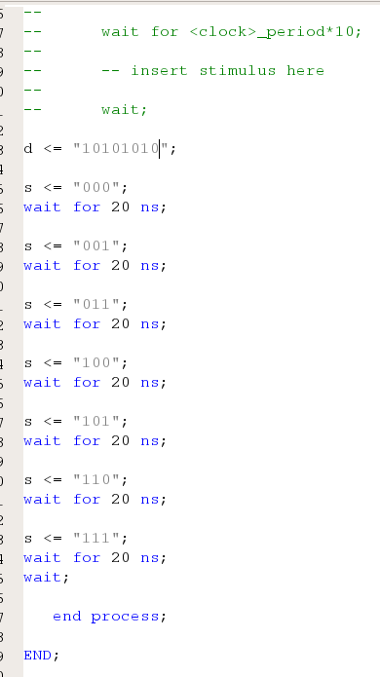

Figure 5

Waveform:

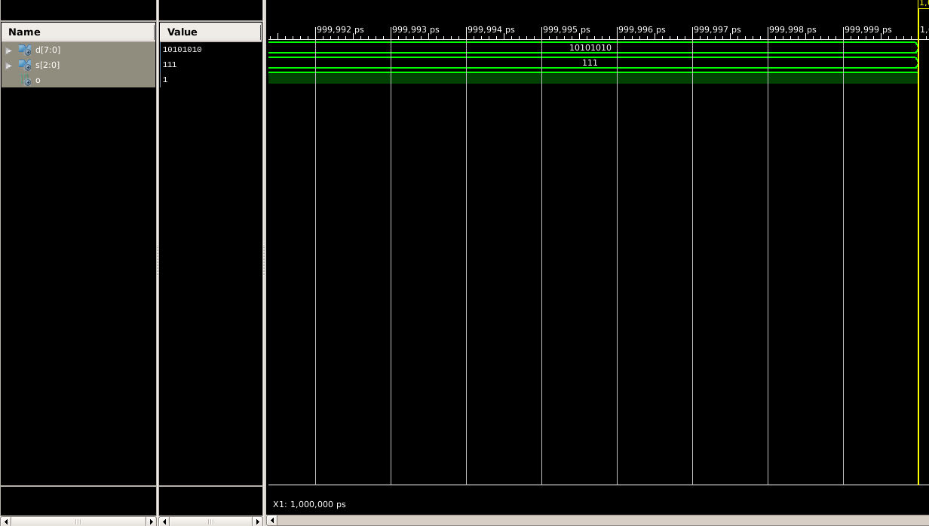

Figure 6

USING STRUCTURAL BY USING 2:1 MULTIPLEXER :

VHDL Code: RTL Diagram:

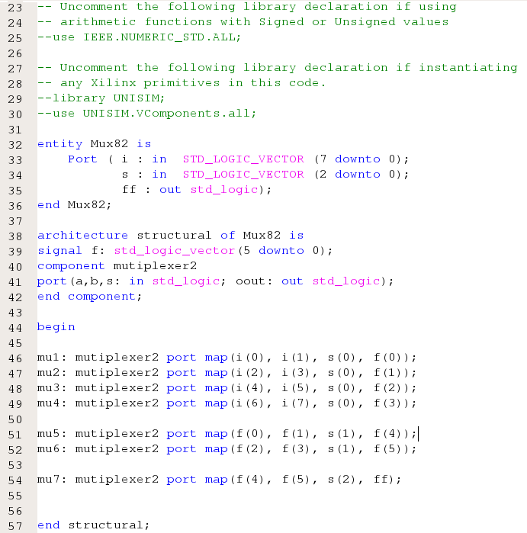 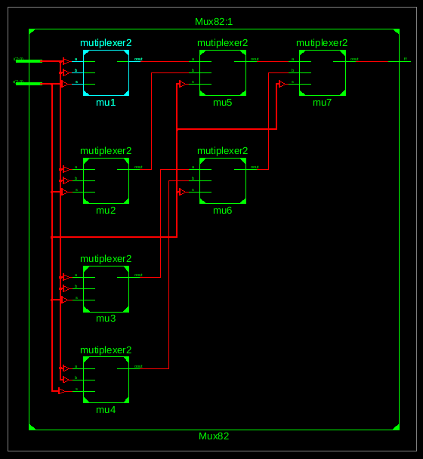

Figure 7 Figure 8

Test Bench Code:

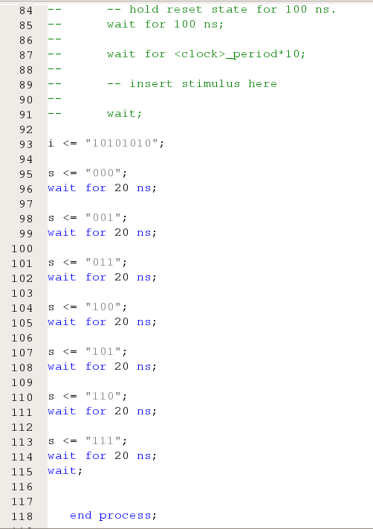

Figure 9

Waveform:

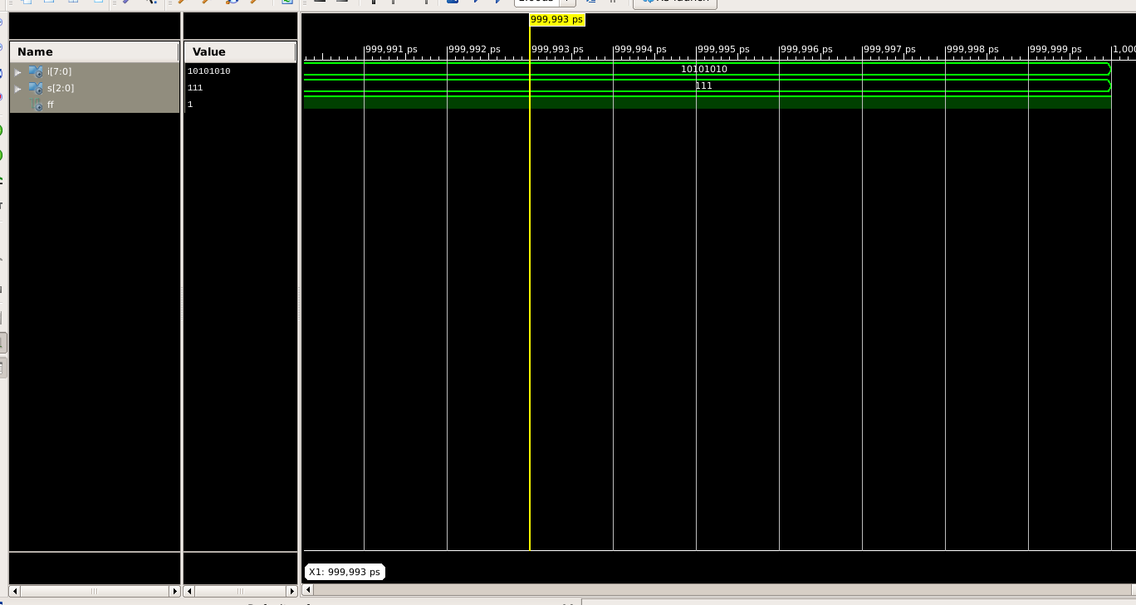

Figure 10

Here the yellow line in figure 6 and 10 represents the input (I(vector) = 10101010 and S(vector) = 111) and therefore the I7 will be represented as the output which in this case is 1. The table for 8:1 multiplexer lists all possible combinations of inputs (S2, S1, and S0) and the corresponding outputs (F).

|  |  |  |  |
| --- | --- | --- | --- |
| S2 | S1 | S0 | F |
| 0 | 0 | 0 | I0 |
| 0 | 0 | 1 | I1 |
| 0 | 1 | 0 | I2 |
| 0 | 1 | 1 | I3 |
| 1 | 0 | 0 | I4 |
| 1 | 0 | 1 | I5 |
| 1 | 1 | 0 | I6 |
| 1 | 1 | 1 | I7 |

Table 1

The Equation can be drawn as :

F = (S2)’(S1)’(S0)’I0 + (S2)’(S1)’(S0)I1 + (S2)’(S1)(S0)’I2 + (S2)’(S1)(S0)I3 + (S2)(S1)’(S0)’I4 + (S2)(S1)’(S0)I5 + (S2)(S1)(S0)’I6 + (S2)(S1)(S0)I7

# RESULT: We have concluded the Equation of 8:1 multiplexer using VHDL language in Xilinx ISE Tool.

APPLICATION IN DAILY LIFE:

* **Data Routing:** In digital systems, data often needs to be routed from various sources to a single destination. An 8:1 multiplexer can be used to select one of eight data sources and pass its output to the destination based on control signals.
* **Memory Addressing:** In computer memory systems, a multiplexer can be used to select a specific memory address. In an 8-bit memory system, an 8:1 multiplexer can be used to choose one of 8 memory locations.
* **Signal Switching:** Multiplexers can be used to switch between different signals in communication systems. For example, in telecommunications, multiple input signals may need to be selectively routed to a single transmission line based on specific conditions or commands.
* **Control Unit Design:** In computer architecture, multiplexers are often used in the design of control units. They can be used to select control signals or data paths based on various conditions or instructions.

Activity 12

Design a full adder in FPGA boards

using VHDL language.

Date : 2nd April 2024

Name : Bobby Sharma

Roll no. = 2023BTECH023

# AIM: Design the FA and implement it in FPGA Board (zybo z-7010 zynq) using VHDL Xilinx.

SOFTWARE REQUIRED: Xilinx ISE tool in your device, and FPGA Board (zybo z-7010 zynq).

THEORY: The Zybo Z-7010 is a development board based on the Xilinx Zynq-7000 system-on-chip (SoC), which combines an ARM Cortex-A9 processor with programmable logic resources in a single device. This integration allows developers to create highly flexible and customizable embedded systems by leveraging both the processing power of the ARM core and the parallel processing capabilities of the programmable logic fabric.

Here's a brief overview of the theory behind the Zybo Z-7010 FPGA board and its components:

1. Xilinx Zynq-7000 SoC: The heart of the Zybo Z-7010 board is the Xilinx Zynq-7000 SoC, which consists of two main components:

* ARM Cortex-A9 Processor: The ARM Cortex-A9 processor provides the processing power needed to run embedded software applications, operating systems (such as Linux), and control tasks.
* Programmable Logic (FPGA Fabric): The programmable logic fabric consists of configurable logic blocks (CLBs), digital signal processing (DSP) slices, block RAM (BRAM), and input/output (I/O) resources. This programmable fabric allows developers to implement custom digital circuits, accelerators, interfaces, and signal processing algorithms in hardware.

1. Development Tools: Xilinx provides a suite of development tools, including Vivado Design Suite and Xilinx SDK, for designing, synthesizing, implementing, and debugging FPGA-based designs targeting the Zynq-7000 platform. These tools enable developers to create complex embedded systems by integrating hardware and software components seamlessly.
2. Peripherals and Interfaces: The Zybo Z-7010 board includes various peripherals and interfaces for connectivity and expansion, such as:

* HDMI and VGA video outputs
* USB ports
* Ethernet port
* Audio codec
* MicroSD card slot
* GPIO headers
* PMOD connectors for additional expansion modules

1. Programming and Configuration: FPGAs are typically programmed and configured using a hardware description language (HDL) such as Verilog or VHDL. Developers write HDL code to describe the desired functionality of the digital circuits they want to implement in the FPGA fabric. This code is then synthesized, placed, and routed using FPGA synthesis tools to generate a configuration bitstream. The configuration bitstream is loaded into the FPGA at runtime to configure the programmable logic fabric according to the specified design.
2. Application Areas: The Zybo Z-7010 FPGA board is suitable for a wide range of embedded system applications, including:

* Digital signal processing (DSP)
* Real-time video processing and streaming
* Embedded vision and image processing
* Industrial automation and control
* Robotics and autonomous systems
* Internet of Things (IoT) devices
* Education and academic projects in digital design and embedded systems

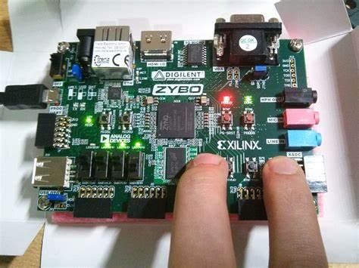

Figure 1

We can make full adder as shown in figure 2. A full adder is a digital circuit that adds three input bits, incorporating a carry-in bit along with two operands. It produces a sum output and a carry-out bit. The sum output is the XOR of the three inputs, while the carry-out is generated through a combination of AND and OR gates. The circuit comprises two half adders and an additional OR gate for handling the carry. Full adders are fundamental building blocks in arithmetic circuits, used extensively in processors, calculators, and other digital systems. They provide a mechanism for adding binary numbers efficiently, considering both the operands and the carry from the previous stage.

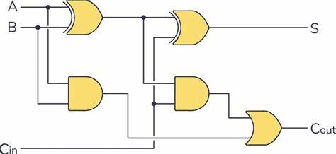

Figure 2

OBSERVATION: The observed outputs of full adder are as follows:

USING DATAFLOW:

VHDL Code: RTL Diagram:

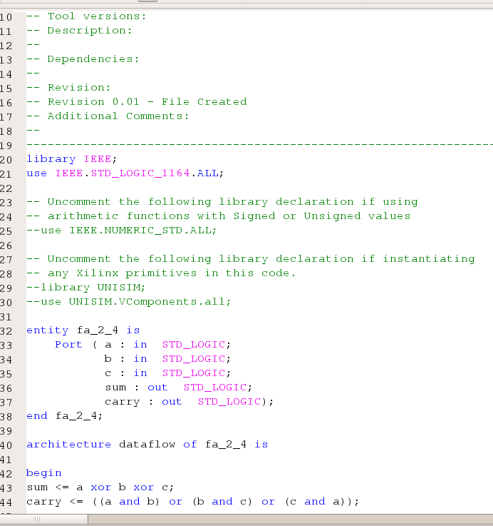 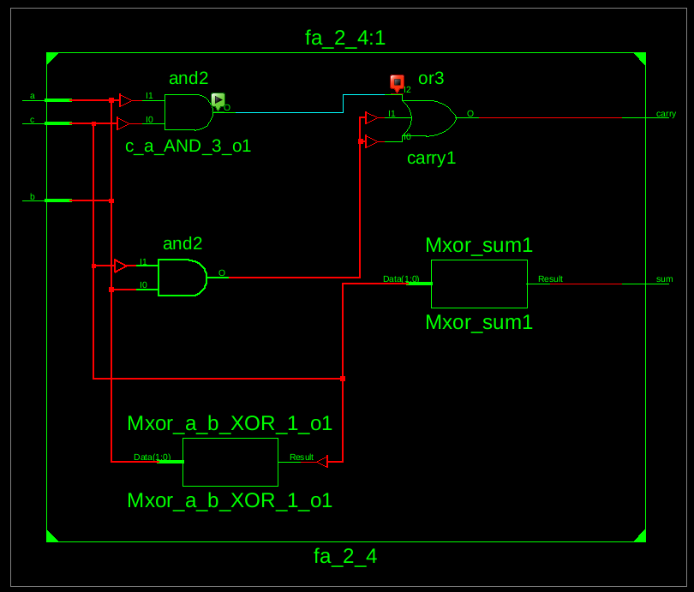

Figure 3 Figure 4

Test Bench Code:

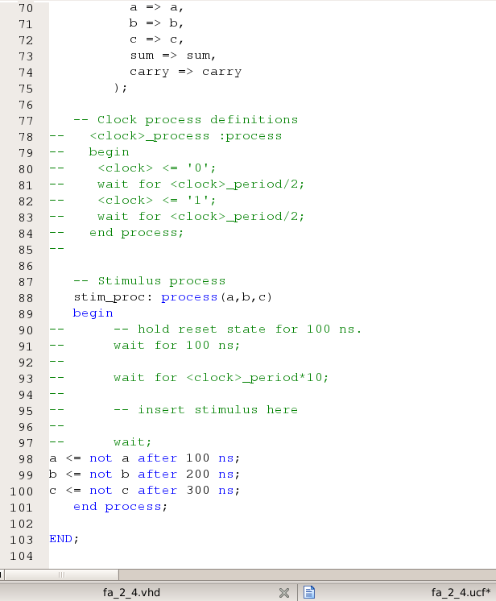 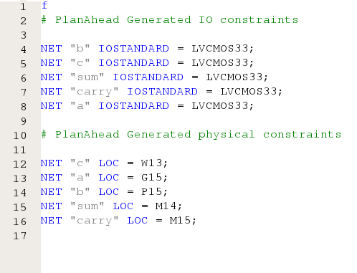

Figure 5 Figure 6

Waveform:



Figure 7

As we already know, that the vhdl code and rtl diagram gives the basic structure of the full adder and with the help of them we can easily conclude the truth table of full adder:

|  |  |  |  |  |
| --- | --- | --- | --- | --- |
| a | b | c | sum | carry |
| 0 | 0 | 0 | 0 | 0 |
| 0 | 0 | 1 | 1 | 0 |
| 0 | 1 | 0 | 1 | 0 |
| 0 | 1 | 1 | 0 | 1 |
| 1 | 0 | 0 | 1 | 0 |
| 1 | 0 | 1 | 0 | 1 |
| 1 | 1 | 0 | 0 | 1 |
| 1 | 1 | 1 | 1 | 1 |

Table 1

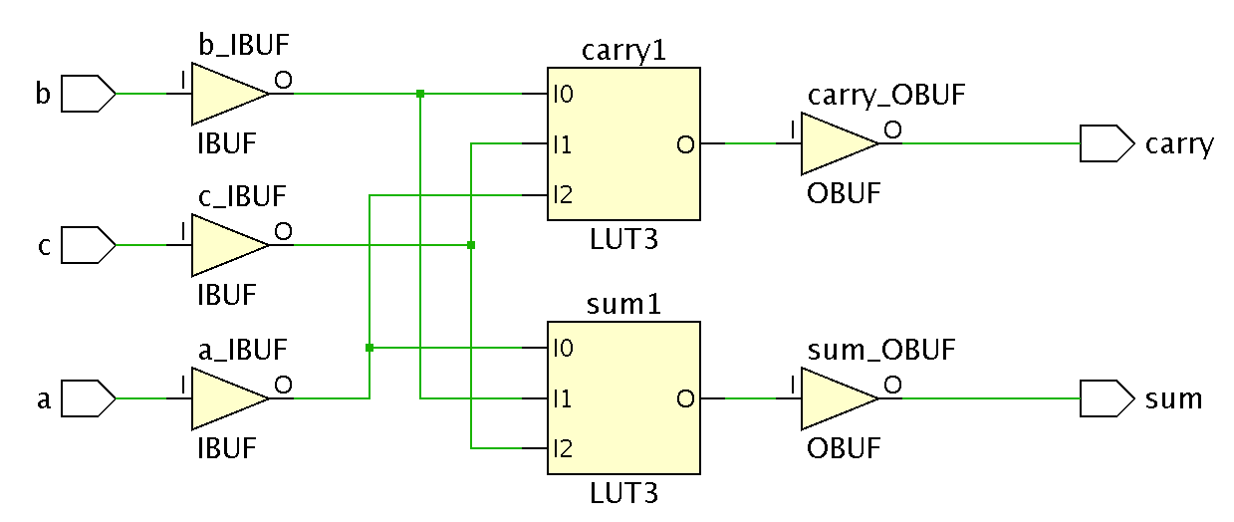

Figure 8

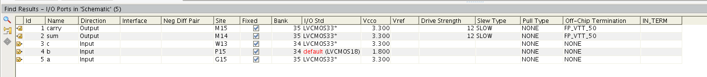

Figure 9

But to implement into the fpga boards, we have to make the usf file as well as bit file (which was read by the board itself ). Thus Figure 8 and 9 specifies the circuit and the pin numbers attached to the input and output.

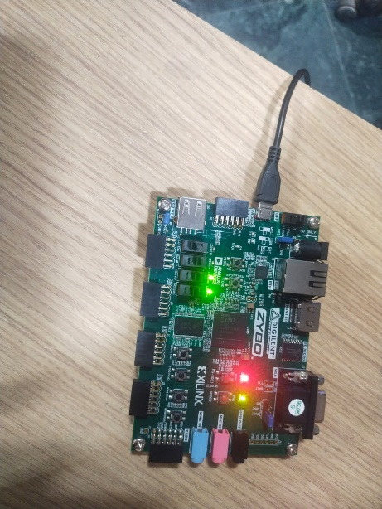

Figure 10

After allocating the pin numbers and provide our devise the bit file. It can be easily observed in the FPGA board as shown in figure 10. The changes can be done through the switch present on the board.

The Equation can be drawn as :

Sum <= a xor b xor c;

Carry <= (a and b) or (b and c) or (c and a);

# RESULT: We have concluded the truth table of full adder and understand the working of the FPGA Board (zybo z-7010 zynq) using VHDL language in Xilinx ISE Tool.

APPLICATION IN DAILY LIFE:

* **Communications and Networking:** FPGAs are extensively used in networking equipment such as routers, switches, and network interface cards (NICs). They are utilized for tasks such as packet processing, protocol parsing, encryption, and traffic management. FPGAs enable flexibility and high performance in these critical networking functions.
* **Consumer Electronics:** FPGAs are increasingly being integrated into various consumer electronics devices, including smart TVs, set-top boxes, and gaming consoles. They can be used for video processing, image enhancement, audio processing, and user interface customization. FPGAs enable manufacturers to implement complex features and differentiate their products in the competitive consumer electronics market.
* **Automotive Systems:** FPGAs play a vital role in modern automotive systems, contributing to functionalities such as advanced driver assistance systems (ADAS), infotainment systems, vehicle networking, and engine control units (ECUs). FPGAs offer high reliability, low latency, and flexibility, making them suitable for demanding automotive applications that require real-time processing and adaptation to changing requirements.
* **Industrial Automation and Control:** FPGAs are extensively used in industrial automation and control systems for tasks such as PLC (Programmable Logic Controller) programming, motion control, process monitoring, and machine vision. FPGAs offer deterministic performance, high-speed processing, and customization capabilities, making them ideal for industrial applications that demand precision and reliability.
* **Medical Devices:** FPGAs are employed in various medical devices and equipment, including MRI machines, ultrasound systems, patient monitoring devices, and laboratory instruments. They are used for signal processing, image processing, sensor interfacing, and data acquisition. FPGAs enable high-performance computation and customization to meet the specific requirements of medical applications.

Activity 13

Design D Flip Flop using VHDL language.

Date : 2nd April 2024

Name : Bobby Sharma

Roll no. = 2023BTECH023

# AIM: Design and Simulation of D Flip Flop using data flow modelling in VHDL language using Xilinx ISE software.

SOFTWARE REQUIRED: Xilinx ISE tool in your device.

THEORY: A D flip-flop is a type of sequential logic circuit that stores a single bit of data. It has two stable states (0 or 1) and is capable of toggling between these states based on certain input conditions. The fundamental operation of a D flip-flop involves the following key components:

* Data Input (D): The D input is the primary input of the flip-flop. It determines the state (0 or 1) that the flip-flop will store. When the D input is high (logic 1), the flip-flop will store a 1, and when the D input is low (logic 0), the flip-flop will store a 0.
* Clock Input (CLK): The clock input controls the timing of when the flip-flop samples the D input. The flip-flop will only update its stored state when the clock input transitions from one state to another (e.g., from low to high or from high to low).
* Output (Q): The Q output represents the current state of the flip-flop. It reflects the value stored by the flip-flop based on the last clock transition.
* Inverted Output (/Q): The inverted output (/Q) is the complement of the Q output. When Q is high, /Q is low, and vice versa.

The operation of a D flip-flop can be summarized as follows:

* When the clock input transitions (e.g., from low to high), the flip-flop samples the value of the D input.
* If the D input is high, the flip-flop sets its output Q to high.
* If the D input is low, the flip-flop sets its output Q to low.
* The output Q remains unchanged until the next clock transition occurs, at which point it will reflect the sampled value of the D input again.

D flip-flops are commonly used in digital circuits for various purposes such as data storage, synchronization, and control. They are building blocks for more complex sequential logic circuits, including counters, shift registers, and state machines.

There are different variations of D flip-flops, including positive-edge-triggered and negative-edge-triggered types, which determine whether the flip-flop samples the D input on the rising edge or falling edge of the clock signal, respectively. Additionally, synchronous and asynchronous types of D flip-flops exist, each with different timing requirements and behaviors.

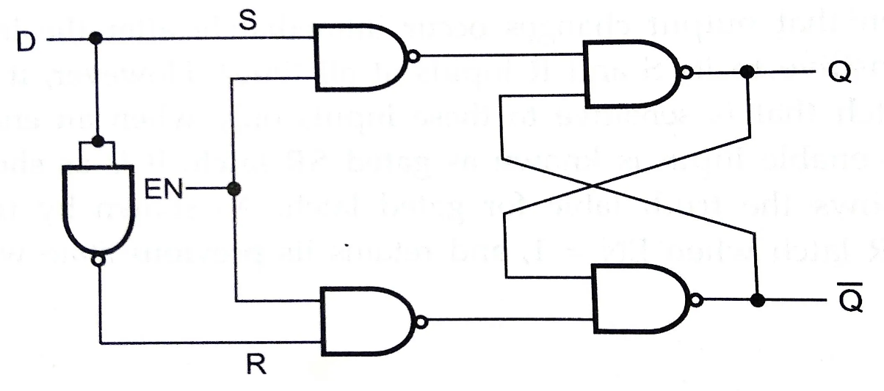

Figure 1

OBSERVATION: The observed outputs of D Flip Flops are as follows:

USING DATAFLOW:

VHDL Code: RTL Diagram:

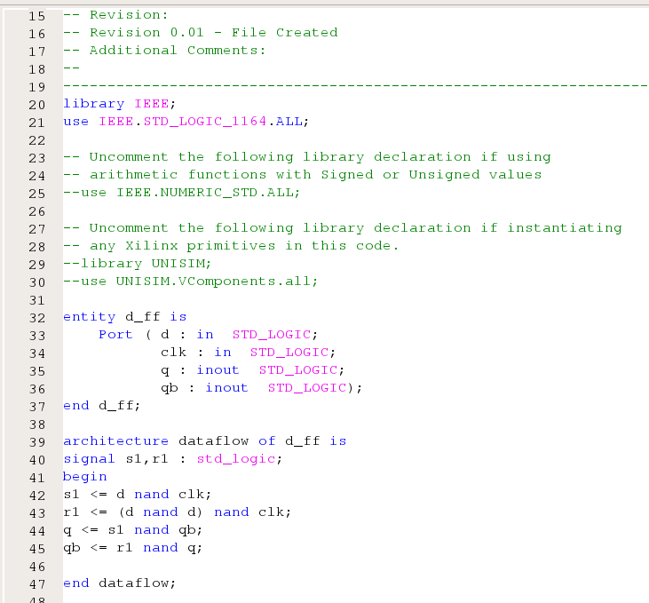 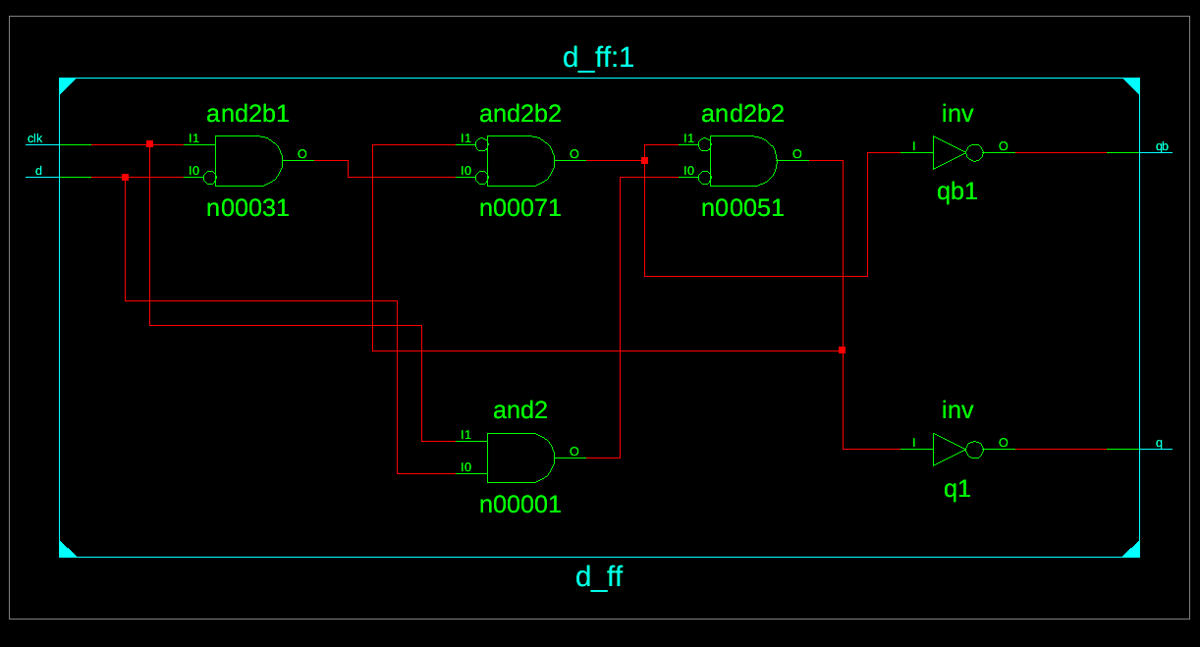

Figure 2 Figure 3

Test Bench Code:

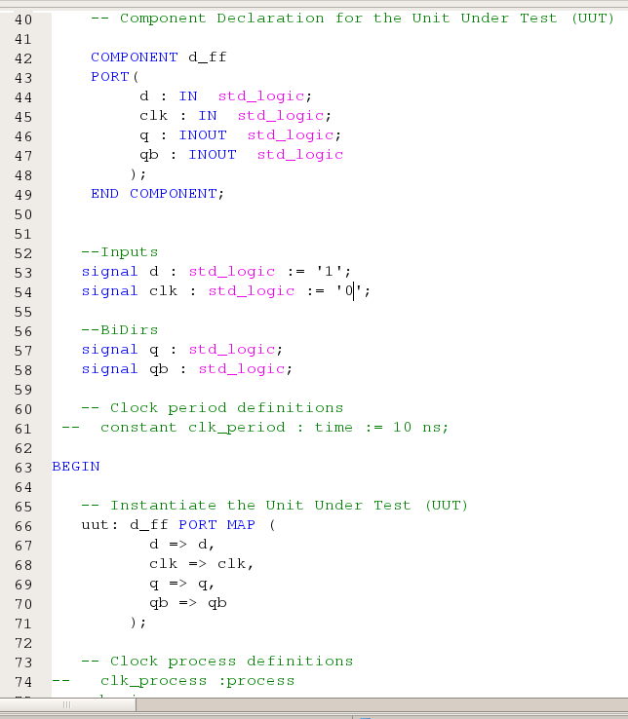

Figure 4

Waveform:

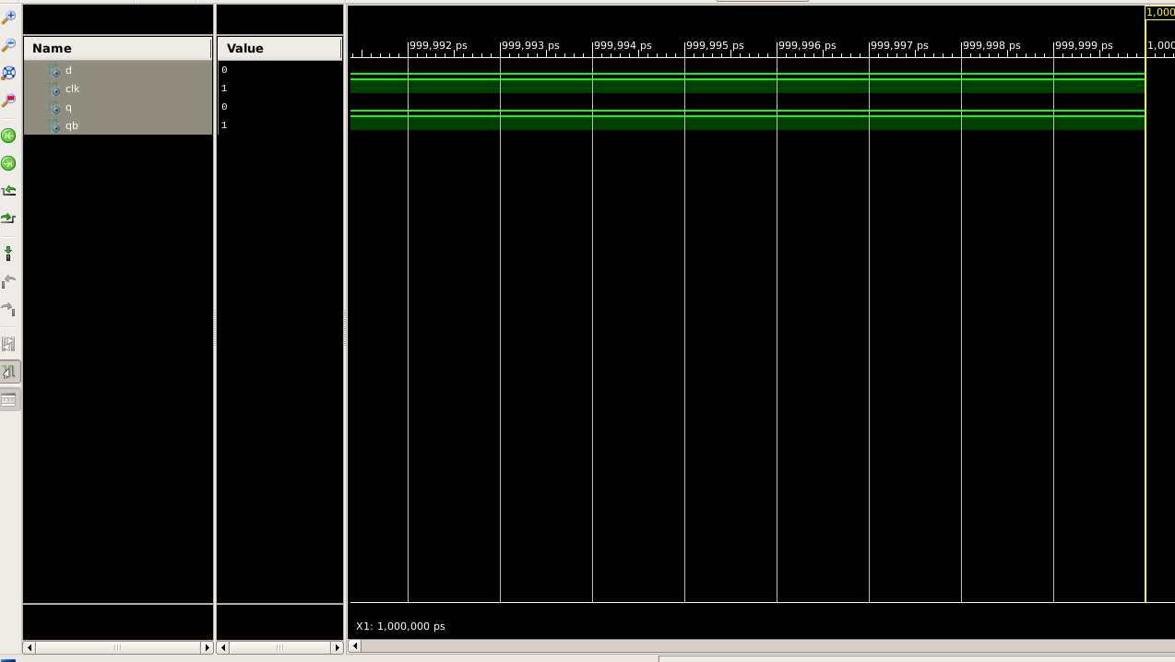

Figure 5

Here the yellow line in figure 5 represents the input (d and clock = 0 and 1 ) and therefore the output (q and q (bar) ) will be represented as the output which in this case is 0 and 1. The truth table ford flip flop until our clock’s input is 0 can be concluded by this observation.

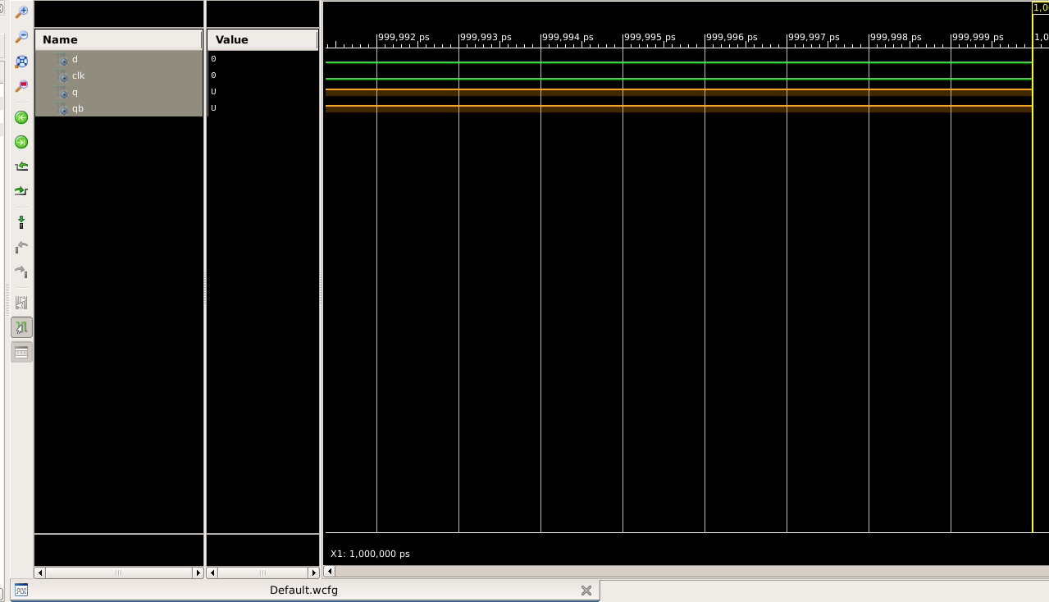

Figure 6

Here the orange line in figure 6 represents the input of clock is 0 and therefore the output will be the previous state. Hence, the truth table of D Flip Flop is as follows:

|  |  |  |  |
| --- | --- | --- | --- |
| D | Clock | Q(n+1) | Compliment of Q(n+1) |
| 0 | 1 | 0 | 1 |
| 1 | 1 | 1 | 0 |
| x | 0 | Qn | (Qn) bar |
| x | 0 | Qn | (Qn) bar |

Table 1

Further we can also make the characteristic table and through that table we can easily conclude the characteristic equation :

|  |  |  |  |  |
| --- | --- | --- | --- | --- |
| D | Qn | Clock | Q(n+1) | Compliment of Q(n+1) |
| 0 | 0 | 1 | 0 | 1 |
| 0 | 1 | 1 | 0 | 1 |
| 1 | 0 | 1 | 1 | 0 |
| 1 | 1 | 1 | 1 | 0 |
| 0 | 0 | 0 | 0 | 1 |
| 0 | 0 | 0 | 0 | 1 |
| 1 | 1 | 0 | 1 | 0 |
| 1 | 1 | 0 | 1 | 0 |

Table 2

The characteristic equation that can be drawn as :

Q(n+1) = D

After forming Excitation table, the same equation can also be drawn.

# RESULT: We have concluded the truth table, characteristic table, characteristic equation, and excitation table of d flip flop using VHDL language in Xilinx ISE Tool.

APPLICATION IN DAILY LIFE:

* **Memory Devices:** D flip-flops are essential components of memory devices like RAM (Random Access Memory) and registers. RAM in computers stores data temporarily while the system is running. Registers are used for storing data temporarily within the CPU during processing. So, every time you use a computer or any digital device that requires memory, you're indirectly utilizing D flip-flops.
* **Communication Systems**: In communication systems such as wireless networks, D flip-flops are used in various components like modems and routers. These components utilize flip-flops in data synchronization, timing recovery, and other functionalities critical for reliable data transmission.
* **Control Systems:** D flip-flops are used in control systems for sequential logic and state memory. They play a role in maintaining the state of the system, ensuring proper sequencing of events, and implementing control algorithms.
* **Digital Clocks and Timers:** D flip-flops are utilized in digital clocks and timers to store and manipulate time data. They help in counting seconds, minutes, and hours accurately, ensuring precise timekeeping in various devices ranging from simple alarm clocks to sophisticated industrial control systems.